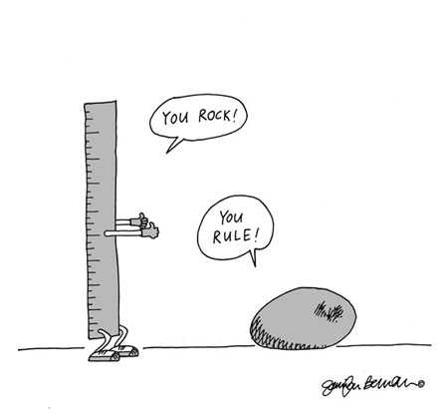
WORKSHOP – 3b
Grammar Revision

Do the following tasks carefully and keep in mind that you are doing them in order to learn to use the present perfect tense correctly.

You will find the explanations and the materials you need at the different stations. All you have to take along is a pen.

Have fun!

Station | Task(s) | Number of Students
Working with Newby-grammar | Needle in a Haystack | Whole class
Present Perfect Tense: Changes and Completion | Changing Rooms | Pairs
Present Perfect Tense: Duration | How long have you… | Pairs
Present Perfect Tense: Duration | Since 1908 | Groups of 4
Present Perfect Tense: General Experience | Mr. and Ms. Strinex | Groups of 4
Present Perfect Tense: General Experience | Postcards (three different worksheets – choose one!) | Alone
Irregular Verbs | - Dice and grid game  - Irregular verbs board game | 2 – 4 students

Teacher notes:

ad 1)
explanation: on worksheet
Group teacher: Ms Göttlich
materials: 2 different worksheets, one per student, different colour pencils

ad 2)
explanation: on worksheet
Group teacher: Ms Krammer
material: one worksheet per student

ad 3)
explanation: Mr and Ms Strinex: oral // postcards: on worksheet
Group teacher: Ms Knapp
material: one sheet to write on, postcard sheets (copy each sheet appx. 1/3 of number of students)

ad 4)
explanation: on worksheet
Group teacher: Ms Pölzleitner
material: one worksheet per person (students must have the Newby books), prize (on the worksheet it says “the fastest pair will win a prize”)

ad 5)
explanation: on extra sheets
Group teacher: --
material: 5 different colour pencils, 3 dices (two for “dice and grid game”, one for irregular verbs game), games, notepad (to write down the verbs)

