My Grammar Page

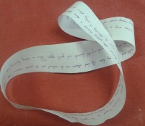
This is what I usually do:


These are the activities that are going on around me right now:


