Fake news: Reporting unbelievable things that someone said

Flying penguins? Watch the BBC video.


This is what the explorer said This is what Robert told his friends

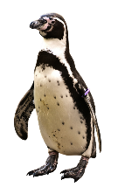
I saw a cool video on YouTube the other day. It was about penguins that can fly!
It was a BBC documentary but it can’t be true! The reporter said that they had recently discovered a colony of penguins that was unlike any other. He claimed that they could fly and actually flew south every winter and spent the cold season in warmer regions.
He showed the video and you could see the penguins flying! He said that they didn’t need to huddle together to keep warm because they could fly to the South.

“This recently discovered colony of penguins is unlike any other.”

“These little fellas can do something no other penguins can.”

“They fly thousands of miles to the rainforests of South America where they spend the winter basking in the tropical sun.”

“They don’t need to huddle together every winter for protection against the bitter cold.”
They didn’t need to huddle together every winter for protection against the bitter cold.

Now it’s your turn:
STEP1: Look at the words in bold. What do you notice?

Then read what Maxi and his brother said about it.
Maxi is announcing some cool news | Robert is reporting fake news
 | 
“Wow, you won’t believe what they have discovered in Madagascar.  I saw a BBC video where an explorer showed some flying penguins. I didn’t know they can do that. I thought penguins were too heavy to fly, but the video really showed flying penguins. How amazing.  The explorer explained that they are unlike any other penguins in the world. They don’t spend the winter in the ice, and they don’t need to huddle together to protect themselves against the cold. They fly south to warmer countries, just like other birds. He said that they can fly thousands of miles and spend the winter in the tropical sun. Isn’t this amazing? I would really like to see these flying penguins myself.” | “Have you seen the BBC video about flying penguins? It went viral on all the social media. It showed an explorer in Madagascar and he said that he had discovered a colony of penguins that was unlike any other in the world. He said that these penguins didn’t spend the winter in the ice – huddling together against the cold, but that they could fly. He explained that these special penguins could fly to warmer regions and spend the winter there, just like other birds do. In the video you could see the penguins running and then starting to lift off. Then the video showed lots of black birds flying in the sky. At first it seemed very convincing – but then I noticed that it was published on April 1st. So, the whole thing is obviously a hoax. Of course, penguins do not fly.

What do you notice?

Both Maxi and his brother Robert are talking about the same video. Why are they using different tenses here?
Maxi uses the _____________________ because….
Robert uses the ___________________ because …

The Reporting Circle
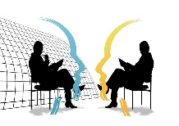
FAKE NEWS!
T E N S E
I don’t quite believe this.
I don’t trust this.
I don’t care. It’s just a fact.
TENSE
ME
HERE
NOW
WOW! This is interesting!
This is so real and so relevant for us….
yesterday, last week, five years ago, in 1875…
Thinking back to the conversation


For the teacher


Let’s explain:
Announcing interesting news | Reporting fake information
Maxi is announcing cool news. He thinks this is great and wants to tell us about these cool animals.  Therefore, he is using the ……………………………….. tense. | Robart knows that penguins are too heavy to fly, and he does not believe that the information is correct. He thinks this is fake news.  Robart is reporting the news in the ………………….. tense.
In everyday situations we often use the present tense to talk about interesting news or facts that we have heard of or read.  We use the present tense, because these facts seem important and relevant to us now.  “I have some good news for you all. We are going to buy a new basketball hoop for the schoolyard.”  Ms. Wagner said that we will get a new basketball hoop for our schoolyard.  Your Turn  What did the teachers actually say?  “We …  Our teacher told us that we are going to visit the Zotter chocolate factory next week.  Cool, isn’t it?  Ms. Pö said that we can take part in the GOAL project and write our own online story books with our international friends.  Ms. Bergmann promised that we will watch a film in the next lesson. | When we report fake news or things that are no longer true, we report these in the ………………….. tense.  We use the ……………………………tense to “push the information away from us” – that means – to show that we do not trust it.  The phrase he/she claimed that – also shows that we do not trust the information that we are reporting.  Your Turn  What did the people actually say?  The reporter claimed that the penguins in Madagascar could fly.  Trump announced that he would build a wall at the border to Mexico.  Ms. Bergmann promised that we would watch a film but then we had to do a grammar exercise!

More examples of reporting fake news

Last week I met an old friend of mine and we got into a really weird conversation. Mark really thinks that aliens exist and are all around us. He claimed that they were abducting humans and were doing strange experiments on them. He was really scared and said that he didn’t leave the house at night anymore.
He then added that you also had to be careful outside, even during the day. He asked if I knew about chemtrails. He claimed that politicians wanted to control people, so they added chemicals to the fuel of airplanes and if you wanted to be safe, you had to wear a helmet made of metal or stay inside.
I tried to reassure him, but he didn’t want to hear my arguments. He told me to read the warnings on Facebook and Telegram and he promised to send me some links to shocking videos. Mark seemed really scared – I don’t know where he got all the fake news from. Maybe he spends too much time on the internet!


What were Mark’s exact words?

He said: “I am sure that aliens …………… and …………………..all around us. They are abducting humans and …………………………..………… strange experiments on them. I …………… really scared. I ……………………………. the house at night anymore.
But you also ……………………. careful when you go outside during the day. Do you ____________ about chemtrails? The politicians ……………………………… people, so they ………………….. chemicals to the fuel of airplanes. If you ……………… to be safe, you ……………………………….. a helmet made of metal or stay inside.
I’ll send you some links so you can watch the shocking information yourself. You won’t believe it – it’s really scary what they are trying to do to us. “

Now it’s your turn.

Here are a few examples of recent fake-news headlines. Report in 1 sentence what the articles or videos said.
Research Team taught Gorilla to Knit
The article said that a research team …………………………………………….. ………………………………………………….but I don’t think gorillas can do this.
Boy saw UFO over Vienna
The boy claimed that he ………………………………………………..………………...…….
but I am sure it was just an airplane.
Facebook: Global warming does not exist
I saw a comment on Facebook. The writer claimed that ………………..………………………………………………………………………………………………….... but ………………………………………………………………………………………………………………………………………………………..
Now add 3 more examples of fake news that you have come across.
I read on the internet that _______________________________________________
Someone told me that ______________________________________________________
My classmate claimed that ________________________________________________

Let’s recap: Reporting fake news

We report fake news in the past tense (or the past perfect tense) . We use the tense to show that we are distancing ourselves from information that we doubt (anzweifeln)
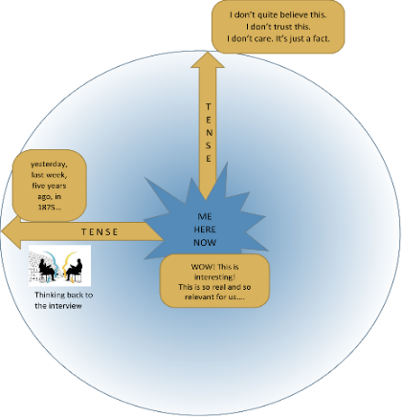
The phrase he/she claimed that – also shows that we do not trust
the information that we are reporting.

“Aliens are abducting humans.” He claimed that Aliens were abducting humans.
“Gorillas can learn to knit.” He said that gorillas could learn to knit.
“I have discovered flying penguins.” The explorer explained that he had discovered flying penguins.

But, we can use the present tense to announce important, interesting and trustworthy information that we have heard or read.

Our teachers promised that we will soon get a new basketball hoop for our schoolyard. (Here you trust your teachers)

Mom told us that she is going to have another baby. I am so excited.

