Fake News: Reporting unbelievable things that someone said

Flying penguins? Watch the BBC video.


This is what the explorer said This is what Tom told his friends

I saw a cool video on youtube the other day. It was about penguins that can fly!
It was a BBC documentary but it can’t be true! The reporter said that they had recently discovered a colony of penguins that was unlike any other. He claimed that they could fly and actually flew south every winter and spent the cold season in warmer regions.
He showed the video and you could see the penguins flying! He said that they didn’t need to huddle together to keep warm because they could fly to the South.

“This recently discovered colony of penguins is unlike any other.”

“These little fellas can do something no other penguins can.”

“They fly thousands of miles to the rainforests of South America where they spend the winter basking in the tropical sun.”

“They don’t need to huddle together every winter for protection against the bitter cold.”
They didn’t need to huddle together every winter for protection against the bitter cold.

Now it’s your turn:
STEP1: Look at the words in bold. What do you notice?

Then read what Maxi and his brother said about it.
Maxi is announcing some cool news | Robert is reporting fake news
 | 
“Wow, you won’t believe what they have discovered in Madagascar.  I saw a BBC video where an explorer showed some flying penguins. I didn’t know they can do that. I thought penguins were too heavy to fly, but the video really showed flying penguins. How amazing.  The explorer explained that they are unlike any other penguins in the world. They don’t spend the winter in the ice, and they don’t need to huddle together to protect themselves against the cold. They fly south to warmer countries, just like other birds. He said that they can fly thousands of miles and spend the winter in the tropical sun. Isn’t this amazing? I would really like to see these flying penguins myself.” | “Have you seen the BBC video about flying penguins? It went viral on all the social media. It showed an explorer in Madagascar and he said that he had discovered a colony of penguins that was unlike any other in the world. He said that these penguins didn’t spend the winter in the ice – huddling together against the cold, but that they could fly. He explained that these special penguins could fly to warmer regions and spend the winter there, just like other birds do. In the video you could see the penguins running and then starting to lift off. Then the video showed lots of black birds flying in the sky. At first it seemed very convincing – but then I noticed that it was published on April 1st. So, the whole thing is obviously a hoax. Of course, penguins do not fly.

What do you notice?

Both Maxi and his brother Robert are talking about the same video. Why are they using different tenses here?
Maxi uses the _____________________ because….
Robert uses the ___________________ because …

The Reporting Circle
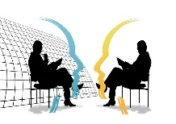
FAKE NEWS!
T E N S E
I don’t quite believe this.
I don’t trust this.
I don’t care. It’s just a fact.
TENSE
ME
HERE
NOW
WOW! This is interesting!
This is so real and so relevant for us….
yesterday, last week, five years ago, in 1875…
Thinking back to the conversation


Let’s explain:
Announcing interesting news | Reporting fake information
Maxi is announcing cool news. He thinks this is great and wants to tell us about these cool animals.  Therefore, he is using the ……………………………….. tense. | Robart knows that penguins are too heavy to fly, and he does not believe that the information is correct. He thinks this is fake news.  Robart is reporting the news in the ………………….. tense.
In everyday situations we often use the present tense to talk about interesting news or facts that we have heard of or read.  We use the present tense, because these facts seem important and relevant to us now.  “I have some good news for you all. We are going to buy a new basketball hoop for the schoolyard.”  Ms. Wagner said that we will get a new basketball hoop for our schoolyard.  Your Turn  What did the teachers actually say?  “We …  Our teacher told us that we are going to visit the Zotter chocolate factory next week.  Cool, isn’t it?  Ms. Pö said that we can take part in the GOAL project and write our own online story books with our international friends.  Ms. Bergmann promised that we will watch a film in the next lesson. | When we report fake news or things that are no longer true, we report these in the ………………….. tense.  We use the ……………………………tense to “push the information away from us” – that means – to show that we do not trust it.  The phrase he/she claimed that – also shows that we do not trust the information that we are reporting.  Your Turn  What did the people actually say?  Mary claimed that the Corona virus was a hoax and did not exist.  Trump announced that he would build a wall at the border to Mexico.  Ms. Bergmann promised that we would watch a film but then we had to do a grammar exercise!

More examples of reporting fake news

Last week I met an old friend of mine and we got into a really weird conversation. Mark said that the Corona pandemic was a hoax and the Corona tests that we are doing in school were dangerous and they would infect us with harmful bacteria. He even said that the swabs would hurt our brains and that the masks were full of poisonous chemicals that would make us sick. He told me that Bill Gates was behind the whole Corona pandemic because he owned some big drug companies and wanted to make a huge profit.
I was really shocked that my friend Mark believes all these things. But then it got even worse. He actually claimed that our government had invented the whole Corona pandemic. He said that they just wanted to gain more power and take away our freedom to travel and move around freely.

I tried to reassure him, but he didn’t want to hear my arguments. He told me to read the warnings on Facebook and Telegram and he promised to send me some links to shocking videos. Mark seemed really scared – I don’t know where he got all the fake news from.

What were Mark’s exact words?

He said: “I am sure that the Corona pandemic …………… a hoax. The tests that you ………… doing in school …………… really dangerous. They ……………………….. you with harmful bacteria.
The swabs …………………. your brains and the masks ………………….. full of poisonous chemicals. They …………………….really bad for you. And you know what, Bill Gates ………………… behind all of this. He …………………. some big drug companies, and he ……………………. a huge profit. Bill Gates …………….. behind all of this – I ……………. sure about it.
And you know it is not only Bill Gates. Our government ……………… behind it too. They have invented the whole Corona pandemic because they ………………. to gain more power and they ……………….. to take away our rights. They ……………….. to lock us in and close the borders.
I’ll send you some links so you can watch the shocking information yourself. You won’t believe it – it’s really scary what they are trying to do to us. “

Now it’s your turn.

Here are a few examples of recent fake-news headlines. Report in 1 sentence what the articles or videos said.
Research Team taught Gorilla to Knit
The article said that …………………………………………….. but I don’t think gorillas can do this.
Boy saw UFO over Vienna
The boy claimed that he ……………………………………….……. but I am sure it was just an airplane.
Facebook: The Corona Virus does not exist
I saw a comment on Facebook. The writer claimed that ………………..…………………….. but ………………………………………………………………………………………………………………………………………………………..
Now add 3 more examples of fake news that you have come across.
__________________________________________________________________________________________
__________________________________________________________________________________________
__________________________________________________________________________________________

Let’s recap: Reporting fake news

We report fake news in the past tense (or the past perfect tense) . We use the tense to show that we are distancing ourselves from information that we doubt (anzweifeln)
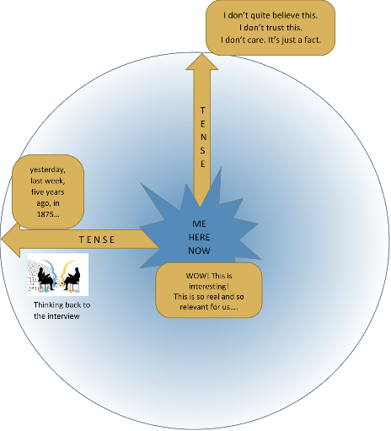
The phrase he/she claimed that – also shows that we do not trust
the information that we are reporting.

“Bill Gates is behind the pandemic.” He claimed that Bill Gates was behind the pandemic.
“The masks are poisonous.” He said that the masks were poisonous.
“I have discovered flying penguins.” The explorer explained that he had discovered flying penguins.

But, we can use the present tense to announce important, interesting or relevant information that we have heard or read.
Our teachers promised that we will soon get a new basketball hoop for our schoolyard.
Mom told us that she is going to have another baby. I am so excited.
Ms. Pö said that we can

Reporting neutral information that someone said in the past –

thinking back to the conversation
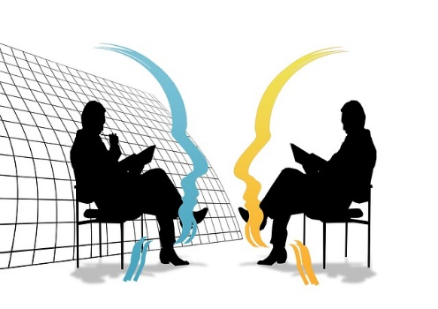

Yesterday I met the new Math teacher during the big break.

Hello, are you the new Math teacher?  Yes, it’s my first day here at your school.  Where did you teach before?  The last 3 years I taught at a school in Vienna,  and before that I taught at a school in Salzburg.  Why did you come to Graz?  I decided to move to Graz because my wife got a good job here and my parents live here as well.  Do you also teach any other subjects?  Yes, I also teach Geography, but I prefer Math. | We had a little chat. He seems quite nice.  He told me that it was his first day here at our school.  He said that he (had) taught in Vienna before and before that he had taught at a school in Salzburg.  When I asked him why he came to Graz he told me that his wife got a good job here and that his parents lived here as well.  He is also a Geography teacher, but he told me that he liked teaching Math more. That’s strange. Math is much more difficult than Geography.

Reporting: Thinking back to the conversation

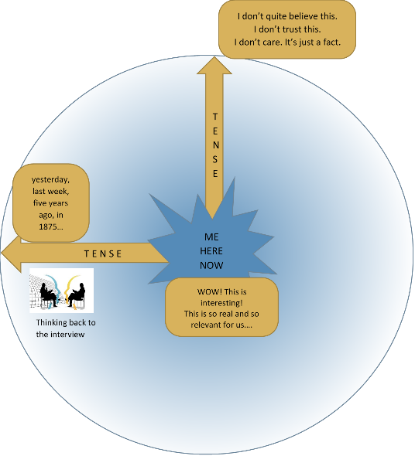
We report in the past tense (or the past perfect tense) to show that we are thinking about the past and reporting what other people said in that situation.

- neutral facts that someone else said in the past
- a situation that is past and no longer true

In last week’s interview, the actress said that she was working on a new film.
Last night the minister of education said in the news that all students would get free laptop computers.
I knew she would not show up for the date. She is too shy.
He promised he would come to the party and bring some food, but he didn’t even show up.

Your Turn
What did they actually say?
“…

She said she could speak five languages.

The reporter asked the actress if she had ever played in a movie with Daniel Radcliffe.

The witness said that he was looking (or had been looking) out of his window when the accident happened. He told the police that he saw (or had seen) the red car racing down the street.

Socrates said he could not teach anybody anything. He could only make them think.

Einstein said that he had no special talent. He was only passionately curious.

Churchill said the best argument against democracy was a five-minute conversation with the average voter..

Reporting what someone asked me to do

So much to do! This is what This is what you tell your friend
Ms Bergmann told us last week
Last Monday, our teacher was quite strict. She told us to hand in our vocab books on Monday and to show our tests to our parents. She also told us to complete the text and to bring it to class the next day.
Don’t forget to hand in your vocab books tomorrow and show your test to your parents. Complete the text at home and bring it to class tomorrow.


If everybody finishes their project by Friday, I will show you a film in the next lesson.
Friday,
Then she promised to show us a film.

She asked us to bring some cookies and popcorn.
Can you bring some cookies and popcorn, so that we have a real cinema experience.
Friday,

Your turn:

Now find your own examples. Report what your teachers, parents, friends, brothers and sisters asked you to do and told you to do last week?
________________________________________________________________________________________
________________________________________________________________________________________
________________________________________________________________________________________
________________________________________________________________________________________
________________________________________________________________________________________
________________________________________________________________________________________
________________________________________________________________________________________
________________________________________________________________________________________

Reporting Questions

Nosy parents! You spent the weekend This is what you tell your
with a friend. Your parents want to know friend
everything!
My mother wanted to know everything!
She asked me if we went to the park.
She wanted to know if we had a picknick.
She asked me if we drank alcohol!
She wanted to know if we met other friends.


Did you go to the park?
Did you have a picknick?
Did you drink alcohol?
Did you meet other friends?

Where did you go afterward.
When did you come home?
Why are your clothes dirty?
What did you do all day?
My father asked me where we went afterwards.
He wanted to know when I came home.
He wanted to know why my clothes were dirty.
He asked me what we did all day.
HE



Your turn:
Now find your own examples. What did teachers, parents, friends, brothers and sisters ask you last week?

________________________________________________________________________________________
________________________________________________________________________________________
________________________________________________________________________________________
________________________________________________________________________________________
________________________________________________________________________________________
________________________________________________________________________________________
________________________________________________________________________________________
________________________________________________________________________________________

