Looking at the little things again

No! No! No! :
  - I do not like/ X does not like…
  - I don’t like / X doesn’t like…
What are the foods you do not like at all.
I do not like….
Then ask five classmates what they do not like at all and write sentences.
1
2
3
4
5

My- your- his-her-our-your-their…
I know Mr. Watson but I don’t know …………… wife.
Mr. and Mrs. Baker live in London. ……………… son lives in Paris.
Ann is going out with ……………… friends tonight.
I like tennis. It’s ………. favorite sport.
We’re going to have a party. We’re going to invite all ………………….. friends.

Dirty hands:
Finish the sentences:
I’m going to wash …………… ..hands. He’s going to wash ……………hands.
She’s going to wash …………...hands. The children are going to wash…..…… hands.
We’re going to wash …………. hands. Are you going to wash ………….. hands too?

A or an? Listen carefully
Write a or an:
orange | hamburger | nut | lemonade | slice of pizza
banana | apple | ice-cream | olive | piece of chocolate

Dogs, dogs, dogs.
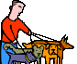
- Whose dogs are these? Match the pictures with the words.
Peter’s dog.
Tom’s dogs.
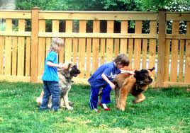
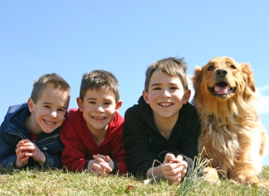
The boys’ dog.
The boys’ dogs.
The dog’s tricks.
No dogs allowed here.
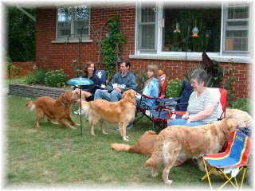

- Now label these pictures. Where do you need an apostrophe?
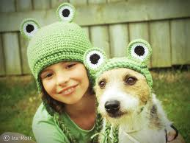

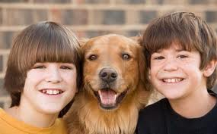
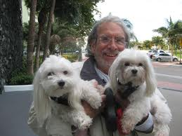
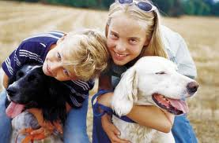

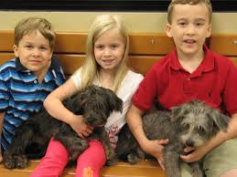
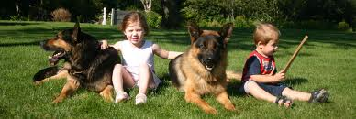

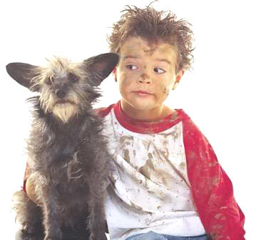

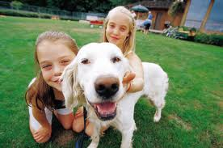
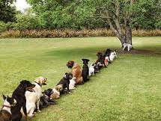
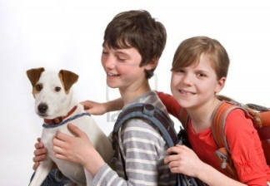

Homework:
Make your own matching exercise (like exercise 1). Choose a different topic – find or draw 6 pictures and write 6 sentences. Bring your page to class and ask one of your classmates to match the pictures and the phrases.


Asking questions:
Use the words from the boxes to write five questions. Use each word once.
When  What  Why  How  Where | does  are  is  does  do | the children  Sue and Katy  Thomas  Anna  Mrs. Pölzleitner’s | have for dinner  birthday  not at school today  live  go to school | ?

Now find out more about your teacher(s). Write questions and guess the answers. Then ask your teacher and find out if your guesses were correct.
What… | Tick off your correct answers:
Your answer:
When
Your answer:
Where
Your answer:
Why
Your answer:
How
Your answer:
How many
Your answer:
Who
Your answer:

