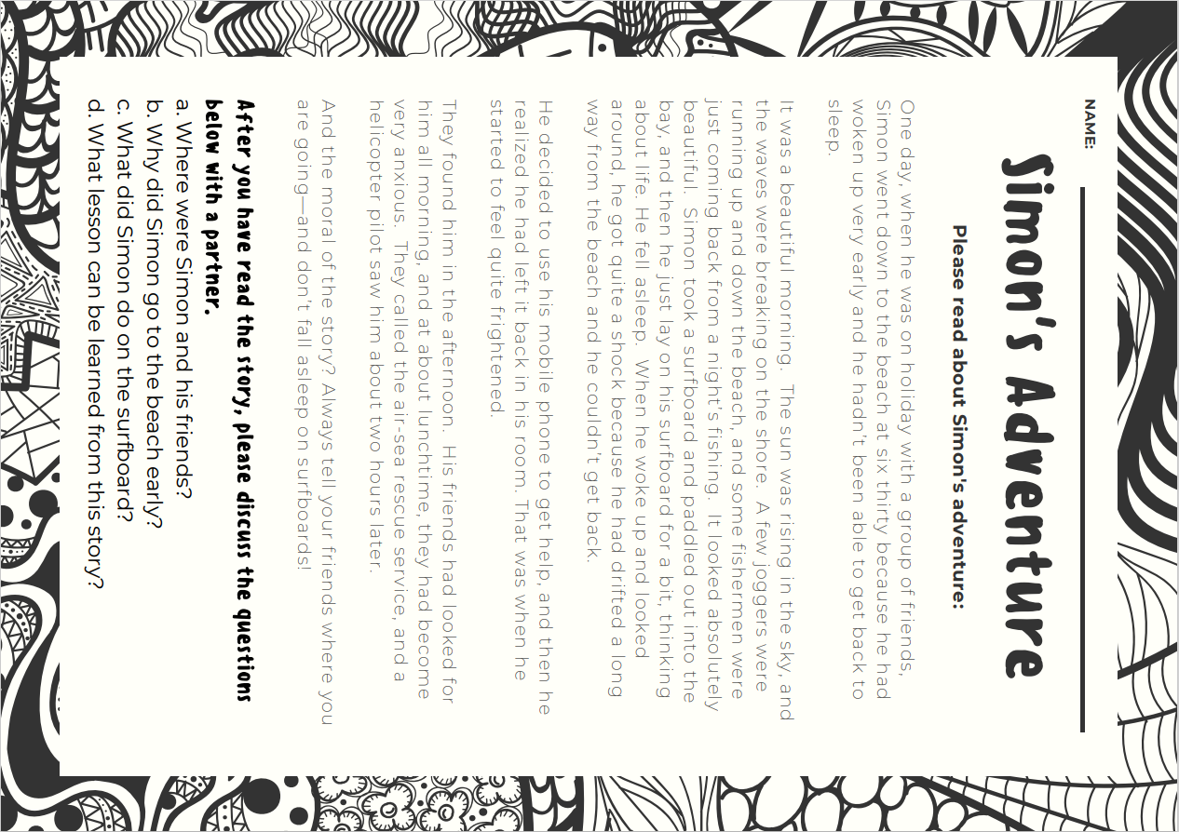
Harmer, Jeremy. The Practice of English Language Teaching, 5th ed. Pearson, 2017, pp. 250-251.

