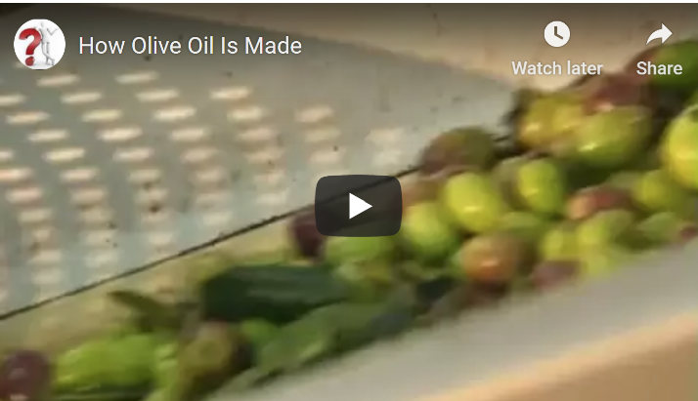
Passive Bricks
1. Watch the video about how ketchup is made.
2. Then sum up what you have found out. Drag and drop the bricks to form meaningful sentences.
Process

are collected | are used | are washed
are harvested | should be pressed | can be removed | are filtered out
are sent | is ground | is squeezed out | is filled
is considered | are heated | is spun
Additional information
to the factory as fast as possible. | in a large hopper together with some branches and leaves. | into green glass bottles or steel containers.
using a grill that only allows the fruit to pass through. | by using tiny rakes. | to harvest large amounts of olives.
to remove any dirt and leaves. | as soon as possible. | more gently.
in a centrifuge. | in a hydraulic press. | in the process of grinding.
the most valuable. | later.

Traditionally, olives
Nowadays, automated harvesters
The olives
The leaves
The olives
The last few branches and twigs
To get high quality oil, the fruit
The olives
In a modern olive press the fruit
Olives would lose flavor if they
In the traditional method the oil
In the modern method the pulp
Pure, unfiltered oil
Finally, the oil

