Find someone who…
Are you going to
………….
- Step 1: Write down 10 things you are planning to do in the Christmas holidays.

- Step 2: Talk to your classmates if they are going to do the same things. Write your friends’ names into the grid. Use each name only once (1x).
Write your questions here: | Names:
Are you going to…
Are you going to…
 | 
Now ask 5 friends about the coolest thing they are going to do in the holidays.
………………….. is going to………….
………………….. is going to …………

Horoskopes
  Aries March 21-April 20  This year will be very successful for you! You will travel and meet a lot of new friends. Maybe you will even meet the love of your life! |   Libra September 23-October 22  This year won’t have a very good start.. Perhaps you will have problems with friends. Things will get better in the summer, but the winter will be the best!
  Taurus April 21-May 20  This will be a tough year. You will have problems in the beginning, but because you are such a hardworking student, things will work out in the end! |   Scorpio October 23-November 21  Hungry for adventure? This will be your year! The stars will help you in your troubles, but try to listen to your brain, too.
Gemini May 21-June 21    This year will be complicated. You will lose some friends, but your real friends will stand by you! Winter will be dangerous for your health. | Sagittarius November 22-December 21    This year will bring happiness to your life. Problems that made you sad last year will end and you will feel much better and free!
  Cancer June 22-July 22  Parents, parents, parents! This year they will try to control your life more than ever. This will make you angry, but try to listen to them. Perhaps you will benefit from their advice. | Capricorn December 22-January 19    This year won’t bring you much luck. There will be some small problems in school and the teachers won’t be very patient with you, so be careful! Try to work harder, if you can!
Leo July 23-August 22    This year will bring love to your life. You will fall in love madly. Be careful! Summer will be critical. You will need money this year, so try to find some kind of job. |   Aquarius January 20-February 18  This will be a fun year! You’ll meet interesting people, you’ll visit interes-ting places and you’ll have enough money. Love will also find you, but you’ll have to wait until the end of the year!
  Virgo August –September 22  This year, the stars will help you at school. You will think fast and everything will seem easy. If you study, you will be the best student in the class! | Pisces February 19-March 20    Chaos! This year, you will sometimes wonder why all problems seem to find you. Don’t worry, and trust your instincts. You will always find the right way. This year will also bring some romance!

What does the horoscope say about you?
Find out your friends’ signs of the zodiac and tell them what’s in for them this coming year.

Do you believe in horoscopes? Do you ever read them in the newspaper?

Good Fortunes: Tulips
Step 1: Draw a name-card from the box on your teacher’s desk. Write 4 good fortunes for the person on your card. If you do not know the person very well, ask his/her friends (secretly) and find out what would make them happy.
Step 2: Produce a few “tulips fortunes” or a “ good fortunes boat” for your classmate and write the 4 good fortunes onto it. Don’t forget to start all your fortunes with: “You will….”
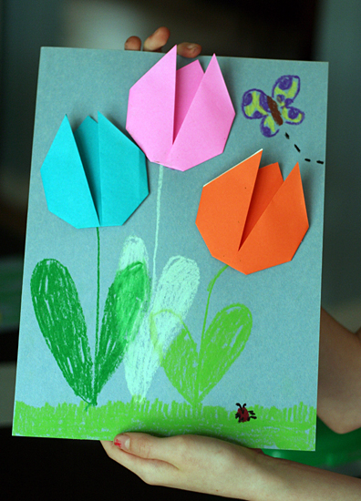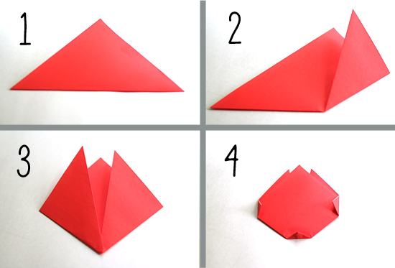
For each step, press each fold well with your fingers.
Step 1: With the colored side facing down, fold your paper on the diagonal to make a triangle.
Step 2: Bring the bottom right corner up and to the right of the center point.
Step 3: Repeat with the left corner, bringing it up and to the left of the center point.
Step 4: Flip the paper over. Fold the side and bottom points in just a bit, to create a more rounded tulip shape.
Flip it back over and check out your finished tulip! So cute and easy, right? I showed my girls how to make one, and they proceeded to whip out a whole pile in minutes.
Write a good fortune into each tulip, then glue the tulips on a colored card and draw the stems.

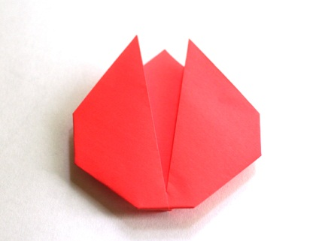

Good Fortunes: Where will the future take you?
Write a good fortune for your friend on each side of the boat – inside and outside.

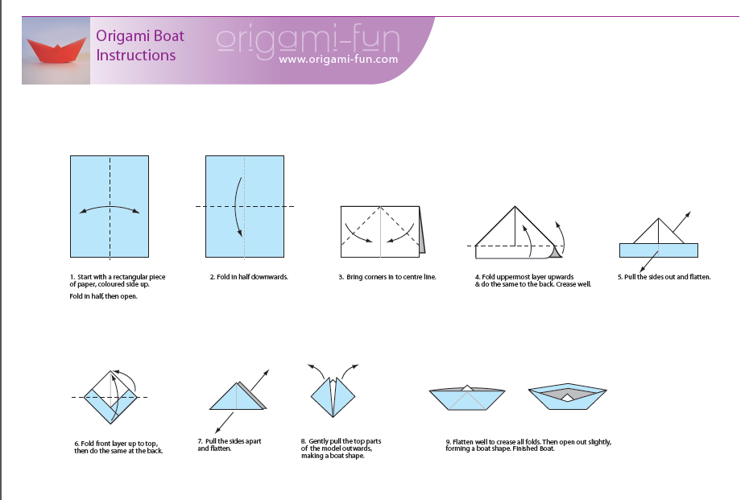

Palm-reading
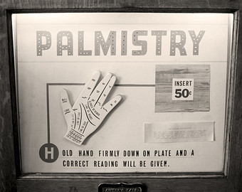
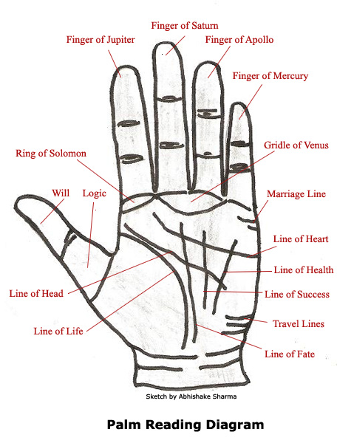
Do the palm reading with your teacher.
(groups of 3)

http://www.buzzle.com/articles/palm-reading-learn-how-to-read-palms.html (04.02.2014)
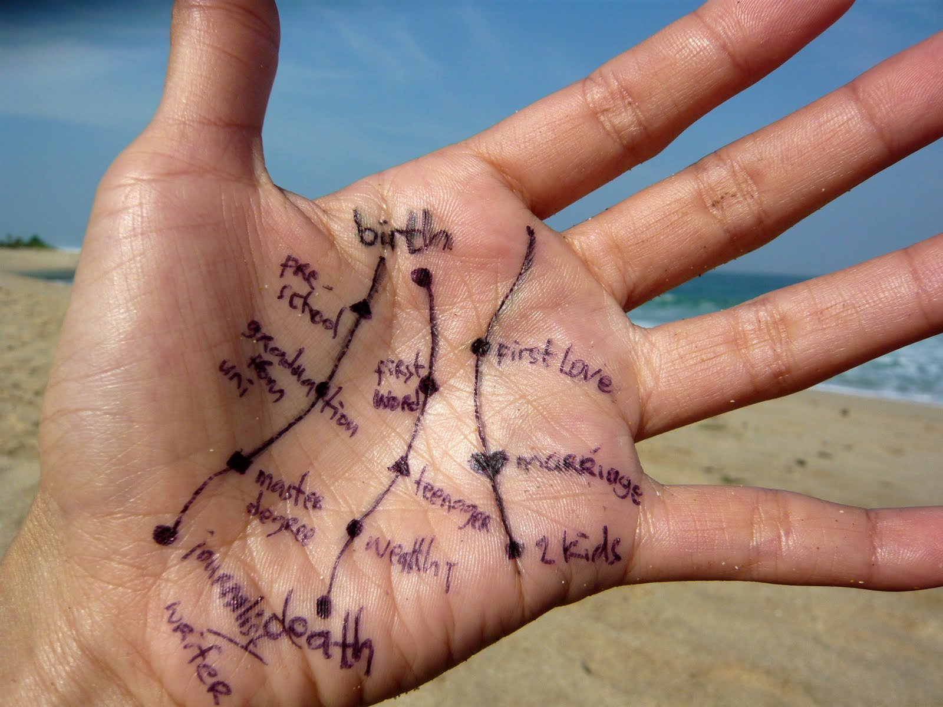
http://tattoojockey.com/tattoo-design/13111/palmistry-designs-palmistry-tattoo-design.html (04.02.2014)

Fortune Tellers

You will…….
Fold your personal paper fortune teller and write in 8 good fortunes that you think will happen to your friends.
Then talk to 3-4 of your friends and tell them what’s in store for them in the future.
To fold your paper fortune teller follow these instructions:
Start with a square.   |  |  | Now turn it over.
 |  | 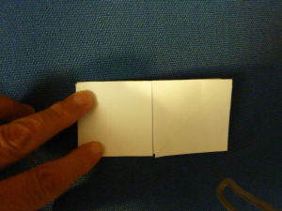 | Push together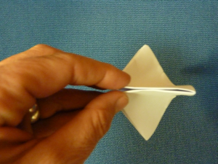
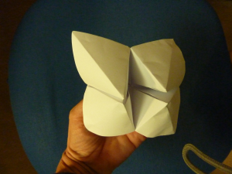 | Open up your fortune teller and write in eight good fortunes.  You will….  You will…  You will… | 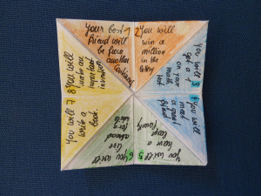 | Add numbers 1-8  and  choose 4 colors to decorate your fortune teller.  Optional: Decorate the outside of your fortune teller.
To play:  Ask your friend to choose a number between 1 and 10.  Open and close your fortune teller counting up to the chosen number. | Ask your friend to choose a color.  Open your fortune teller so you see the chosen color.  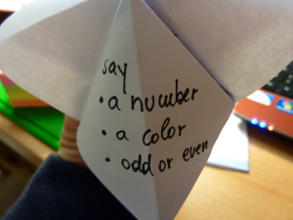 | Ask your friend to choose odd (ungerade) or even (gerade).  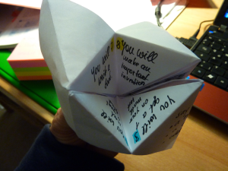 | Read out your friend’s fortune and wish him/her good luck.

