k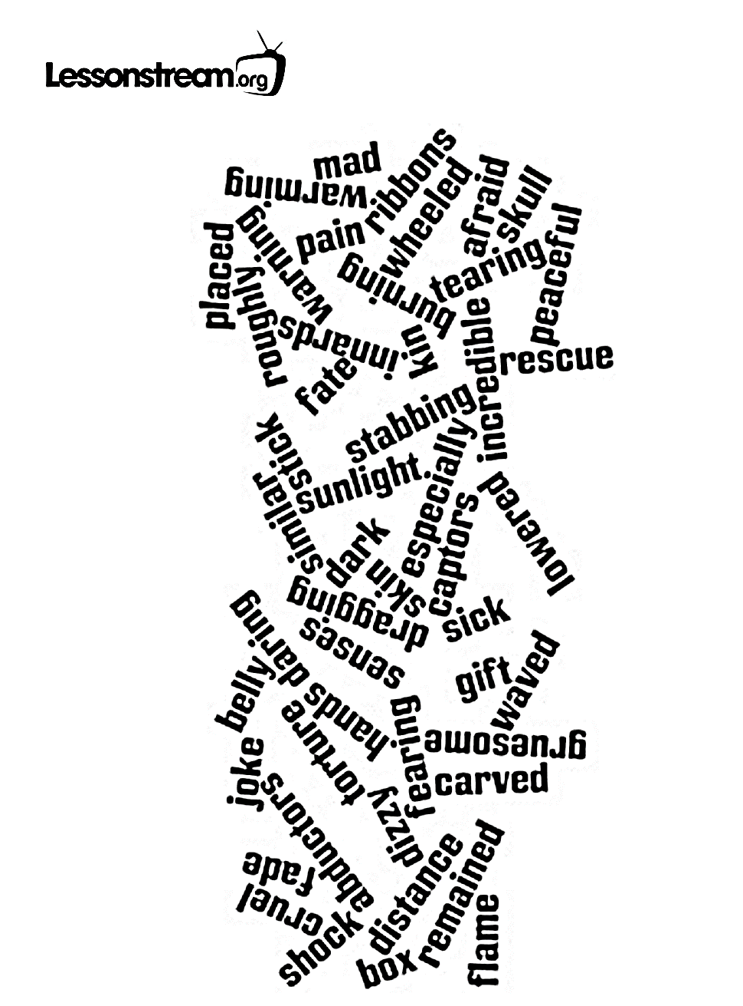

Jamie Keddie, Lessonstream.org: http://lessonstream.org/2011/10/26/halloween-horror-story/
Horror Story

I am a ………………………. Hello
In the beginning, my life was peaceful: Days spent with my family in the garden; The sunlight warming my skin. Peaceful.
Until they came without warning – cruel hands dragging me roughly from my dreams into a wheeled box.
I was carried past my brothers and sisters and friends. My family. I cried out for rescue but my kin remained silent and unmoving, perhaps fearing similar fate.
My home began to fade in the distance. And suddenly, everything went dark.
When I came to my senses, I saw that my abductors had placed me on hard grey earth. I was afraid I had just been left to die. Now I know if I had, I would have been lucky.
The pain was incredible. I became dizzy – I felt sick. They had cut a giant hole in my skull and were now tearing my innards from my body and throwing them in front of me, like ribbons from a gift.
Moments later, the knives returned, stabbing me over and over again.
What made those people do what they did that day? I do not know. I began to think they were playing some sort of mad game especially when they put a really big knife inside me and just sort of waved it around.
When the cutting was done I sat in shock, not daring to think that the torture might be at an end. But of course it was not.
They lowered a stick of hot fire into my belly. Burning, burning flame.
My captors had carved a gruesome visage into me, as if this was all some kind of sick joke. Who were these sick people and why had they done this to me? Why? Why? Why?

Continue…

Jamie Keddie, Lessonstream.org: http://lessonstream.org/2011/10/26/halloween-horror-story/

Personification

Writing from the Object’s Point of View
TASK: Now come up with your own object and write a story from the object’s point of view.

Once you have chosen an object begin by brainstorming what the object would be like if it was a human being by using the table below.
How old is the object?
What/how does it see?
What/how does it hear?

Where does it live?

What are its fears?
What are its dreams?

What is it good at?

What does it hate to do?

How does it feel about the people and/or objects it meets?

How does it feel about how it is used by others?
What is its overall personality like?
https://www.tes.com/teaching-resource/personification-examples-and-prompts-for-writing-6137325
http://livingwriterscollective.blogspot.co.at/2012/04/personification-prompt.html

Let’s publish our stories…

What you need:
- A revised, polished draft of your story.
- Several handmade pictures to illustrate your story. Scan these pictures on the school copy machine or use a scanner app on your mobile phone.

In order to produce and publish your video-story choose one of the two options:
- Present.me: Put your pictures into a powerpoint presentation. Upload your pictures to present.me and record the sound. If you do not yet have a free present.me account follow this link: https://present.me/plans/free
- Jing: Put your pictures into a powerpoint presentation. Open the presentation. Then record the presentation with Jing and read your text as you are recording.

Share the link to your presentation on Moodle and/or on the web.

