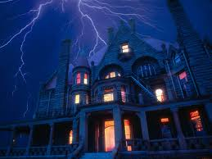  1http://www.google.com/imgres?imgurl=http://gurneegraded56.sharpschool.com/UserFiles/Servers/Server_2464887/Image/Mr.%2520Butler/spooky-house-with-lightening.jpg&imgrefurl=http://gurneegraded56.sharpschool.com/cms/One.aspx?portalId%3D2465012%26pageId%3D11 | 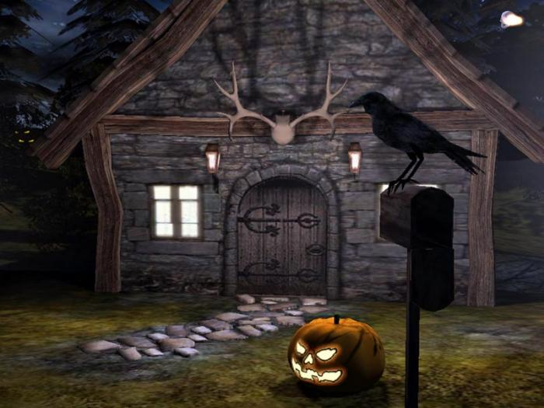  2http://www.google.com/imgres?imgurl=http://sandbox.yoyogames.com/extras/image/name/san2/212/335212/original/SA0...jpg&imgrefurl=http://sandbox.yoyogames.com/games/131960-spooky-adventures&h=525&w=700&sz=54&tbnid=7WPZvWYruZvqbM:&tbnh=120&tbnw=160&zoom=1&u
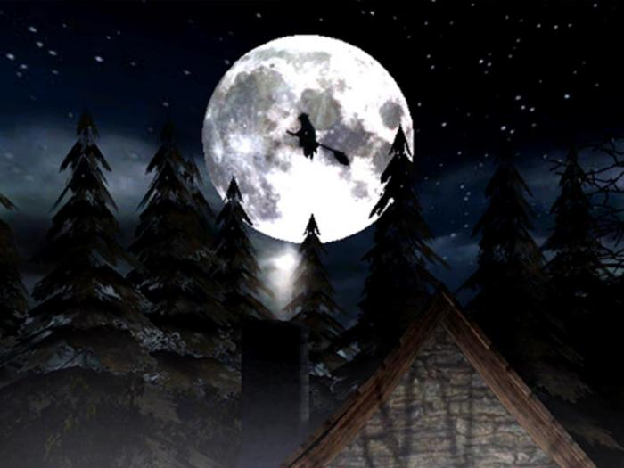  3http://www.google.com/imgres?imgurl=http://screenshots.de.sftcdn.net/de/scrn/55000/55380/3d-spooky-halloween-screensaver-2.jpg&imgrefurl=http://3d-spooky-halloween-screensaver.softonic.de/&h=525&w=700&sz=36&tbnid=B6v40djnoeaHeM:&tbnh=129&tbnw=172&zoom=1& |   4http://media-cache-ak0.pinimg.com/originals/7e/a2/9e/7ea29e14c98c799e93526dd0192b7f99.jpg
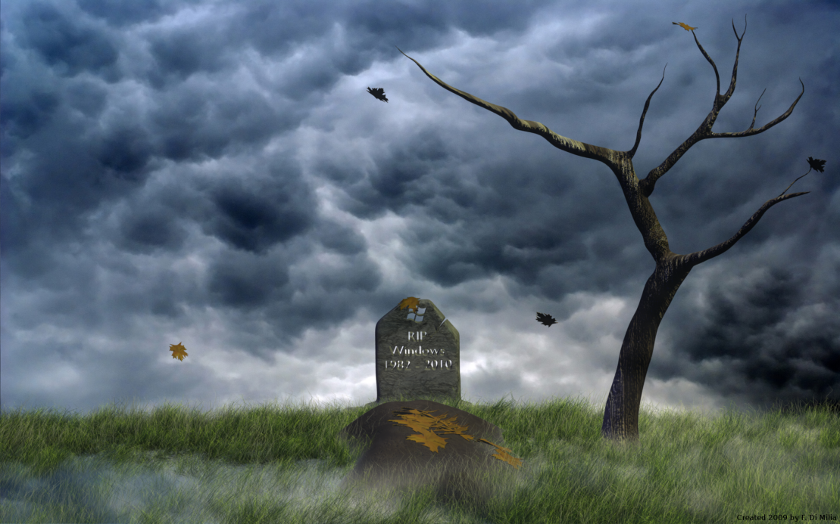  5https://www.google.com/search?q=spooky+pictures&client=firefox-a&hs=23l&rls=org.mozilla:en-US:official&channel=np&source=lnms&tbm=isch&sa=X&ei=2gR-UrS7Aqa84ATZ74DoDw&ved=0CAkQ_AUoAQ&biw=1238&bih=761&dpr=0.8#facrc=_&imgdii=_&imgrc=CLXs0h_r4fcbeM%3A%3B61Ox | 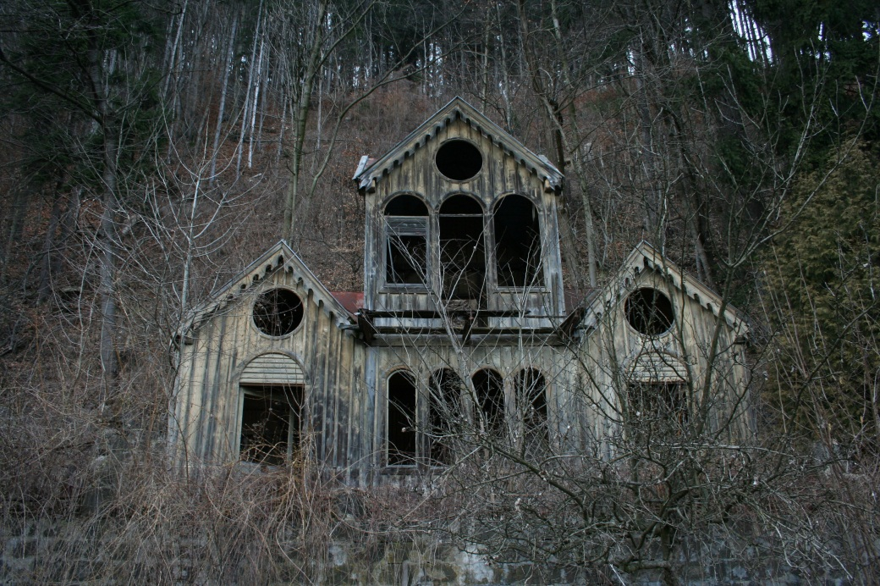  6https://www.google.com/search?q=spooky+pictures&client=firefox-a&hs=23l&rls=org.mozilla:en-US:official&channel=np&source=lnms&tbm=isch&sa=X&ei=2gR-UrS7Aqa84ATZ74DoDw&ved=0CAkQ_AUoAQ&biw=1238&bih=761&dpr=0.8#facrc=_&imgdii=_&imgrc=NvrP5immhSpUkM%3A%3B0Pdh
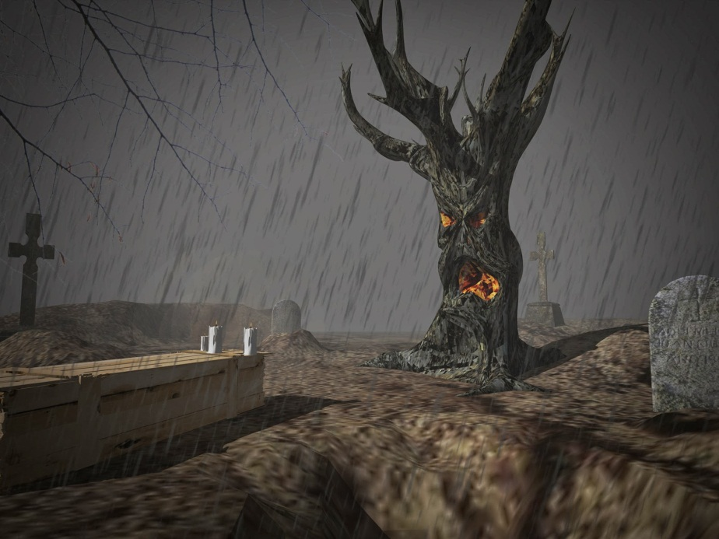  7https://www.google.com/search?q=spooky+pictures&client=firefox-a&hs=23l&rls=org.mozilla:en-US:official&channel=np&source=lnms&tbm=isch&sa=X&ei=2gR-UrS7Aqa84ATZ74DoDw&ved=0CAkQ_AUoAQ&biw=1238&bih=761&dpr=0.8#facrc=_&imgdii=_&imgrc=9MhtdnTyFff5uM%3A%3Bove6 | 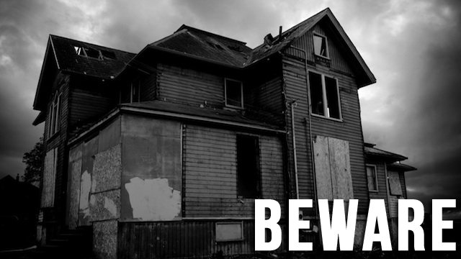  8http://jezebel.com/5854965/ten-super+spooky-ghost-stories-to-keep-you-awake-tonight
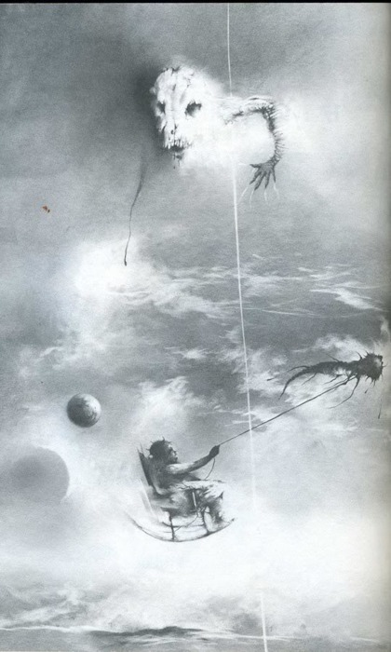  10 http://tuneinrockon.wordpress.com/2011/10/28/the-15-most-disturbing-illustrations-from-scary-stories-to-tell-in-the-dark/ | 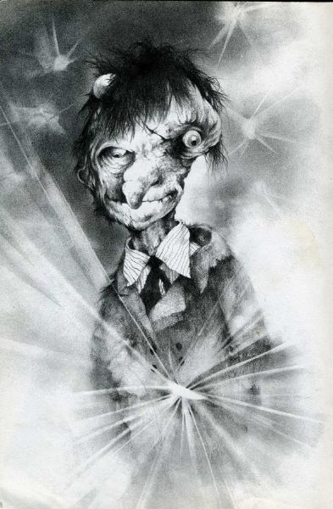  11http://tuneinrockon.wordpress.com/2011/10/28/the-15-most-disturbing-illustrations-from-scary-stories-to-tell-in-the-dark/

