Adding comments in Adobe Acrobat or Adobe Reader XI
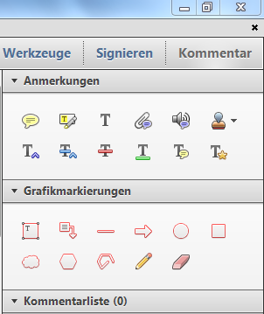
Whether you have Adobe Reader XI or Adobe Acrobat, you always add different kinds of comments (text boxes, text boxes with arrows, audio comments, underlining things,…) the same way:
1st Step
If you can see “Kommentar” in the upper right corner just click on it. A window with different commenting options appears. You can choose between various designs for “Anmerkungen” and “Grafikmarkierungen.”
If you can’t see “Kommentar” in the upper right corner your “Werkzeugleiste” is probably hidden. You can then get to the same window with the different commenting options by first clicking on “Anzeige,” then on “Kommentar” and then on either “Anmerkungen” or “Grafikmarkierungen.”
2nd Step
Now choose Anzeige > Ein-/Ausblenden > Werkzeugleistenelemente > Eigenschaften-Leiste.
A VERY USEFUL little window appears, which allows you to change certain characteristics of your “Grafikmarkierungen,” such as font size, colour, and alignment.
3rd Step
If you want to be able to open the PDF file you’ve created with other applications (say, for example, on your tablet or smart phone) you need to ‘flatten’ it first. This just means that the comments are fully integrated with the file and can’t be changed anymore. The easiest way to do this is by using a PDF printer. You just click on print and then choose your PDF printer. This creates a new pdf file that is automatically ‘flat’.
If you are using Adobe Acrobat (Uni has it) an Adobe printer called Adobe PDF is automatically installed on your computer. If you are using Adobe Reader, on the other hand, you have to install a PDF printer yourself. There are many free ones available on the internet. One of them is PDF24 Creator. Once this program is installed and you click on print, you can choose PDF24 PDF as your printer. The resulting PDF file is ‘flat.’
Here you can find more detailed descriptions:
German:
http://help.adobe.com/de_DE/acrobat/using/WS58a04a822e3e50102bd615109794195ff-7e80.w.html
English:
http://help.adobe.com/en_US/acrobat/X/standard/using/WS58a04a822e3e50102bd615109794195ff-7e5a.w.html

It might work with older version as well.

