Go to google.com, click MORE, then in the pulldown menu click DOCUMENTS

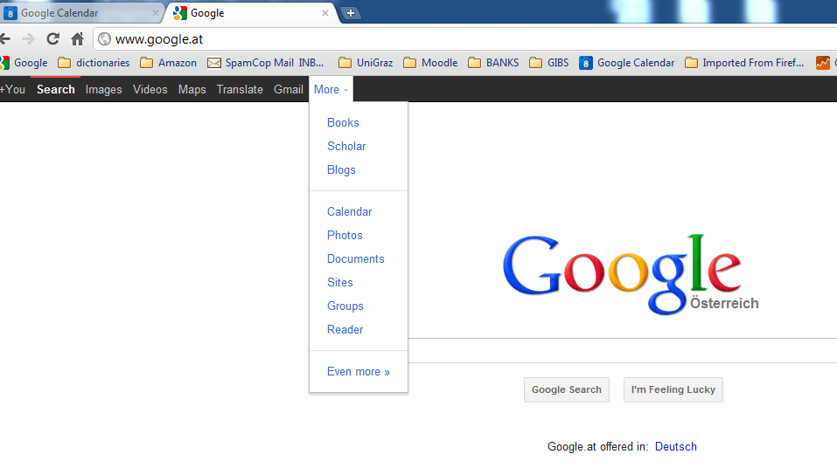

You will see this:

