How to find the URL to your Jing video
Go to your JING icon on top of your screen. Click on the second golden bubble (History).
Choose a video and click on it. You will then get the three options:
view, share (upload) or delete.
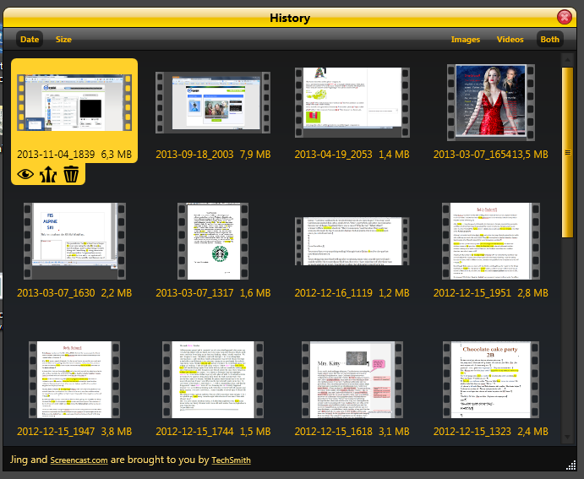
Click on upload and wait till the video has been uploaded to techsmith.com. As soon as the uploading is finished you will get the link to your video in your mouse.
Paste your link (URL) into Moodle so we can all watch your video.

