How to sign up for Glogster 

In order to produce your cool multidimensional posters, you’ll need to sign up at Glogster.com.
Don’t worry: You will all be students on Mrs. Pölzleitner’s teacher account. This is a paid account, so only your class and Mrs. Pölzleitner have access to your work and your data. This will be a safe place where we need not worry about copyright issues for every picture we use.
In order to sign up enter the following link into your browser: http://edu.glogster.com/signup?type=student
Choose your own username and password (please use one that you will remember, preferably one that you are using on Moodle or on Gibsters or on ReadingIsCool.
You’ll also need to enter Mrs. Pölzleitner’s educator code. This will automatically assign you to her account and to 6c. The code is: 6FFH69
Happy glogging!!!
By the way: Your first glog is already on the site – it’s your super-cool spooky story videos from year 2. Have fun watching them again.
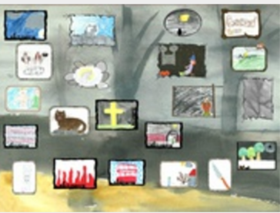
http://lispolzleitner.edu.glogster.com/2c-spooky-stories

