
How to use the Moodle Databank
Click on the databank link. For example:

In many of our courses you will find a special icon for the databank. Just click on the file-cabinet to open it:

To add your own entry, click Add entry…
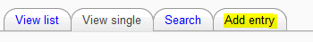
Fill in all the fields or upload the required files.
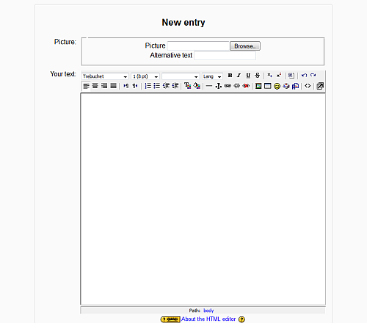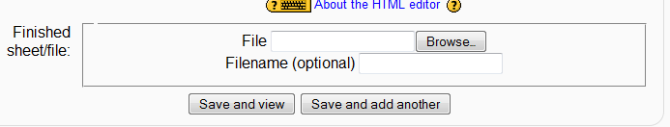
Before leaving, click “save”.
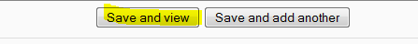
If you want to come back to your entry and edit it or add something, click the first of the three icons below. Use the second one of you want to give feedback to an entry.

In order to view all the entries you have a choice of “View list”. This shows you all the entries and you can scroll down the page.
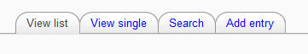
If you click “View single” you will see the full entry AND you can also give feedback to the writers.
Warning: In some cases you will have to upload your own entry BEFORE having access to the other students’ entries.
HAVE FUN

