WIKIs for Dummies
  - How to use a Moodle WIKI:
Enter your Moodle course using Firefox or Internet Explorer. Do not use Safari, it doesn’t work with these WIKIS.
Step 1: click on the WIKI link (for example to open the WIKI.
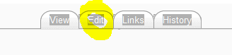
Step 2: click “edit” to open the WIKI text editor.
Step 3: Enlarge the editor for more options and more comfortable work:
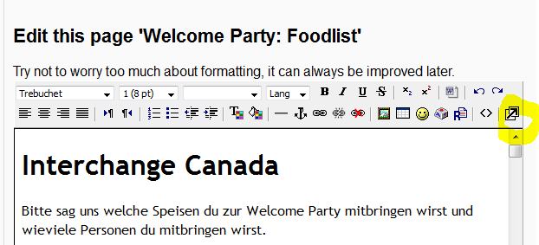
Step 4: Now you are ready to enter your text, change things etc.. Don’t worry about formatting – you’ll see the editor works just like your text editor at home.
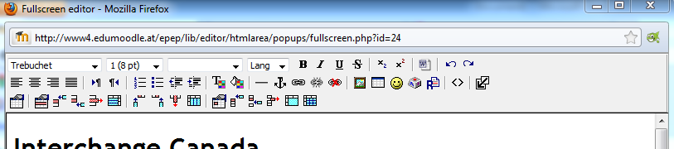
Step 5: IMPORTANT: When you are finished reduce the editing window again
and
do not forget to click “save” to save your changes.
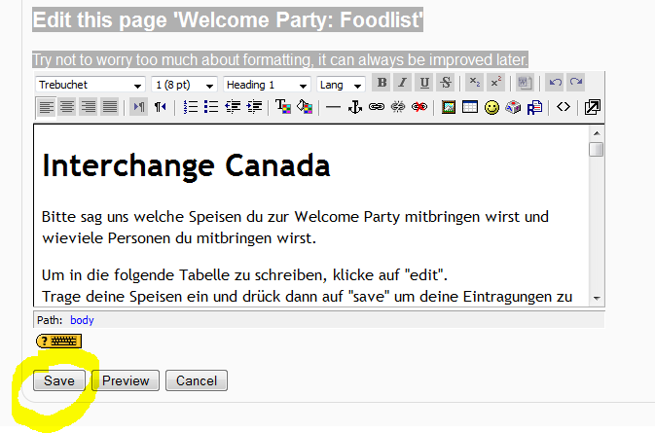
That’s it! See, it is really easy. Don’t worry. If you mess the wiki up completely, send a message to your course administrator. He/she can solve the problem and reinstall an older version of the page you have lost or messed up.

