Zoom Tips for Teachers
Sign up for the free plan (meetings up to 40 min) or the Pro plan for endless meetings
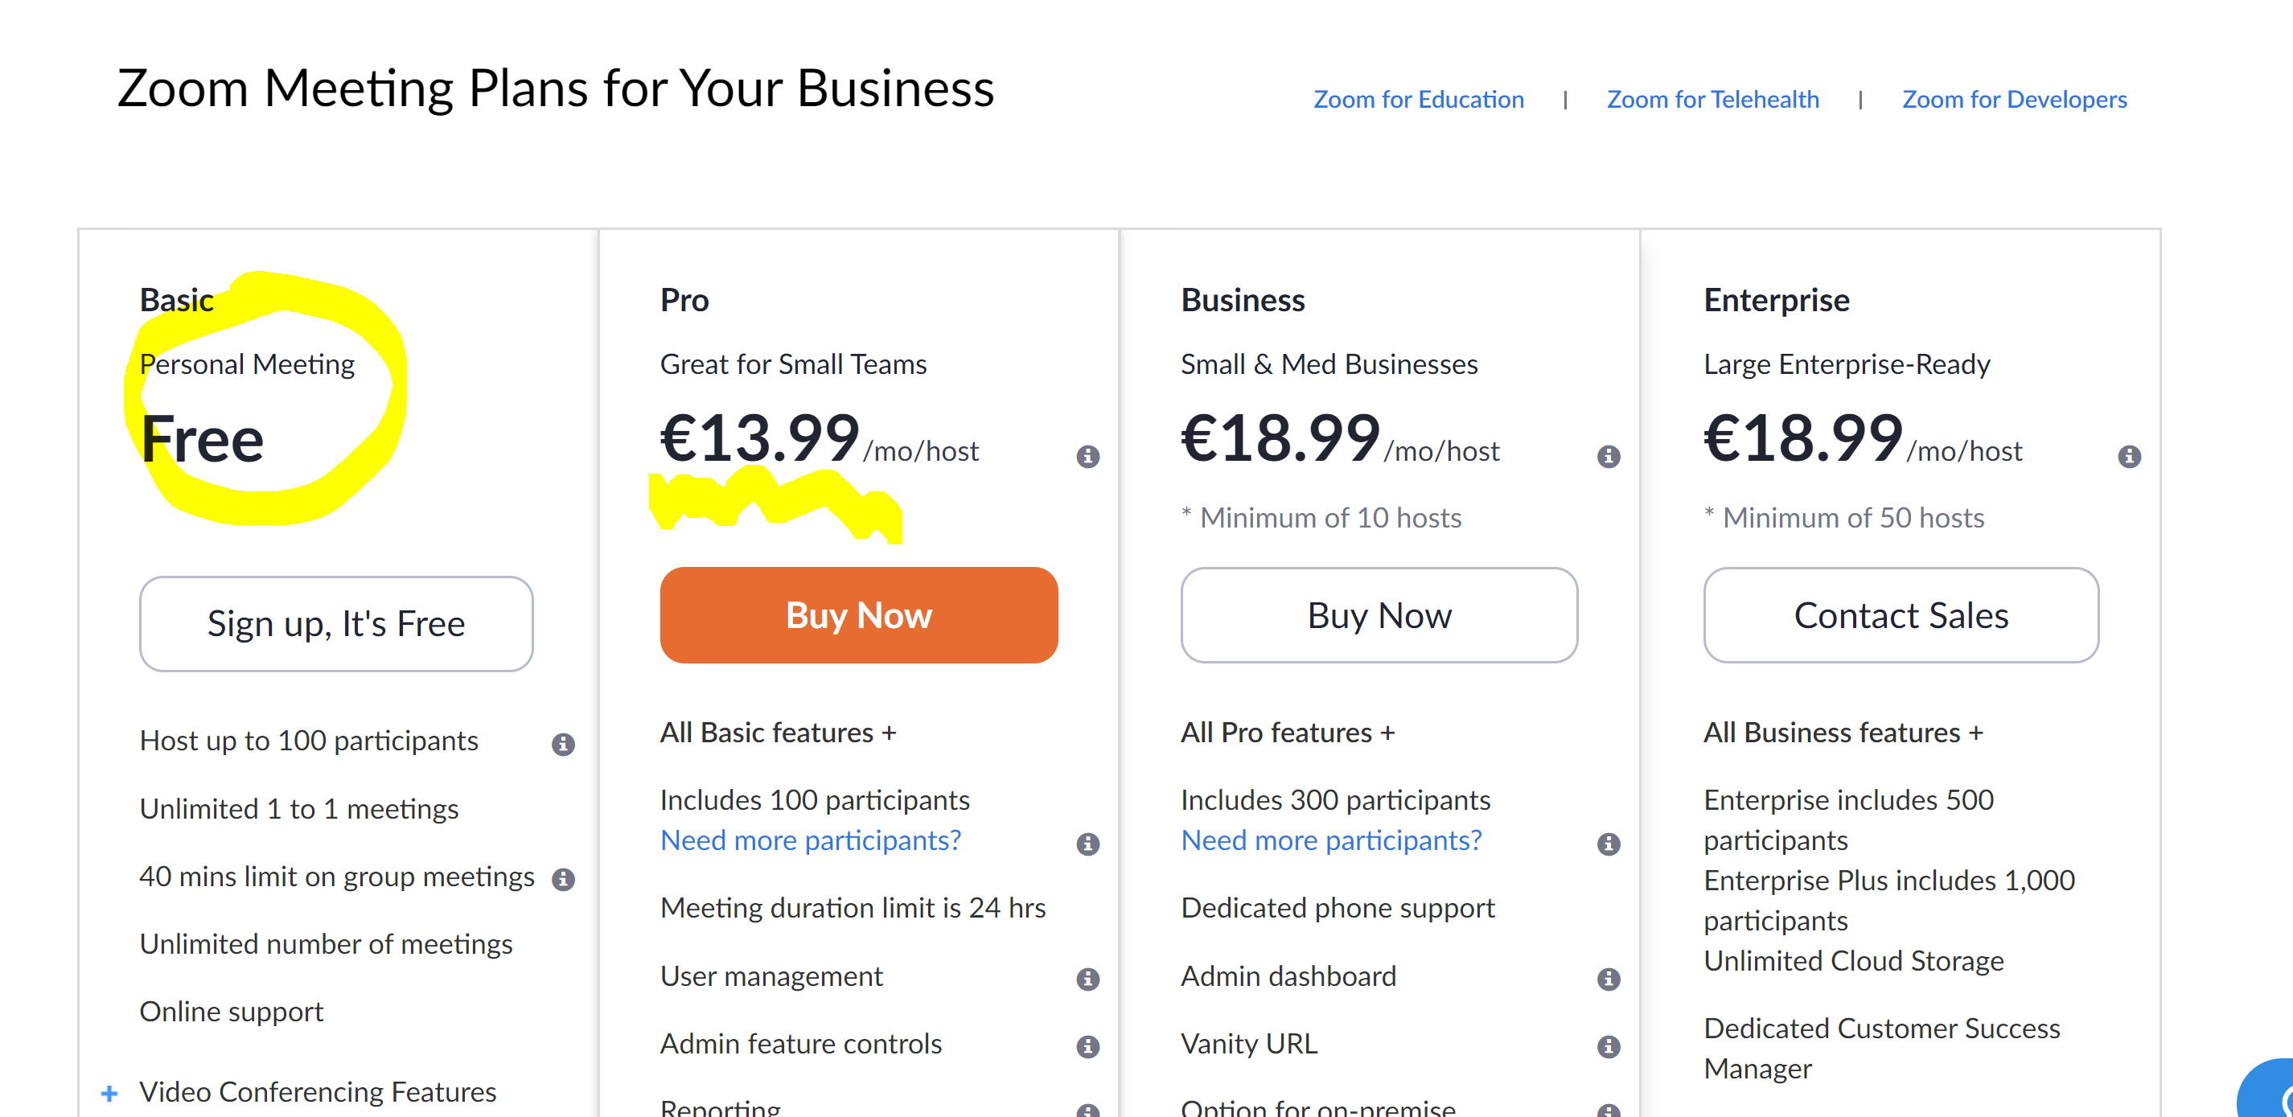
Complete your profile and open SETTINGS
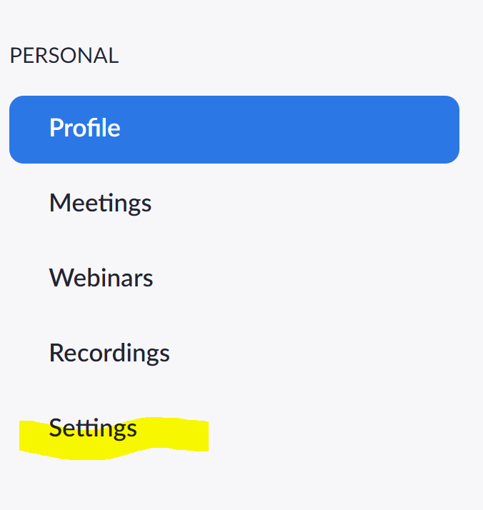
Basically, stick with default settings:
Scroll down to: In Meeting (Advanced) and allow Breakout room.
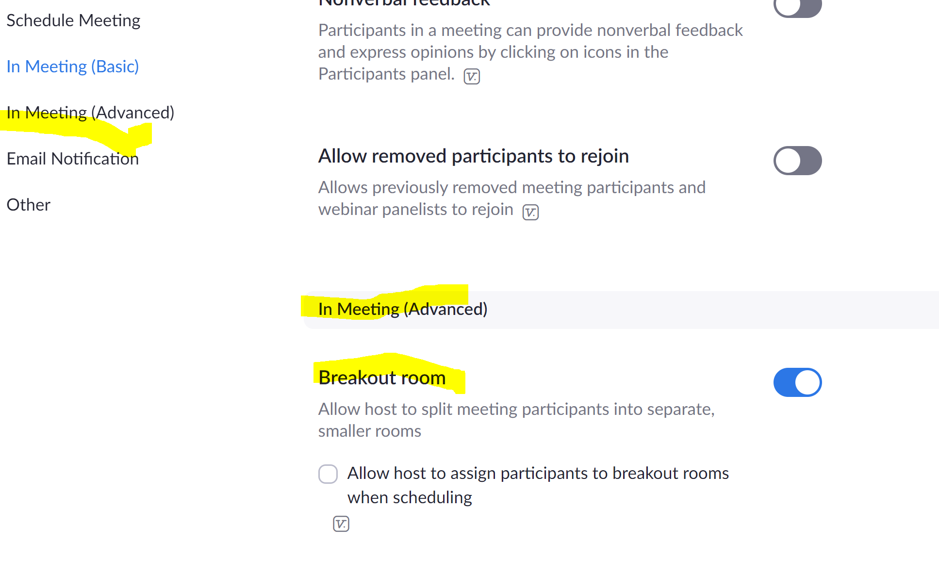
Scroll down to Invitation Email and choose the language you want: default is English

