How to edit your mybrainshark presentation …

Change some of the slides and pictures
- Login to mybrainshark.
- Go to: My Content and open the presentation that you would like to revise
- If you want to add or change some slides click on Add Slides this will open a dropdown menu – choose the kind of slide you would like to add or chang: PowerPoint Slide or PhotoSlide
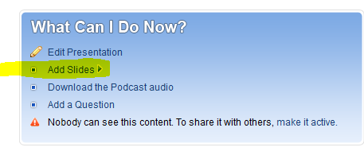
- Then choose if you would like to add new slides (append…) or replace existing slides and click on BROWSE to find the slides on your computer.
- If you want to replace existing slides choose where (at which number) you would like to start with the replacement. Then click next (on the right side)
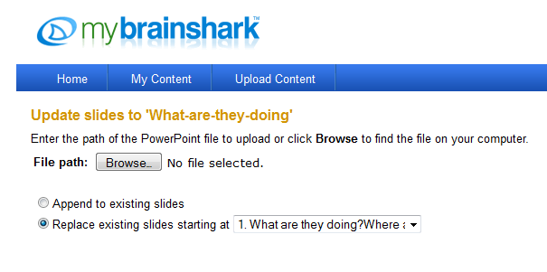
- Wait till the program has processed your new slide(s). Then continue to “Record your voice” The GREAT THING IS: your old voice recordings will still be there – even with the new slides. You can now choose if you want to keep the old recording or of you want to record a new voice.

Change some of the recordings
Just go to your presentation:
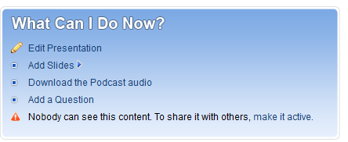
Click on “Edit Presentation” , then “Manage Slides”
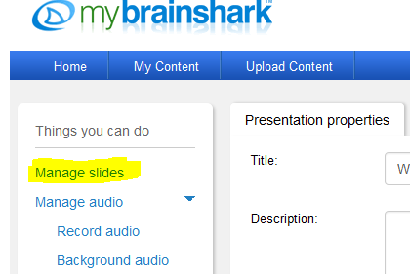
You will then see all a list of all your slides. Click on “Audio” and choose “Replace”. Record your new audio for just this one slide…
