How to upload pictures to flickr
Go to http://youtu.be/3R_MWGFvDEE and watch the short video. Follow the steps and
- Create a yahoo account (www.yahoo.com) and a flickr account (www.flickr.com). Make sure you remember your username and your password. Tip: Use the same password you are using on Moodle, if possible. Write your username and password down in a safe place (best make a file for such things on your computer).
- Upload your photos from your computer or from your USB stick to flickr.
- IMPORTANT: now you have to tag your photos so you can find them easily on bookr or other programs. Go to YOU. You will see your PHOTOSTREAM – that is your uploaded pictues.
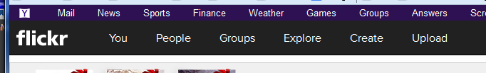
- Click on the 1st picture. You will see “all rights reserved”. That means only you can use this picture. If you want to use your pictures on bookr you will have to change this setting to “some rights reserved”
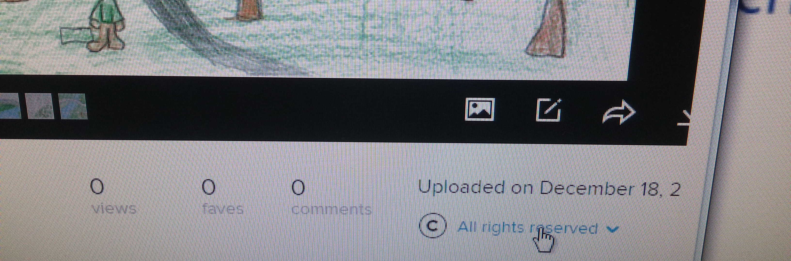
In order to change this setting click on All rights reserved. This will open a pulldown menu: Choose “Attribution” – in German this is “Namensnennung”. It means that anyone can use your picture but must quote you as the owner or artist.
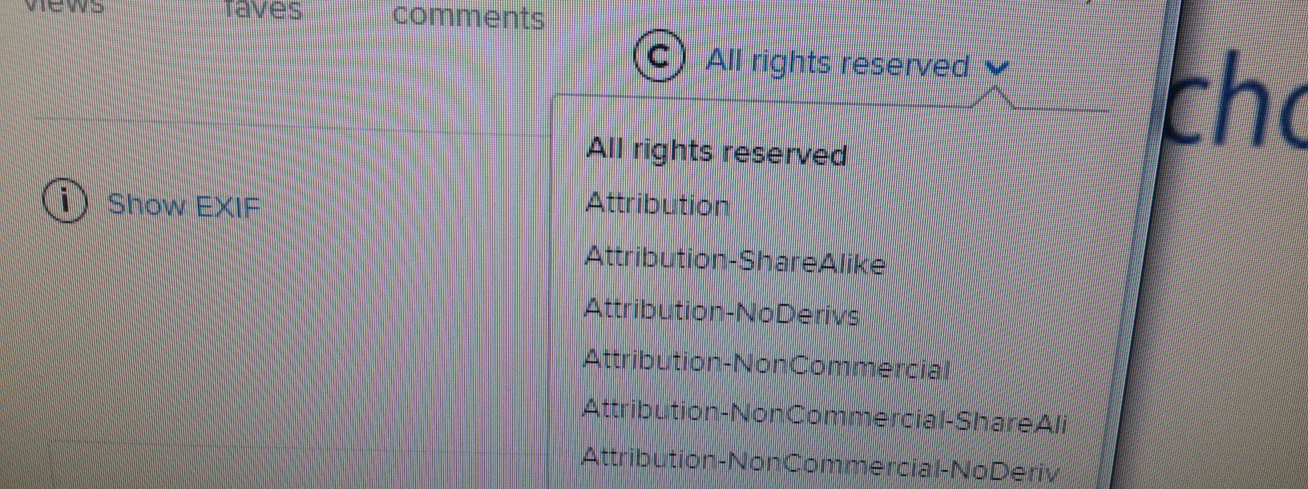
After changing this you will see the following symbol under your picture. Now programs like bookr will be able to find your pictures.
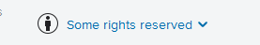
- Do this for each picture. (If you have LOTS of pictures there is a shortcut – but I can show you this another time.)

- Now tag your pictures. Choose a simple, short tag, use small letters only, – you will have to type it many times. For our Christmas books I recommend that you use the initials of your group members: e.g. moma (for Moritz and Max) or solil (for Sophie and Lilly). Don’t be too creative here. To tag your pictures just click on “Add tags” (a few lines below the place where you have just changed the rights. 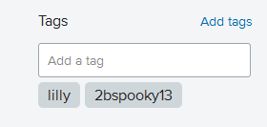 Type in your tag and press the enter key. You tag will show up below.
- Now your pictures can be used on bookr.
- WARNING: It might take a few hours for your pictures to show up on bookr. Flickr checks the pictures before releasing them – they do this to make sure that people don’t upload pornography or other forbidden pictures. Just wait a few hours and keep checking –your pictures will appear if you have followed all these steps.

