Interactive Posters

How to add text-files, audio and video to Glogster
In this project you’ll design an interactive poster using Glogster. You can add all kinds of media to your poster to get your message across as effectively as possible.
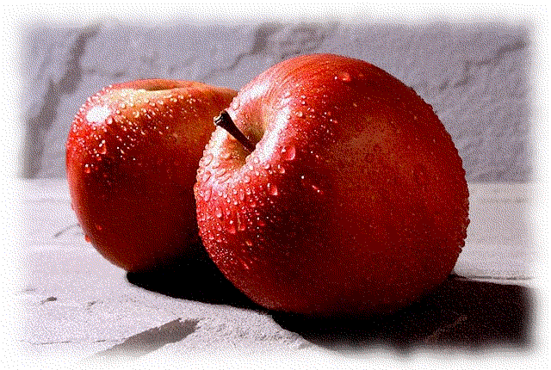
Add pictures by uploading them directly to your glog. Choose fitting frames for your pictures – Glogster offers a wide variety of frames for different themes. Please make sure your pictures are copyright free. Use your own pictures or find them on pixabay.

Adding video-presentations is just as easy. Glogster has several options of integrating videos.
If you ever get the message “connection lost…”, just switch to a different browser and record your video there. This seems to be a good solution to any little bug that you might encounter. Some things work better with Chrome, others with Firefox or Edge. Don’t waste any time trying to fix problems, just use another browser.

Webcam: Glogster has an integrated grab-tool that allows you to record from your webcam and/or your microphone directly into your glog. Tips: Click on the camera icon at the top, choose what want to record (snapshot, audio or webcam) – record your message. After a minute or two your file will show in the respective media library of your glog (images, audio or video). Add a frame and position it in your poster.
Videos from file: If you have the video-file on your computer (e.g. mp4), you can upload it directly to Glogster. This will be useful if you want to produce your presentation in Powerpoint . PPT allows you to record the sound for each slide and then produce an mp4 file using the add-on “MIX”. This will also work with videos produced with Knovio. You can download your finished Knovio video as an mpf file and then use it in your glog.
Youtube videos: The video module of Glogster allows you to upload videos from youtube. Just enter the url to your video.
Other online videos (urls): If your video is stored on any other online platform (Knovio, Present.Me,...) you can easily integrate it into your glog by adding a screenshot or other fitting picture into your glog and adding the url to your video to this picture.

Adding text: In order to add short pieces of text ( headings, text bubbles or paragraphs of text) use the built-in “text” feature and just type in your text.
For longer texts (e.g. a diary page or some background info) you have two options:
Attachments: Glogster allows you to attach files. Just upload the file as an attachment.
URL: If you want your readers to open the text by clicking on a picture (e.g. a diary), you’ll have to store your text somewhere online (dropbox, google.docs, word-online). You can then add the url to your text to a fitting picture. Just make sure you have set the reading rights to “anybody with a link can read” for these files.
Tip: always use pdf files for these purposes. They load much faster and will look the same on any system.

On a free Knovio account you can record 5 presentations. If you want to produce more, download or delete the old ones and use the freed space for new ones.

