How to create a presentation on MyBrainshark
Sign up at MyBrainshark.com and create an account. Write down your username and password so you can access your work later.

Log in with your username or e-mail and your password. You will go to your brainshark account. There you can see all your previous videos.
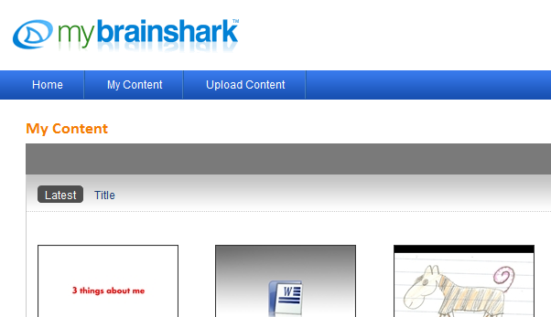

To get started: Make a powerpoint presentation about your topic. Include important steps and keywords – not long texts. Use telling pictures to illustrate your points. Be careful about copyright: Use your own photos or drawings, do not use other people’s pictures from the internet. If you want to use your own drawings scan them on the school copy-machine (or take a picture with a scanning app on your mobile phone.)
Upload your powerpoint:
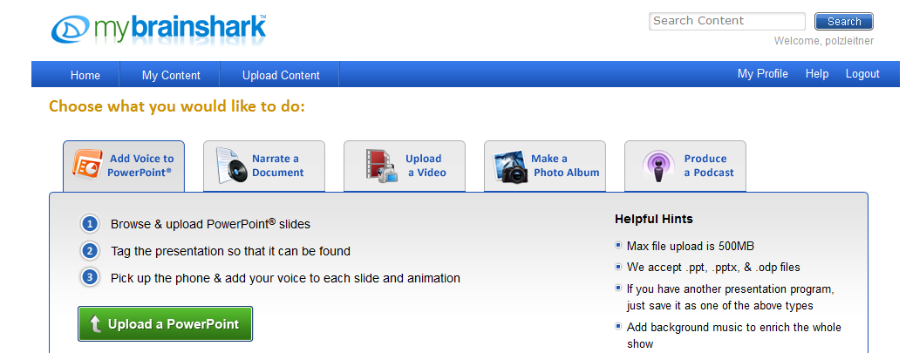
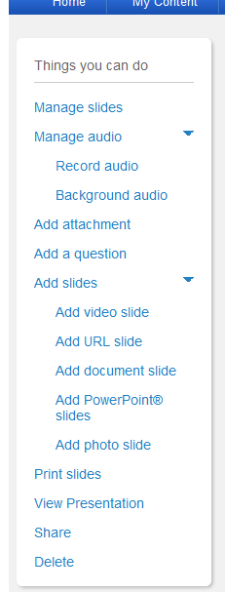
After uploading your presentation you have the following choices: 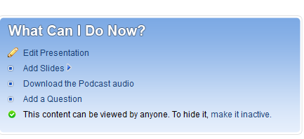
To record your voice you will have to EDIT your presentation. Click on edit and you will get a new menu: Choose RECORD AUDIO and record your voice for each slide. Check it – and do it again if you are not satisfied.
Save your finished presentation and share the link to your brainshark presentation on moodle.

If you want to change and edit a finished presentation afterwards, read the helpfile: “How to edit your brainshark presentation afterwards”

