How to scan your pictures on the school copy machine
- Bring your pictures and put the first picture on the glass surface of the copymachine. | 8. . …then VOLLFARBE  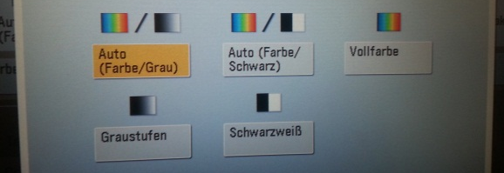
- Enter your code or password for the copy machine. | 9 . Press DATEIFORMAT and choose JPEG  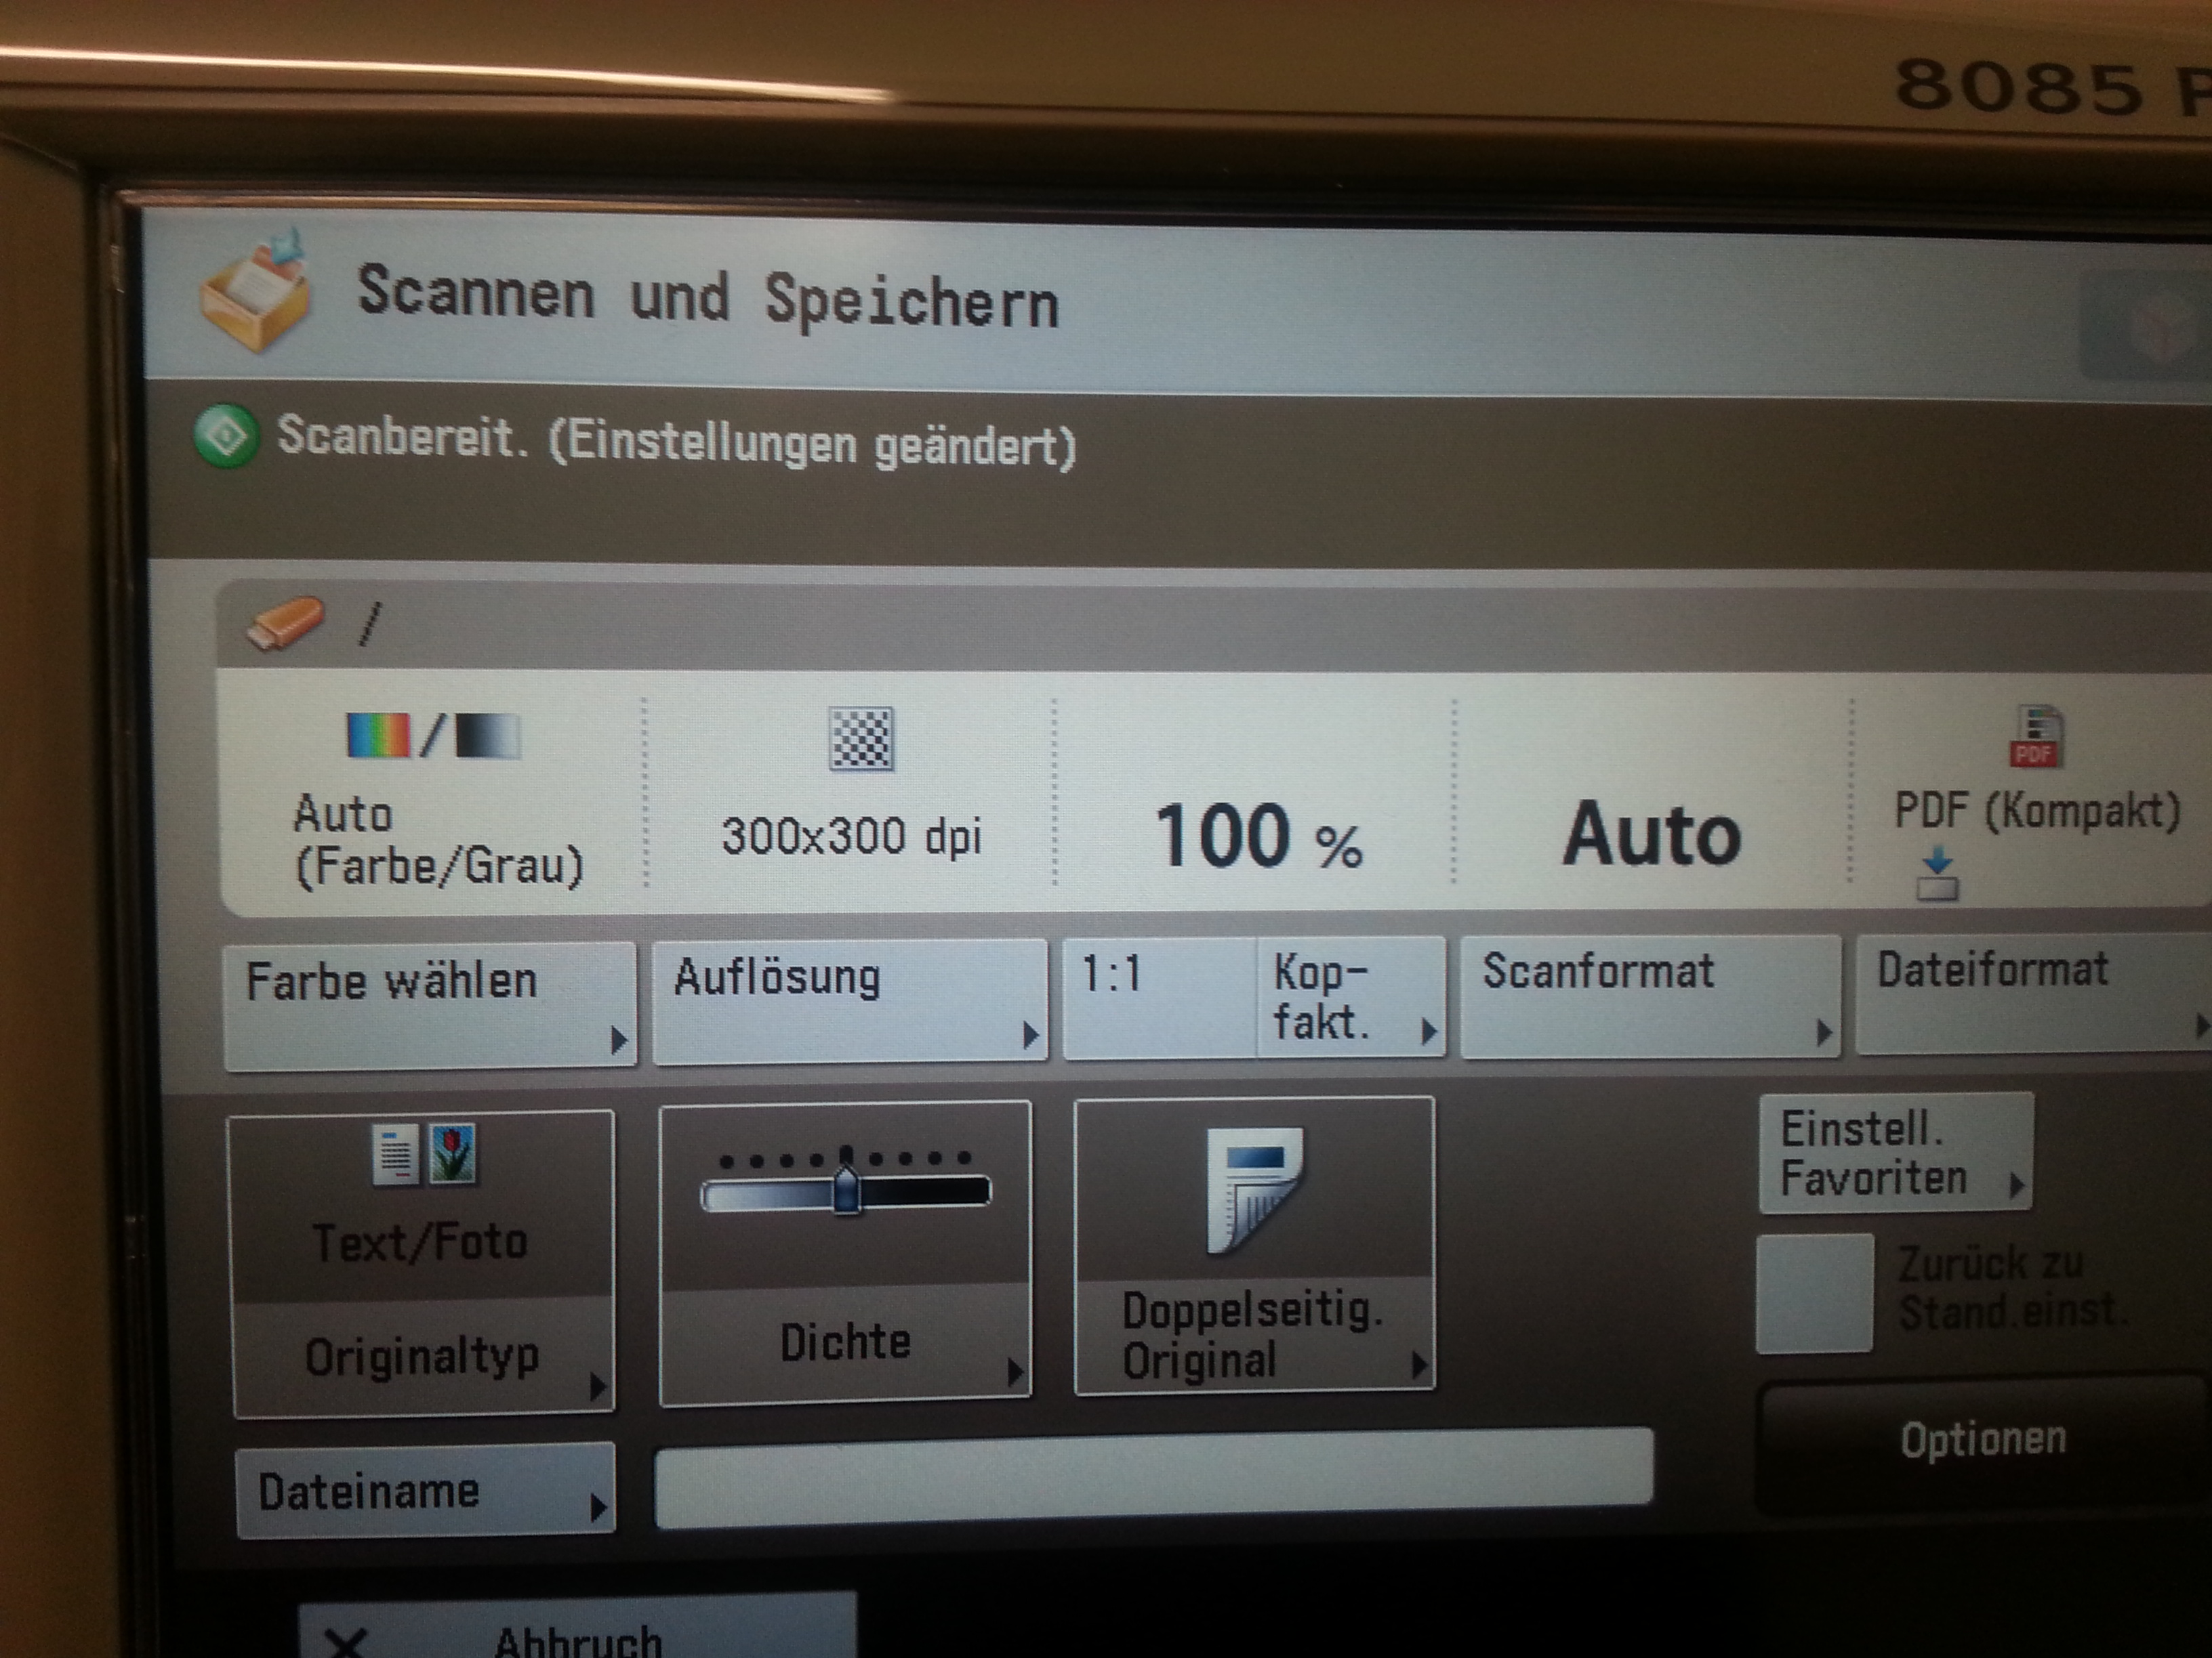  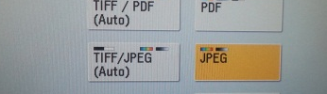
- Plug in your USB stick  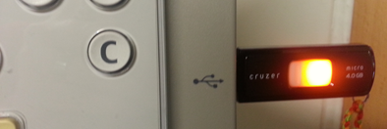 | 10 . Then press the green copy button to start scanning:  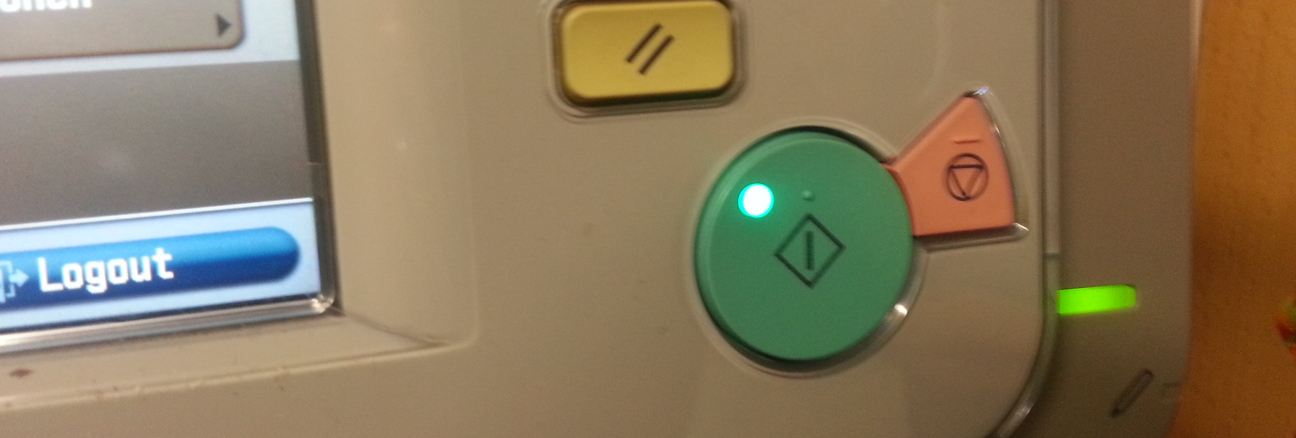
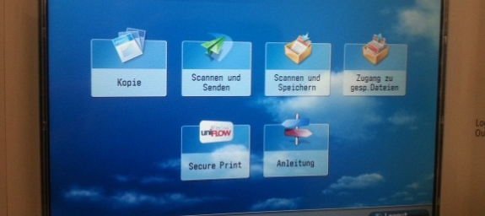  - Press SCANNEN und SPEICHERN , your USB stick will show up on the screen. | 11. Wait till the words: Speichern starten appear in black. Click on Speichern starten. A green light will be blinking while your page is being saved.  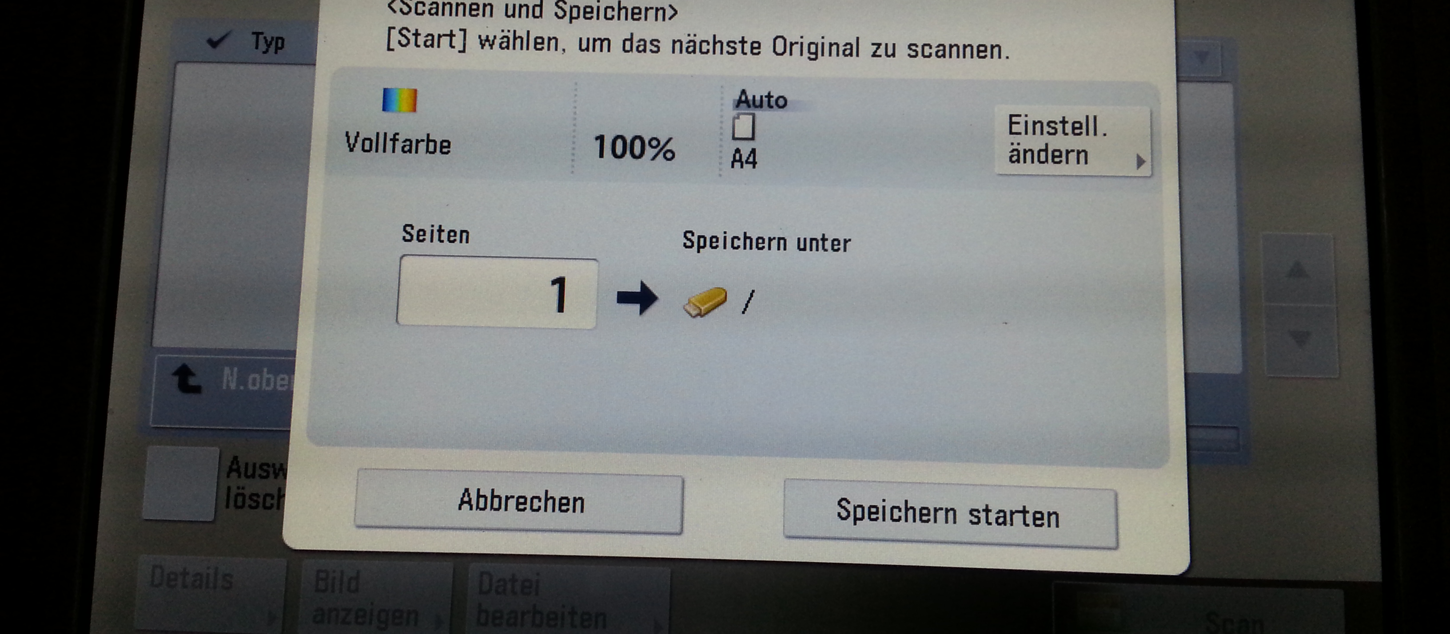
- Click on the USB stick that shows up to choose it.  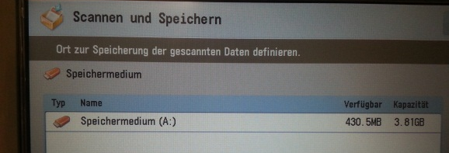  Do all the following steps for each picture | 12. Then scan the next picture. You will have to make all the choices again: Farbe – Vollfarbe – Dateiformat – JPEG – Go (green button).  NEVER PULL OUT YOUR STICK while the green light is blinking.
- Press: SCAN  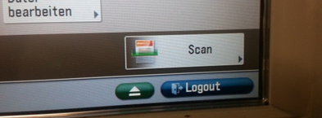 | 13. When all your pictures have been scanned and saved press eject and THEN pull our your stick.  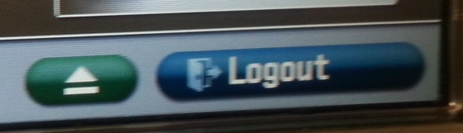
- Press: FARBE WÄHLEN   | 14. Go to a computer to check if your pictures are there. They will have strange names consisting of the date and lots of other numbers and letters.jpg

