How to use Screencast-O-Matic
  - A great new alternative to JING

- Go to:

- Click on login to go to the signing up page
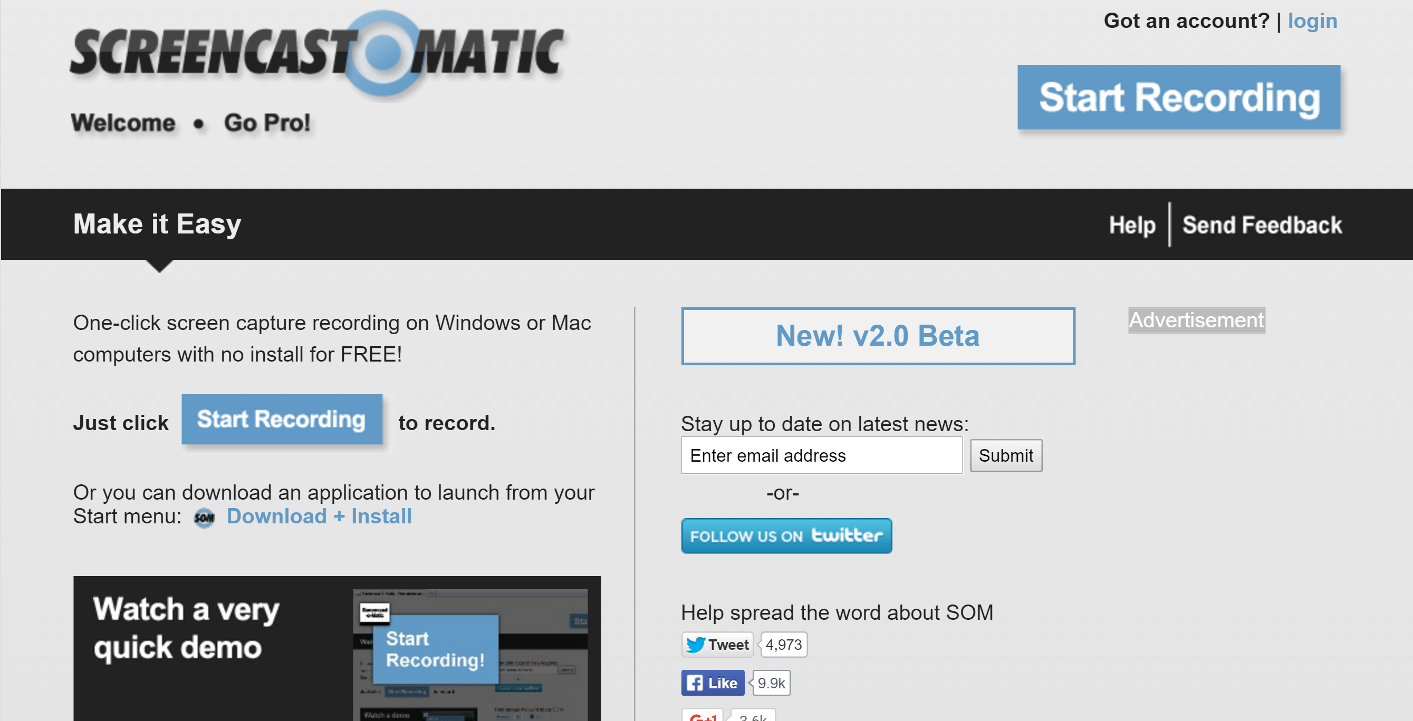
- Create a free account. Use a password that you will remember easily and write it down in a secret place that YOU will find again.
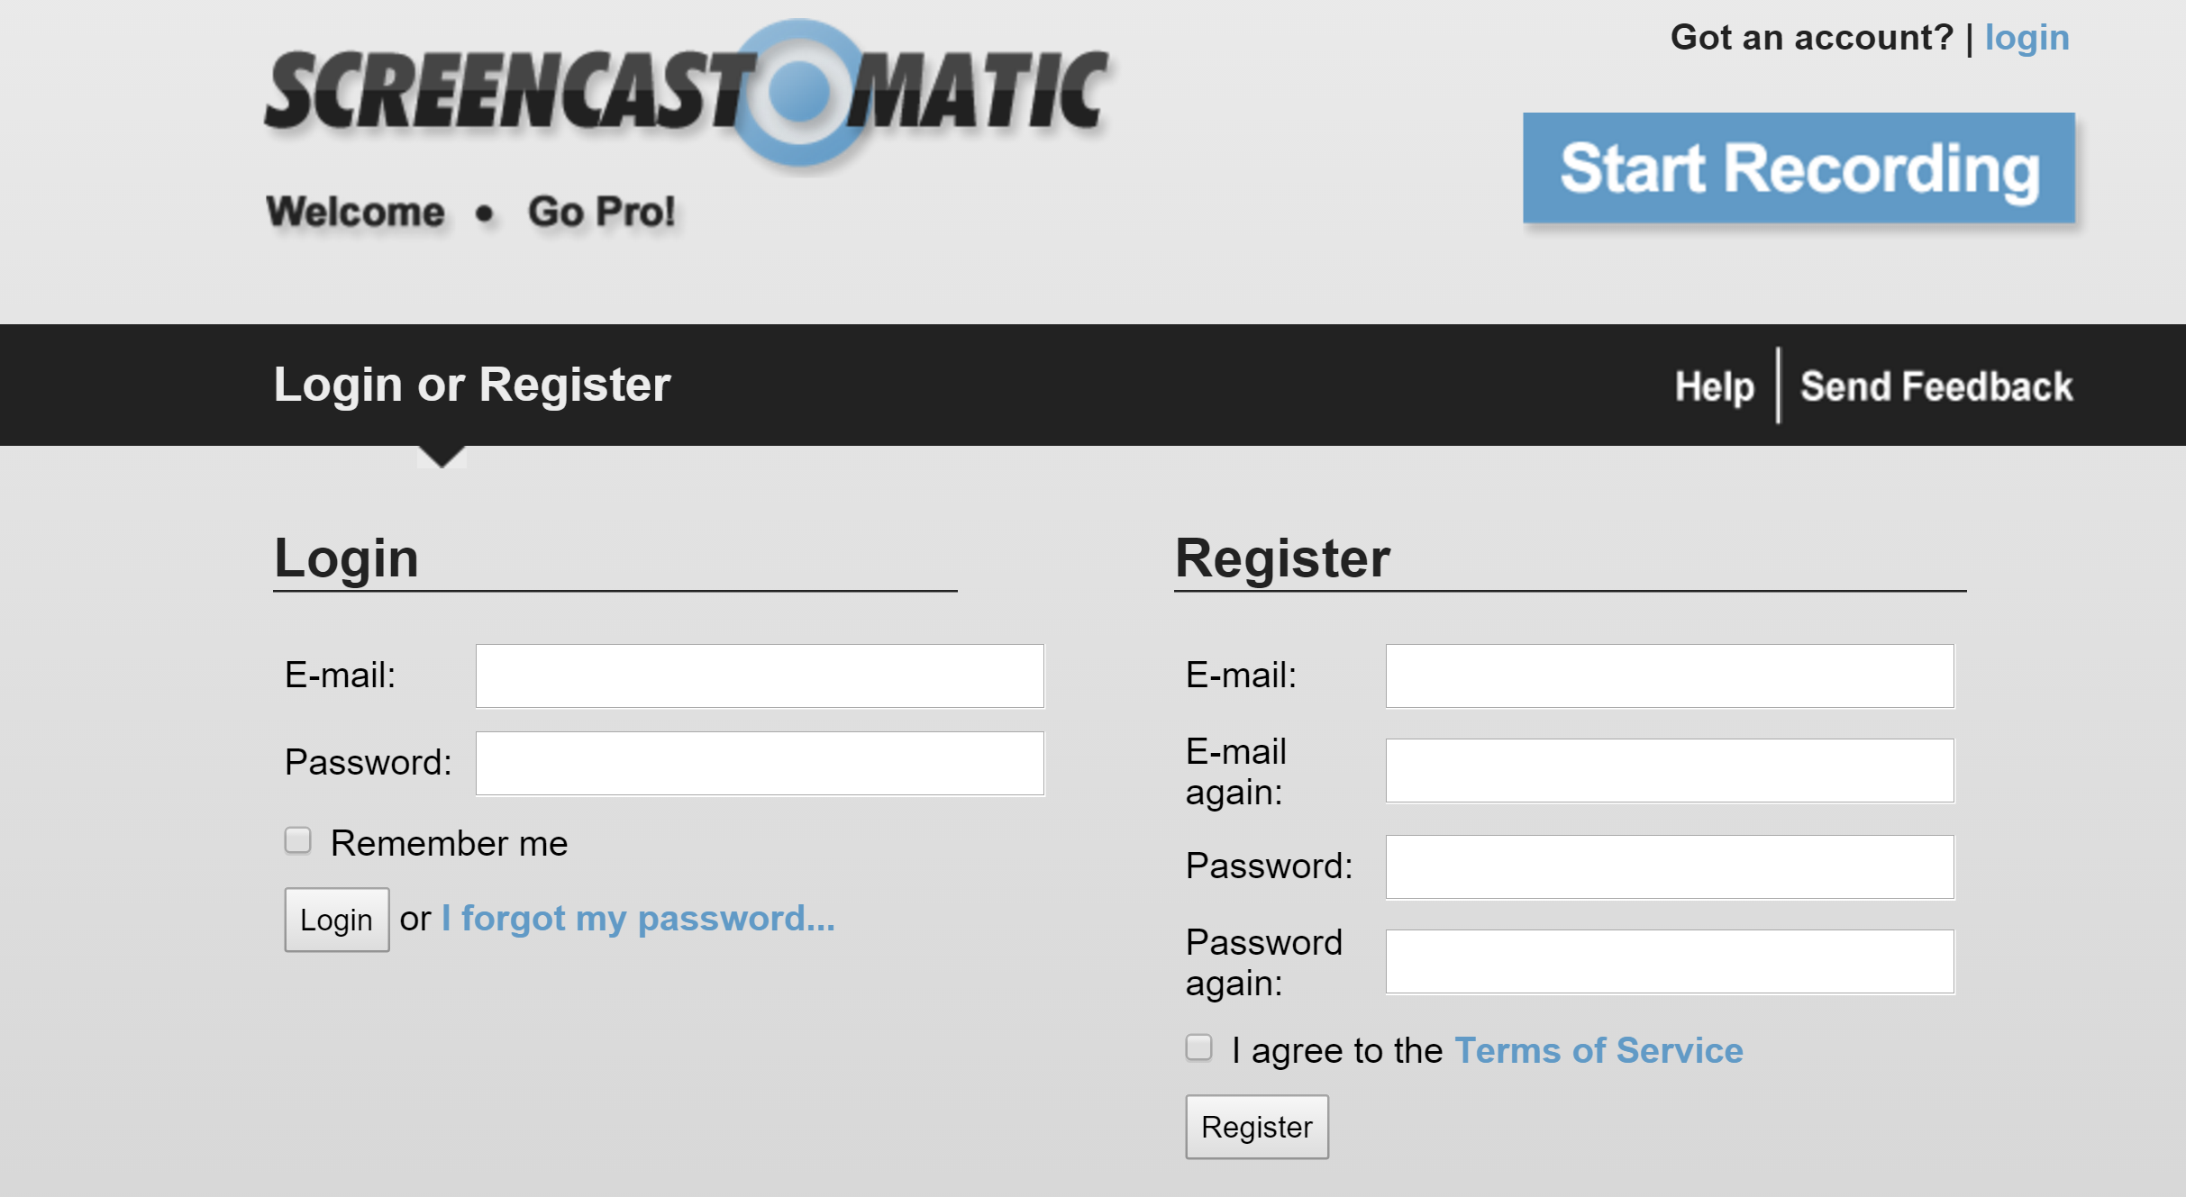
- Click on START RECORDING and follow the steps on the screen in order to download the program launcher (just like a small app). When you see the download file (.exe) doubleclick it. It is a small program that won’t cause any trouble on your computer.

- Watch the little video to see how screencast o matic works –it’s very simple. You simply draw a boxed area on your screen and click on Start recording. You can choose between recording the SCREEN or recording your webcam or both. Just PERFECT for our purposes.

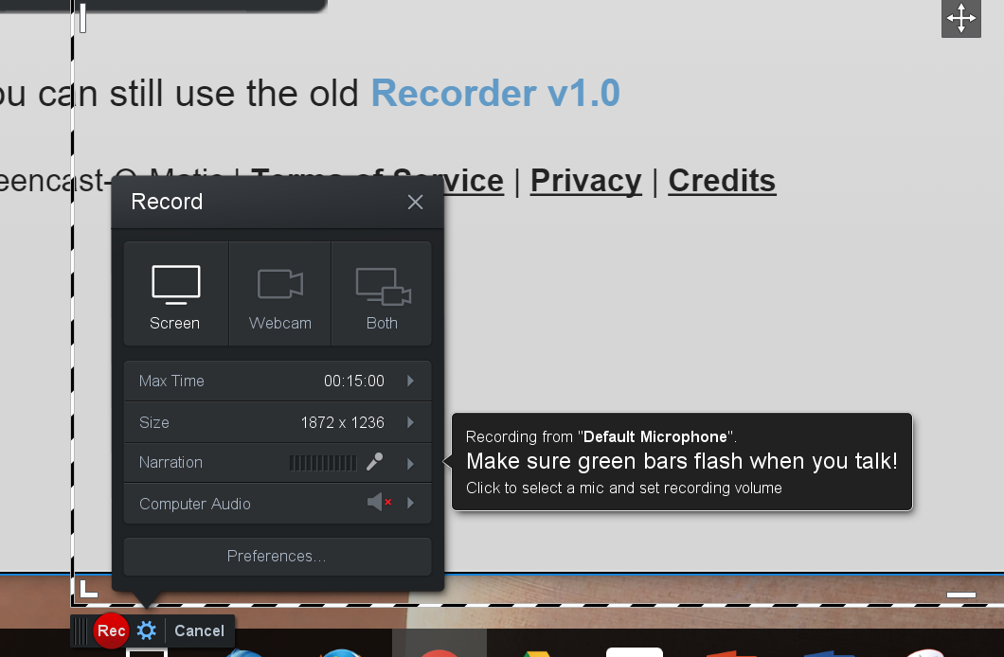
- Upload your finished video to screencast-o-matic or directly to youtube.

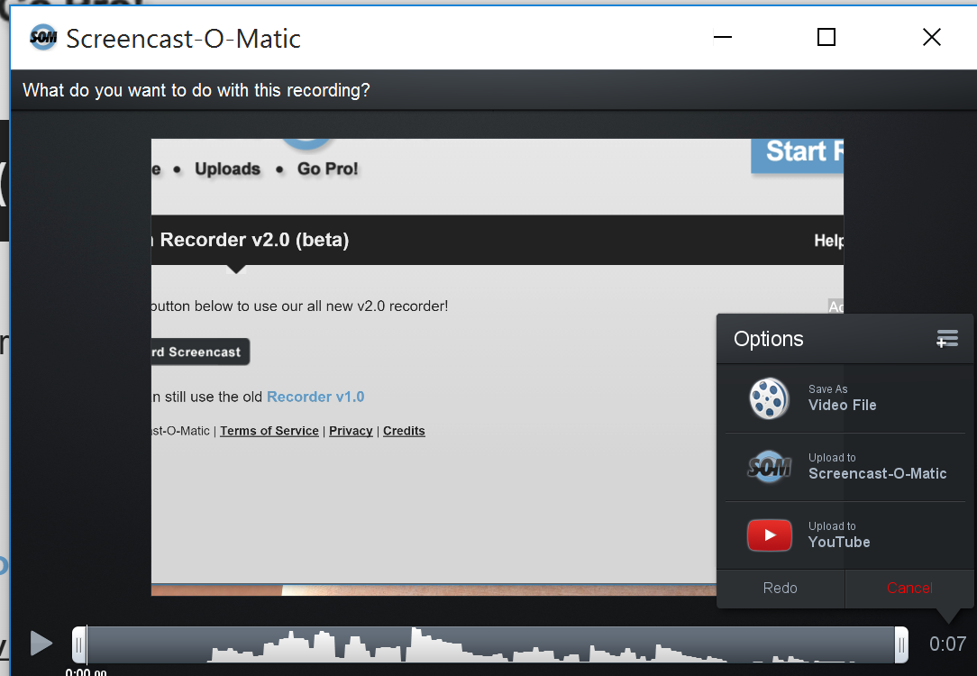

Share your link with the class on moodle.

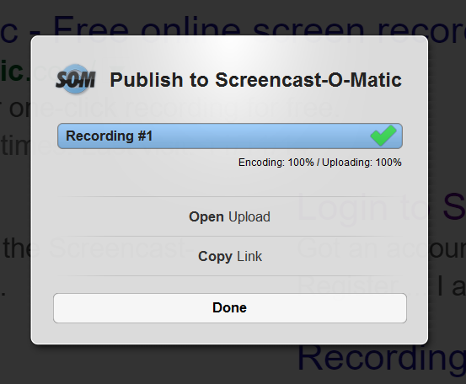

Using Screencast-O-Matic later
When you want to use Screencast-O-Matic again later just google it in your browser and login. You do not need to download the launcher – that has already been installed on your computer.
