How to join a Zoom meeting

Watch the short info video in German: https://www.youtube.com/watch?v=hxa9wip7AvM
Or watch the instructions in English:
Then follow the 9 easy steps to join your first meeting. Next time, it will be much easier. You will only click on the meeting link and you are there.

1. Open your CHROME browser
2. Click on the link that your teacher has sent you. Then click on “ download & run Zoom”
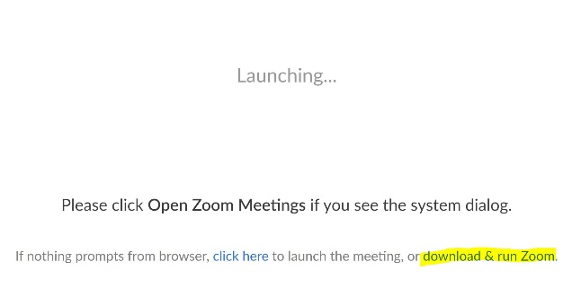
4. Find the downloaded program file on your computer. You will find it in the bottom left corner of your browser window. (ganz unten links)
Double click the exe file
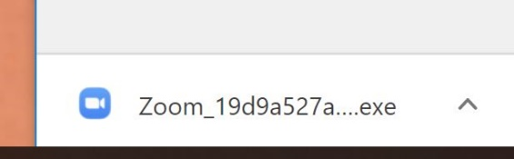
5. Wait for the program to install…
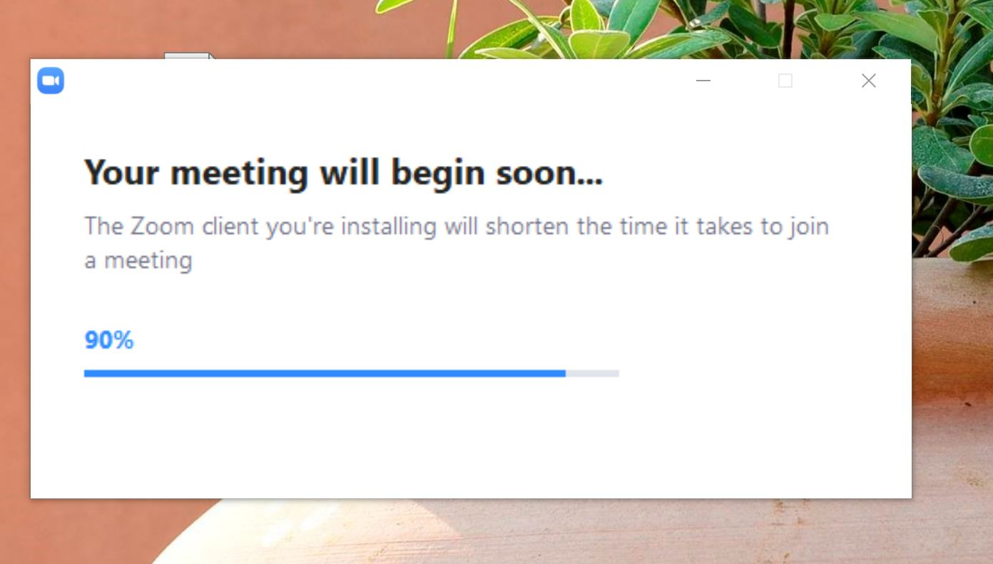

6. Write your firstname into the box and click “Join Meeting”.
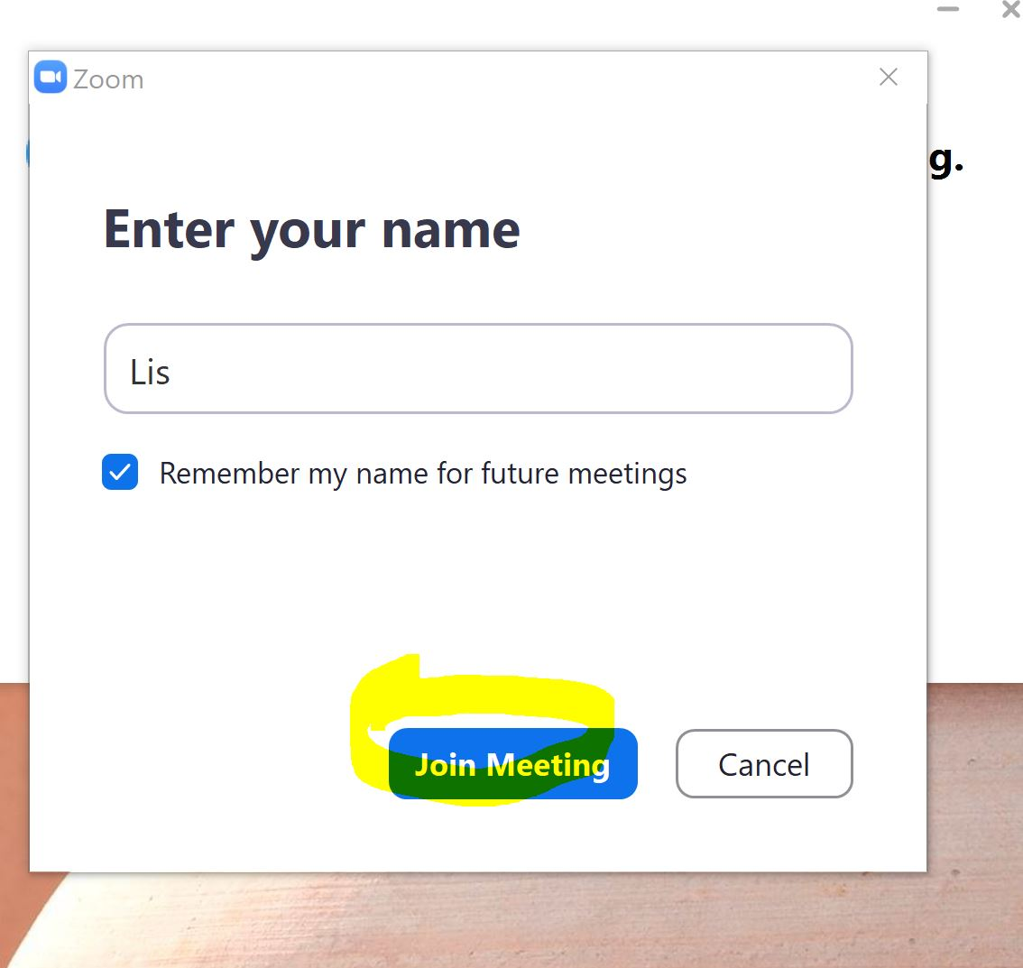
7. Click: “Open Zoom”.
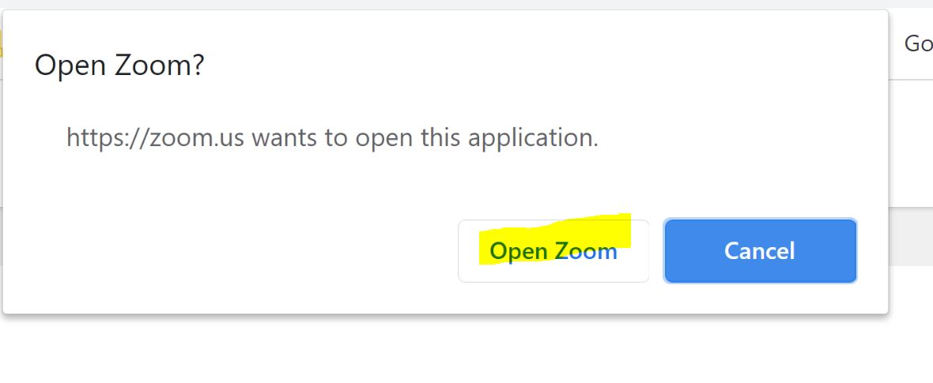
8. Click “Join with Computer Audio”.
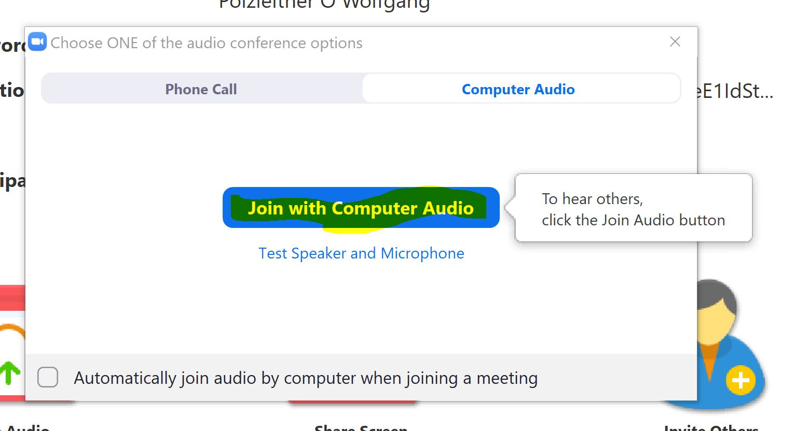
9.: You will now see the meeting screen with your teacher and your classmates.
Try out some of the tools that you have seen in the video.
You can turn your microphone on and off (mute // unmute). You can turn your camera on and off and you can write short messages into a chat.
We will try all these things out together. You’ll see, it is very easy and super fun.
pö

