by Edward Albee
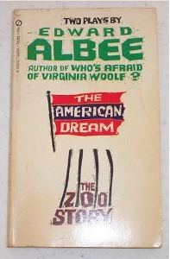
The Characters

Plot Summary
A dominating Mommy and an emasculated Daddy sit in a room and discuss about a hat Mommy had bought. Mommy’s mother, the all-knowing, clever and witty Grandma lives together with them. In the course of the play a neighbor Mrs. Barker enters and is involved in the discussions. When Daddy wants to take away Grandma´s possessions, after she had mentioned that she had hidden them perfectly, and goes off to find them together with Mommy and Mrs. Barker, he can´t find them. Grandma is alone in the room, when the “young man” enters. He is looking for some kind of job, but Grandma in the beginning only adores his physical appearance. For her he is the American dream and gives him hints on why he is here and what might have happened to his twin brother who lived with the family. Grandma then wants the young man to bring all her boxes downstairs and act as if he were the Van Man. After he does that Grandma disappears from stage and the young man is then the servant of the family. Grandma just watches what happens without being seen from the rest of the family.

Edward Albee
* March 12, 1928 in Washington, DC
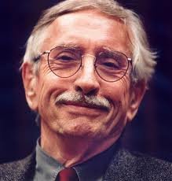
He was adopted in infancy by the wealthy Mr. and Mrs. Albee who introduced him to the theatre at an early age. The relationship between Albee and his adoptive parents wasn’t good and he broke with them at the age of 20. ( adoption is a theme in The American Dream - autobiographical element)
After some unsuccessful experiments with poetry and fiction, he finally started writing for the theatre. He completed his first major work, The Zoo Story in 1958. The American Dream was first staged January 24, 1961 at the York playhouse in New York City. In the last decades, he wrote many plays (other famous are Who’s afraid of Virginia Woolf, The Sandbox and The Goat, or Who is Sylvia?) and he still writes today. He received many awards, including the Pulitzer Prize, the Tony Award and the National Medal of Arts.
He founded the Edward F. Albee foundation in 1967. The foundation exists to serve writers and artists by providing time and space in which to work without disturbance. The Foundation still maintains the William Flanagan Memorial Creative Persons Center.

Most important Themes
- Idealism
- Expectations
- Emasculation
- Abuse and violence
- Old People grandma’s epigram
- Disfiguration & Deformity
- Adoption

Symbolism
- “The young man”- Idealism, Satisfaction
- Boxes – “Blind Ownership”
- The play does not particularly make use of symbols

