Edward Albee

American playwright – works reflect Americanization of Theatre of the Absurd

Born in Virginia (1928) or Washington D.C. – was adopted with 2 weeks – grew up in Larchmont (New York) – adoptive father Reed A. Albee owned several theatres – Edward first gained familiarity with the theatre – adoptive mother tried to raise him to fit into their social circles

Albee attended to Clinton High Scholl – was expelled – was sent to Valley Forge Military Academy – dismissed in less than a year – graduated at Choate School – formal education continued – Trinity College – expelled for skipping classes – “Who is afraid of Virginia Wolf” – believed to be based on experiences at Trinity College

Never felt comfortable with adoptive parents – left home – was thrown out because they didn’t approve of his aspirations for writing – moved to Greenwich Village (New York) – while learning to write plays – worked in odd jobs

First play – Zoo Story (first staged in Berlin) – currently distinguished professor at the University of Houston – playwriting course

Openly gay – first knew that he was at age of 12

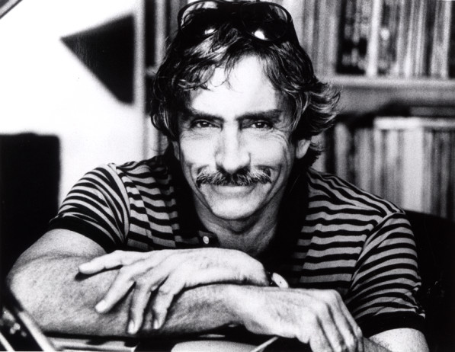
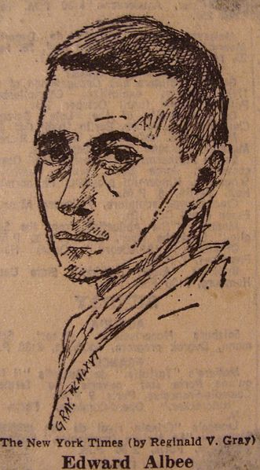
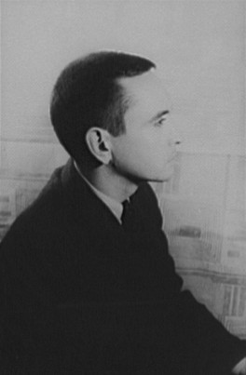

Symbolism in Zoo Story

Human isolation – world is a zoo – also animals and men are separated; also within humans, the supressed instincts, the animal nature, the it (Freud)
New York – big cities are cages, people are caught there – typical expressionist feature
Jerry tries to connect to somebody but does not manage
Jerry is desperate to have a relation – better a bad one than none (dog) – relation using violence – tries to connect through provocation, create feelings in his opponent for him even if they are angry and hostile
In the end he bonds by killing himself, by making peter kill him
Jerry – Jesus, has to sacrifice himself for peter
Jerry: dog – god; worried so much about the dog that it became his god
Jerry and dog – similarities, both animals, both are not free
Peter does defend his bench but not his family
Jerry has 2 empty picture frames at home because he has nobody, no friends, no family
Also jerry has no place to be safe – home – dog is constant danger, exposed to aggressions

Absurdist elements

Lack of communication – “really talk” but they don’t
Isolation – jerry does not get to anyone, cannot get close to another person
Talk about god?
Suicide – use force to create a strong connection to peter
Social classes – peter (higher, family, house, kids); jerry (lower, in an empty flat, bad district)
Fertility – jerry is mocking peter because he didn’t manage to get son
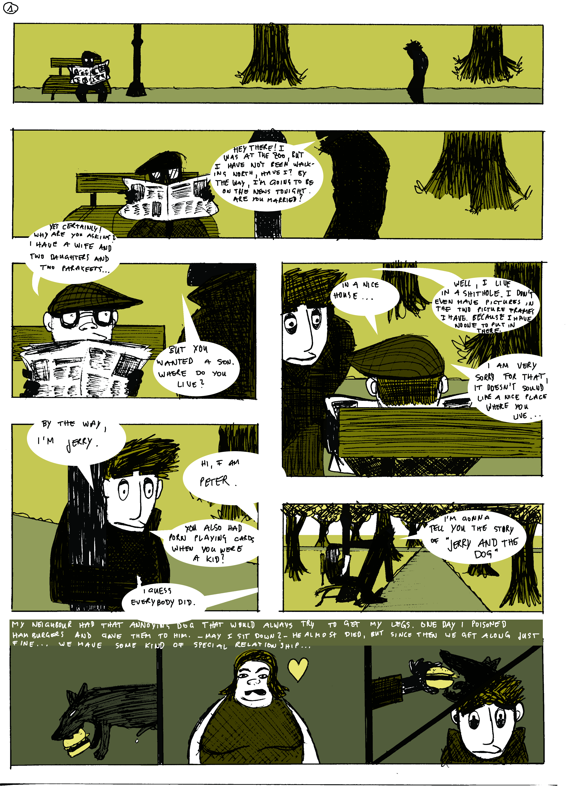
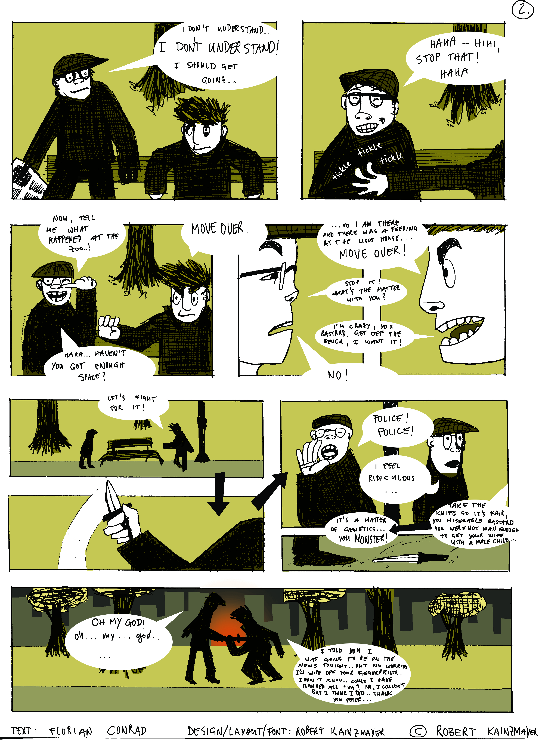

Jerry

In his late thirties
Not poorly, but carelessly dressed
Was once a muscular, well-trained man -> now his muscles have begun to turn into fat

No longer handsome ->evident that he once was
Great weariness
Lives in Central Park, New York
Isolated -> is desperate to have a meaningful conversation with another human being
Lives in a four-story brownstone rooming house
More willing to talk about unpleasant things -> nothing to worry about

Jerry cannot communicate with anyone because no one is willing to communicate with him
Jerry is eager to identify with anyone -> his eagerness has the opposite effect than he actually wants it to have

Free with his thoughts and feelings
Represents the isolation of human existence, life without purpose or meaning, social disparity, dehumanisation in a commercial world and the lack of communication between individuals and class difference

Jerry is unconscientiously trying to teach Peter the nature of human existence
Has to use force to start a relationship

Peter

Married -> a wife, two daughters
Has two cats and two parakeets
In his early 40’s
Ordinary man
Wears tweeds
Smokes a pipe and carries horn-rimmed glasses
He seems younger than he actually is
Has a normal, typical life-> married, owns an apartment
Does not want to talk about certain issues (sex, alcoholism, etc) -> his world is too safe to be disturbed by unpleasantness-> he cannot imagine life outside of his environment
Only listens to Jerry, because Jerry wants to talk to somebody, but not because he wants to connect with him

Does not want to accept that the world he lives in is not safe and jolly
Represents the ignorance of the world outside of his safe environment
Does not understand that Jerry (humans in general) has the need to be acknowledged

Plot Summary-Zoo Story

A man called Jerry starts up a conversation with another man (Peter) sitting on a bench in Central Park, New York. Jerry forces him to listen to his stories and experiences. Peter is a middle-class ordinary man with a wife, two daughters, two cats and two parakeets. Jerry is an isolated, discontented sociopath who is desperate to connect with another human being, for he is a lonely social outcast. He tells Peter about his life and is eager to start some kind of relationship. Peter only listens to Jerry, because Jerry wants to someone to talk to, but not because Peter wants to connect with him. Jerry is eager to open up to Peter and find out about his life. Nevertheless, Peter dodges Jerry’s intimate questions by redirecting to small talk. However, Jerry is able to force Peter into listening to “The Story of Jerry and the Dog”, which describes Jerry’s frustration and failures of trying to establish a relationship with a dog. It shows that he’s willing to make a connection, even if it means to use force to accomplish. During the story, Peter feels more and more unpleasant and disgusted by his experiences. After the story, Peter announces that he “really must be going home…” which is the catalyst for a shocking ending. Jerry begins to try pushing Peter off the bench, and Peter fights back for his territory on the bench and becomes angry. Unexpectedly, Jerry pulls a knife and drops it for Peter to grab. Peter first refuses, but then picks up the knife and holds it defensively. Jerry sets off running towards Peter and the knife and is thereby impaled. Finally, Jerry dies on the park bench and Peter rushes away in shock.

