
Dear Students of „Scandals in Literature“

Our course is going to start two weeks late this semester because I will be away on the first Tuesday and there won’t be any afternoon classes on Mardi Gras.
For this reason I ask you to do two little things BEFORE the first session, so that we can start efficiently when we will finally meet on March 15th.

Sign up for the Moodle Course: Scandals in Literature
www4.edumoodle.at/epep
You won’t find this course on the GIBS homepage – go there directly from your browser. (Use FIREFOX – this will avoid lots of little problems that other browsers seem to have with Moodle.)

First Journal Entry:
Enter the Moodle Course and have a look at the first topic.
- Read the short info about book banning (ALA) and about the West Bend Library Controversy. Which of the banned books do you know or have you read? Do you think any of them are dangerous and should be banned?
- Can you think of any reasons or circumstances why books/texts/films/pictures/cartoons… should be forbidden (for everybody/for a specific group of people)?
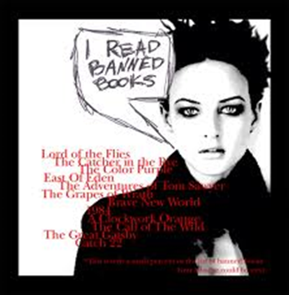
- Write a short, informal reflection about the above issues into your online journal. (10 minutes free, unfiltered writing) Don’t worry about making final decisions about this topic. You might change your mind more than once in the course of this semester. This is absolutely ok. This first reflection should later remind you of your first ideas about this topic.

Book Choosing:
- Have a look at the book-choosing section and do some browsing there as well. Then enter the book of your choice into the book-choosing WIKI on Moodle. Do this soon, otherwise you might not be able to read your first choice.
If you have any questions send me a message or ask me in school. For technical questions concerning Moodle you can also ask students from 7b. They have got a lot of experience with Moodle.
All the best, I am looking forward to this course,
E. Pölzleitner

