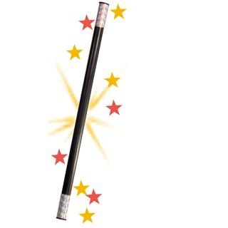
“Confido” by Kurt Vonnegut
Brainstorming: Which superpowers and magical devices (e.g. a magic wand) do you know? Which ones would you consider convenient and would like to have yourself? Which ones could be annoying or even dangerous? Write your thoughts into the box below and choose one superpower that you like the most and one you like the least.

Convenient superpowers/magical devices | Bad superpowers/magical devices

Before you read the story: Think about who or what is Confido? What do you expect or think of when you hear this name? Describe it shortly in the box below and give reasons for your thoughts.

Confido:

Now read the story. While reading highlight any references to and descriptions of Confido. Compare them to your original thoughts about it. Then, imagine what it could look like and draw it into the box below.


After reading the story, write down some notes about the characteristics of Ellen and Henry. What kind of people are they? What does their daily life look life? What are their opinions about Confido and how do they change from the beginning of the story until the end? After you have done that, talk with a partner about your thoughts.

Ellen: | Henry:

Think about advantages and disadvantages of Confido and decide whether you would use a device like this or not.

Advantages | Disadvantages

Continue the story: Choose either Ellen´s or Henry´s perspective and describe what could have happened after Henry had buried Confido. Write about 200-250 words.

Vocabulary:
Mark every word in the text that you don´t understand. Write them into your vocabulary book and look them up in COCA or Vocabulary.com to find out what they mean and in which context they are used. Come up with two different example sentences for 10 of the words.

Teacher notes:
Age and Level: 16-18, B1+ to B2 (Intermediate – Upper Intermediate)
Time: 3 lessons
Learning objectives:
- The first activity should activate the pre-knowledge of the students and get them talking. At first, the students should think about this task on their own. Afterwards, I would let them have a group discussion about their ideas and in the end collect some of their ideas and discuss it with the whole class.
- The purpose of the second activity is to activate their imagination and think about what names can reveal about a character.
- The third activity should be done while the students read the story. It is a continuation of the second activity, because now the students find out what Confido is and should then imagine what it looks like. This is intended to activate their figurative imagination skills and let them visualize this magical device for themselves.
- After reading the story, the students should think about the characters of it and describe them, to deepen their understanding of the story. At first, they should write their thoughts down on their own and afterwards talk with a partner about them to find out whether they have the same understanding of the story.
- The aim of the fifth activity is to activate reflection amongst the students. After they have filled in the box on their own, I would discuss this topic with the whole class to get an idea of their thoughts.
- The writing task could be done as homework or during the lesson, whatever you prefer or depending on how much time you have left. I would collect it afterwards and correct the texts at home.
- The purpose of the last activity then is to enhance their vocabulary knowledge and teach them new words and phrases. Additionally, it should help them to get a better understanding of the story.

