ELEVEN by Sandra Cisneros

- Can you recall what you were like when you were eleven years old?

Write down what you remember about being eleven years old. How did you look and feel like when you were eleven years old? Have you already been quite mature or have you still been very babyish? Were you a rather shy child or did you have the courage to express your own opinion even in front of people who were older than you? How did you feel about adults? Were they to be treated with respect? And what about your teachers; did they influence your views and beliefs?


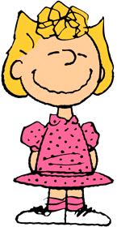

11
11 11

___________________________________________________________________________________________________________________________________________________________________________________________________________________________________________________________________________________________________________________________________________________________________________________________________________________________________________________________________________________________________________________________________________________________________________________________________________________________________________________________________________________________________

- Now get together in groups of four and talk about your memories. What do you think about the process of growing up in terms of behavior and personality changes? Can you think of any correlations between growing older and authority? Take notes and then share your thoughts within a short class discussion.
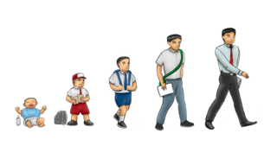

- The following sentences are taken from the story Eleven by Sandra Cisneros. Read them and then get together in pairs to discuss and arrange them in the order you think they appear in the story.

“Mrs. Price takes the sweater and puts it right on my desk….”

“ ‘That’s not, I don’t, you’re not…. Not mine,’ I finally say in a
little voice that was maybe me when I was four.”

“Maybe because I’m skinny, maybe because she doesn’t like me,
that stupid Sylvia Saldivar says, ‘I think it belongs to Rachel.’ ”

“ ’Whose is this?’ Mrs. Price says, and she holds the red sweater
up in the air for all the class to see.”

“It’s an ugly sweater with red plastic buttons and a collar and
sleeves all stretched out like you could use it for a jump rope.”

“That’s when everything I’ve been holding in since this morning,
since when Mrs. Price put the sweater on my desk, finally lets
go, and all of a sudden I’m crying in front of everybody.”

“ ‘Of course it’s yours ,’ Mrs. Price says. ‘I remember you wearing
it once.’ “

“ ‘Rachel,’ Mrs. Price says…. ‘You put that sweater on right now
and no more nonsense.’ “

- Read the story. Then go through the text again and answer the text-dependent questions below. You might want to use colors to highlight passages in the story that give evidence.

- To analyze a short story, you need to consider the following constituents:

When?
(Time of the story)
Where?
(Place of the story)

Who?
(Characters: main & secondary)
What?
(Plot: problem/conflict, rising action, crisis/climax, falling action, resolution

Why?
(Theme: what the idea behind the story is, why the author wrote this story)
How?
(Point of view: who tells the story and how)

- When Sylvia says the sweater belongs to Rachel, how does Rachel respond? What does this reveal about how Rachel feels about herself? Describe the protagonist in the story.

- Why does Rachel feel that Mrs. Price is “right”? Give evidence from the text to support your answer

- How does Rachel feel about the sweater? Include evidence from the text to support your answer.

- In paragraph five and in the last paragraph, Rachel says she wants to be 102. In each instance, why does Rachel want to be 102?

- Draw the metaphor Rachel uses in the story to describe what it is like to grow up.

Then explain what she means in your own words.

…”Because the way you grow old is kind of like an onion or like the rings inside a tree
trunk or like my little wooden dolls that fit one inside the other, each year inside the
next one. That’s how being eleven years old is.”
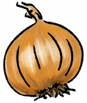
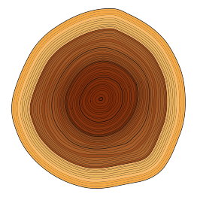

- How has Rachel grown older today? Include evidence from the text to support your answer.

- As a next step, get together with your partner and map out the story according to the circles and the table given below.

Describe what is happening outside of Rachel

Describe what is happening inside Rachel

- Academic Vocabulary

Have a look at the underlined words in the text. Can you guess their meaning from the content? Fill in the table below. Check definitions on COCA and find out how these words can be used together with other words.

Vocabulary | Guess the meaning from the content | Definition on COCA | How does this word fit with other words and concepts

- Homework

Describe a memorable childhood event. Please keep in mind that you do not necessarily have to talk about a negative experience from your childhood, but you can also write about a positive and enjoyable one. You might want to write about your first day at school, a sporting success, an extraordinary trip you went on, a dangerous experience in your childhood or a fight with your friend. Write an essay of 200 words.

Please consider the following WH-questions:

- WHO was with you and WHO was involved?
- WHEN took the event place?
- WHERE took the event place?
- WHAT happened?
- WHY is this event memorable for you?

Eleven
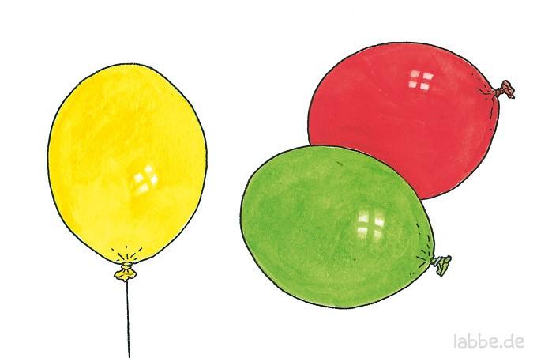
by Sandra Cisneros
What they don’t understand about birthdays and what they never tell you is that when you’re eleven, you’re also ten, and nine, and eight, and seven, and six, and five, and four, and three, and two, and one. And when you wake up on your eleventh birthday you expect to feel eleven, but you don’t. You open your eyes and everything’s just like yesterday, only it’s today. And you don’t feel eleven at all. You feel like you’re still ten. And you are—underneath the year that makes you eleven.
Like some days you might say something stupid, and that’s the part of you that’s still ten. Or maybe some days you might need to sit on your mama’s lap because you’re scared, and that’s the part of you that’s five. And maybe one day when you’re all grown up maybe you will need to cry like if you’re three, and that’s okay. That’s what I tell Mama when she’s sad and needs to cry. Maybe she’s feeling three.
Because the way you grow old is kind of like an onion or like the rings inside a tree trunk or like my little wooden dolls that fit one inside the other, each year inside the next one. That’s how being eleven years old is.
You don’t feel eleven. Not right away. It takes a few days, weeks even, sometimes even months before you say Eleven when they ask you. And you don’t feel smart eleven, not until you’re almost twelve. That’s the way it is.
Only today I wish I didn’t have only eleven years rattling inside me like pennies in a tin Band-Aid box. Today I wish I was one hundred and two instead of eleven because if I was one hundred and two I’d have known what to say when Mrs. Price put the red sweater on my desk. I would’ve known how to tell her it wasn’t mine instead of just sitting there with that look on my face and nothing coming out of my mouth.
“Whose is this?” Mrs. Price says, and she holds the red sweater up in the air for all the class to see. “Whose? It’s been sitting in the coatroom for a month.”
NOTES:
“Not mine,” says everybody. “Not me.”
“It has to belong to somebody, ”Mrs. Price keeps saying, but nobody can remember. It’s an ugly sweater with red plastic buttons and a collar and sleeves all stretched out like you could use it for a jump rope. It’s maybe a thousand years old and even if it belonged to me I wouldn’t say so.
Maybe because I’m skinny, maybe because she doesn’t like me, that stupid Sylvia Saldivar says, “I think it belongs to Rachel.” An ugly sweater like that all raggedy and old, but Mrs. Price believes her. Mrs. Price takes the sweater and puts it right on my desk, but when I open my mouth nothing comes out.
“That’s not, I don’t, you’re not…Not mine.” I finally say in a little voice that was maybe me when I was four.
“Of course it’s yours, ”Mrs. Price says. “ I remember you wearing it once.” Because she’s older and the teacher, she’s right and I’m not.
Not mine, not mine, not mine, but Mrs. Price is already turning to page thirty-two, and math problem number four. I don’t know why but all of a sudden I’m feeling sick inside, like the part of
me that’s three wants to come out of my eyes, only I squeeze them shut tight and bite down on my teeth real hard and try to remember today I am eleven, eleven. Mama is making a cake for me for tonight, and when Papa comes home everybody will sing Happy birthday, happy birthday to you.
But when the sick feeling goes away and I open my eyes, the red sweater’s still sitting there like a big red mountain. I move the red sweater to the corner of my desk with my ruler. I move my pencil and books and eraser as far from it as possible. I even move my chair a little to the right. Not mine, not mine, not mine. In my head I’m thinking how long till lunchtime, how long till I can take the red sweater and throw it over the schoolyard fence, or leave it hanging on a parking meter, or bunch it up into a little ball and toss it in the alley. Except when math period ends Mrs. Price says loud and in front of everybody, “Now, Rachel, that’s enough, ”because she sees I’ve shoved the red sweater to the tippy-tip corner of my desk and it’s hanging all over the edge like a waterfall, but I don’t care.
“Rachel, ”Mrs. Price says. She says it like she’s getting mad. “You put that sweater on right now and no more nonsense.”
“But it’s not –“
“Now!” Mrs. Price says.
This is when I wish I wasn’t eleven because all the years inside of me—ten, nine, eight, seven, six, five, four, three, two, and one—are pushing at the back of my eyes when I put one arm through one sleeve of the sweater that smells like cottage cheese, and then the other arm through the other and stand there with my arms apart like if the sweater hurts me and it does, all itchy and full of germs that aren’t even mine.
NOTES:
That’s when everything I’ve been holding in since this morning, since when Mrs. Price put the sweater on my desk, finally lets go, and all of a sudden I’m crying in front of everybody. I wish I was invisible but I’m not. I’m eleven and it’s my birthday today and I’m crying like I’m three in front of everybody. I put my head down on the desk and bury my face in my stupid clown-sweater arms. My face all hot and spit coming out of my mouth because I can’t stop the little animal noises from coming out of me until there aren’t any more tears left in my eyes, and it’s just my body shaking like when you have the hiccups, and my whole head hurts like when you drink milk too fast.
But the worst part is right before the bell rings for lunch. That stupid Phyllis Lopez, who is even dumber than Sylvia Saldivar, says she remembers the red sweater is hers. I take it off right away and give it to her, only Mrs. Price pretends like everything’s okay.
Today I’m eleven. There’s a cake Mama’s making for tonight and when Papa comes home from work we’ll eat it. There’ll be candles and presents and everybody will sing Happy birthday, happy birthday to you, Rachel, only it’s too late.
I’m eleven today. I’m eleven, ten, nine, eight, seven, six, five, four, three, two, and one, but I wish I was one hundred and two. I wish I was anything but eleven. Because I want today to be far away already, far away like a runaway balloon, like a tiny o in the sky, so tiny—tiny you have to close your eyes to see it.

 | 1 | 2 | 3 | 4 | 5 | 6 | 7 | 8 | 9 | 10
Is the source text appropriate for this level?
Will the students be working actively?
Do the tasks include different skills?
Do the tasks include different work-modes (individual, pair, group, whole class)
Are the instructions clear and idiomatic?
Are the materials designed attractively?
Can you see a clear relationship between the learning aims and the activities? Will the materials help the learners to reach these goals?
Overall impression:

Congratulations, this is excellent. Please polish the materials so you and your fellow students can use them in class.

10pts

I do not know why all my comments are aligned on the right even though I have tried to change this – there must be some formatting in your file that I cannot figure out. Maybe you can get rid of it.
pö

