
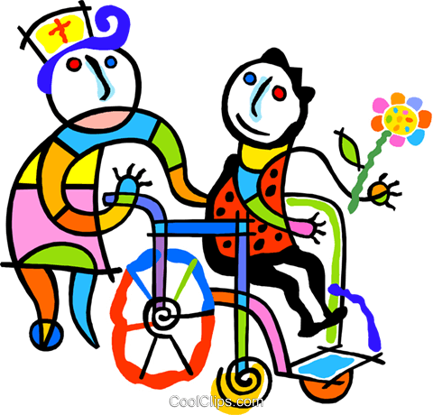
The Ghost Boy
by Elinor Nash
- Have you ever wondered what life is like for someone with a disability? For example, how do people without hands write? Give it a try: Write your name on the top right hand corner of this sheet. Hold the pen with your mouth or with your toes. Don´t use your hands!

- Why is it often assumed disabled people are unhappy? We feel sorry for them, because we imagine it must be miserable to be disabled. Is this really true? What do you think? Discuss your opinion with a partner. In pairs, create a mind map on an A4 page illustrating your opinions. (Leave space for new ideas to add later.)
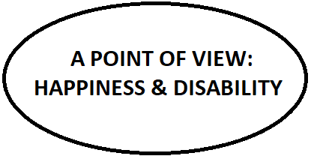
- Imagine you could see the colours of sound and noise. What colours would they be? Write the first colour that comes to your mind next to the sound:
Swirl of a fan:
Turning of pages of a newspaper:
Sound of a vacuum cleaner:
Drilling:

Rain sound:
Laughter:
- What if the soundwaves could also turn into images of food or symbols? What image would you associate with drumbeats?
- Draw your picture of the sound of drumbeats in the left frame:

- Read the first page of the story. How does Jake picture the sound of drumbeats? Draw it in the right frame.

- Continue the story. While reading highlight any colours and food or symbols that Jake can see when he hears certain noises.
- Why does Jake think he is a ‘Ghost Boy’? Discuss your answer with a partner and try to find another catchy title for this short story:

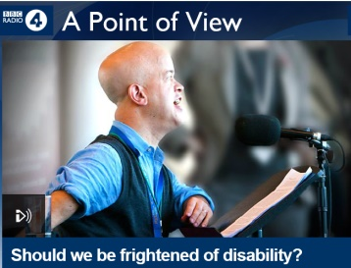
- Listen to the BBC radio 4 podcast ‘A Point of View: Should we be frightened of disability?’ (provided as an mp3-file or online: http://www.bbc.co.uk/programmes/b044jh7k). Tom Shakespeare argues that disability is nothing to fear. Do you agree/disagree? Add new arguments based on the podcast and on the short story to your mind map from task 2.

- How do the following people cope with Jake´s situation? How do they treat him?

His mother:
His father:
His sister Ava:
Gary (plumber/builder):
His teacher Miss Cunning:
Other people:

- Imagine you are Jake´s younger sister or brother. How do you feel about your disabled older brother? Write a diary entry (200 – 250 words).

TEACHER`S NOTES:
- Age group: Year 5/6 (15/16 years old)
- Purpose & learning objectives:
  - Understanding disability.
  - Reduce prejudices against disabled people.
  - Getting to know examples of disabled people who are, nevertheless, happy.
  - Putting themselves in the shoes of Jake´s family members.
  - Understanding Jake´s coloured sounds as a gift.

