The Humbugs, by Kurt Vonnegut

Brainstorm: Make a large Venn diagram on an A4 page and enter your ideas about ART and HUMBUG. What is art for you? Where are the limits of art? What is the purpose of art? How do you recognize a painting is “art” or “humbug”?
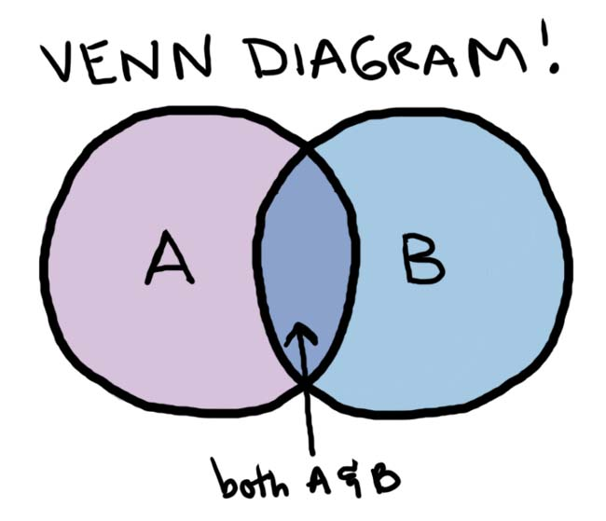
Humbug
ART

What’s in a name? Who might these characters be? What do the names tell you about the men?

Durling Stedman:

John Lazarro:

Read the story. While reading highlight any references to art and artists. Use two colors for Stedman’s and Lazarro’s art.

Sketch the two paintings and describe them


The artists: What do we know about the two artists?

Durling Stedman | John Lazarro

Continue the story: Read the story as far as p. 243.
Group A: Watch Durling Stedman painting “with soul” for a change. Describe exactly what you see him doing. Look for details that show how he feels about what he is doing. Continue the story and try to stay in the same style.
Group B: Watch John Lazarro painting a picture “of something that really looks like something”. Describe exactly what you see him doing. Look for details that show how he feels about what he is doing. Continue the story and try to stay in the same style.
Write about half a page (typed and upload your text to moodle.
Then read the rest of the story and compare it to your own version.

The two paintings:
What is special about these paintings? What do the two paintings show about the artists’ characters?

Vocabulary
The author has used lots of good collocations in the story.
Examples: to meet a payroll, a thunderstruck woman , affectionate, bewildered housewives
Look up the main words in COCA and find at least one additional usage example for each one.
Then collect 10 more collocations from the story and look up the main words in COCA. Find one or two examples how to use them and write all the new phrases into your vocab book.

