“The Time-Sweepers“
by Ursula Wills-Jones
You may not be familiar with the time-sweepers. The time-sweepers are the people who sweep up all the time that is lost and wasted. You cannot see them, though if you are in the railway station and think you see something out of the corner of your eye, that will probably be a time-sweeper, cleaning up around the bench you are sitting on. If you were to see them, you would find a small, bluish person with an intent expression, clutching a broom and a mop. The men wear overalls, the women old-fashioned tweed skirts and scarves on their head.
The time-sweepers are present wherever time is being lost or wasted. There are always several in train stations, and at least one in every doctors surgery. The man who has waited so long to propose to his girlfriend that her hair has gone grey, probably has his own personal time-sweeper following him around. The woman who has spent thirty-five loathed years in an estate agents, dreaming of opening a florists, causes the neighbourhood time-sweeper to sigh, and fetch a bigger dustpan.
You should not feel sorry for the time-sweepers, though their work is menial: they are never sick, do not worry that they are in the wrong career, and have excellent working conditions, though what they do for leisure is unknown. They enjoy bank holidays off, which is why, on these days, there seems so much more time than usual. At Christmas and new year, the time-sweepers have a week's holiday. When they return to work in January, they face a vast backlog of time which has been lost, wasted and thrown away over the holidays. It takes them around three weeks to resume normal service, which is why January always seems to last longer than other months.
The time-sweepers have been around forever, though modern life has created wasted time in such large concentrations that in some places the time-sweepers have been forced to industrialise their operations, buying a number of specialised compressing lorries similar to those used by ordinary bin-men. They use these for the largest collections, at prisons and shopping malls, two venues where the tide of wasted time threatens to swamp even the most dedicated operatives.
< 2 >
Were you to ask a time-sweeper, they would tell you one surprising thing: time enjoyed is never time wasted. Cleaning up in a large office full of staggering tedium, the time-sweeper will pass straight by the desk of the woman who is reading a holiday catalogue under the desk, poring over photos of tropical beaches. They will pass by the next desk, where a man is enjoyably wondering what his mother-in-law looks like naked, and stop by the desk of the young man who is counting every minute, and loathing the hours.
You may wonder what happens to the wasted time after it has all been cleaned up. Never fear, the time-sweepers are ardent recyclers. It is collected, packed into large containers, moved to Liverpool docks, loaded onto a ship, and taken to India. There, in a dusty industrial estate somewhere near Bombay, it is cleaned, sorted, and graded. The most toxic and poisoned time – the residues of failed peace negotiations, wrongful imprisonments and truly poisonous marriages, is skimmed off and buried in a tank underneath a disused army base. There, it will take two or three centuries to decay, and become harmless again.
The rest of the time – made up of stuff such as dull meetings, missed appointments, delayed buses and bad nights at the theatre, is cleaned and put back onto a ship, where it is taken to the Guangzhou industrial export processing zone. Here it is compressed and stored, awaiting redistribution. Around twenty percent goes direct to the factories of the export processing zone, which has the world's highest productivity rate. A quarter is bought in hard dollars by the Chinese government. Ten percent of the most concentrated stuff is sold to a cryogenics laboratory in California. Another twenty or so percent is discreetly sold to a variety of rich private clients, mostly old, rich men who have married beautiful young women.
However, the time-sweepers are not in it for profit. The money from these deals pays for their operations, including dusters, bin-bags, overalls and shipping. The rest is distributed to good causes. No-one who gets any extra time has to fill in any forms, or ask for a grant. They are all quite unaware that they are in receipt of assistance. One of these beneficiaries is a shabby and overtired scientist in a crumbling public laboratory outside Novosibirsk, who will be the man to find the vaccine for malaria. Another is a prostitute in a Nairobi slum who has fostered seventeen children, and who, despite twenty years in the business, never falls ill. A third is the Indian taxi-driver in a cramped flat in Toronto, who, in between sending money home to a sick wife and children, is writing what will later be acknowledged as the greatest novel of the century.
< 3 >
Not all the recipients of the time-sweepers' largesse are people. About forty miles outside Timbuktu, a medieval mosque, buried in sand, receives a delivery every decade or so. Somewhere below the floor in the Aegean sea, a Trojan galley is miraculously preserved in mud. Similarly, the time-sweepers gift a little extra time to a temple in Mexico, and preserve a haul of dark-age treasure in a Galway bog.
A certain amount of charitable time is kept back for emergency situations, both small and large. It is parachuted in in times of desperation, and has facilitated peace deals, changed battles, and allowed numerous fathers to make it to the delivery room in time.
The time-sweepers are, by their very nature, a tidy and orderly sort of people. They wish that humans would think more about throwing away this valuable commodity, but don't expect it'll happen any time soon.
There isn't a moral to this story. It's just that if you are planning on throwing away your time, please remember - somebody has to pick it up.

Source: http://www.eastoftheweb.com/short-stories/UBooks/Time898.shtml

“The Time-Sweepers“
by Ursula Wills-Jones
Pre-Reading Activities:
- Discuss with your partner: What do you think is a time-sweeper? What might be its functions? Then write down your definition and ideas here:
A time-sweeper is …

Its function is to …

- What does wasting time mean for you? Fill in the table below with activities that you think are a meaningful use of time and others which you think are a waste of time:

Such a waste of time!
That’s a meaningful use of time!

While-Reading Activity:
Look for information you find about the time-sweepers. Highlight the passages that describe them. Then draw a time sweeper.
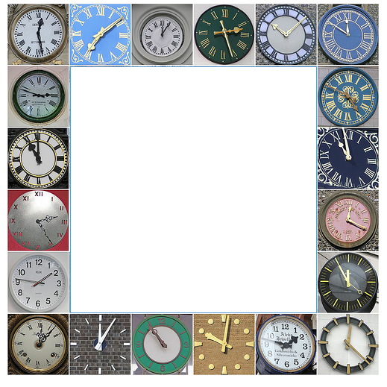

Post-Reading Activities:
- Group Discussion (groups of 4):
Where and when do we waste time? Why do we do that? Who usually “picks up” the time you waste?

- Writing Task:
  - Make a list of everything you did yesterday that was a waste of time.
  - Exchange your list with one of your classmates.
  - Imagine you are a time-sweeper for one day and have to make up for all the wasted time of one of your classmates. What would you have to do?
  - Write a text of about 200 words.

Dear Ms Gräßl,
this is a really nice unit – very well done. Just polish the tiny flaws – great ideas and very attractive layout.
10pts

