Zlateh the goat
needs major work, but the link to the video might be useful
by Isaac Bashevis Singer
Lesson Plan for 5th grade (notes and time table for the teacher)
16 pupils (7 male and 9 female)
End of session 1
Time | What? | How? | Why?
Pre-Reading
~5 min | Pupils have to look at two pictures and discuss with a partner what those pictures might have to do with the story; get them curious about the story | Pupils will be given a worksheet with pre-reading, while-reading and post-reading tasks | Get pupils to talk, activate their creative thinking skills
~8 min | Pupils should take down a few notes what friendship means to them and compare their ideas to their partners | Same worksheet | Friendship is one topic in this short story, get them to think about their own feelings towards friends, get them to talk again
~15 min | Pupils should get together in groups of four, they should read a short extract from an article on human-animal friendship and do some tasks afterwards | Same worksheet, get together in groups | The human-animal bond is the central topic in this short story and therefore pupils should get familiar with it; get them to talk again; connection to their lives (pets)
While-Reading
~15 min | Now pupils should start to read the text; while they are reading they should take down notes concerning the feelings of the animals and the boy Aaron | The short story will be handed out and they have their worksheet to take down their notes | Feelings have a lot do with the bond of animals and humans and there will also be a discussion about feelings afterwards
Post-Reading
~25 min | Pupils should get together in groups of four again and agree on four situations in which they think the human-animal bond is reflected the most; they should then get together in groups of eight and do the same task; then present one or two situations to the whole class and to the teacher | They get a worksheet with tasks they have to do in their groups of four | Make sure they understood the text, understood the task, work on the topic and speak a lot
~25 min (maybe finish it up at home) | Pupils should write an letter to the father telling him why Zlateh should not be taken to the butcher | Worksheet | Improve writing skills; learn to argue against or for something; take a stand; use the knowledge they have learned so far (human-animal friendship)
Homework | Finish up the previous task, watch a video “Friendship: Do animals have friends too?” They should write a short summary about certain aspects of the video | Link on moodle | Listening and Writing
A few comments:
For Homework make sure that all pupils have access to the internet! If not, hand out a text version of the video.
Group formation will be done by the teacher – to make sure that the groups are mixed up
Always walk around to see if pupils are working and remind them of speaking English if they speak in German or any other language.
The title will be provided at the beginning because otherwise they might not be able to talk a lot about the pictures
Link to the text: https://www.wsfcs.k12.nc.us/cms/lib/NC01001395/Centricity/Domain/7672/Zlateh%20the%20Goat.pdf (For class: Use the text without the comments at the bottom)
Pupils will have to use many tenses, exchange views and also practice reading, writing, listening and a lot of speaking.
Zlateh the goat by Isaac Bashevis Singer
Before you start reading…..

Look at the pictures and discuss with your partner what they might have to do with the short story we are going to read soon.
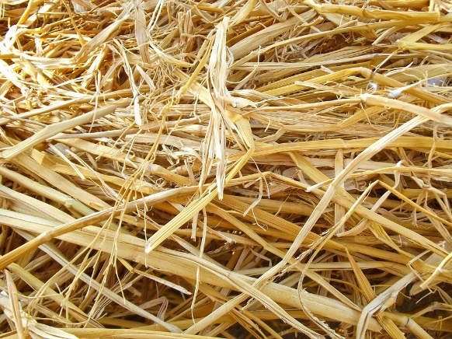


Take down a few ideas what friendship means to you, e.g. loyalty, trust etc….
_____________________________________________________________________________________________________________________________________________________________________________________________________________________________________________________________________________________________________________________________________________________________________________________________________________________________________________________________________________________________________________________________________________

Now compare your outcomes with your partner using the following phrases
- What is your most important attribute (charakteristische Eigenschaft) that a friend needs to have?
- Why is it so important to you?
- What is not so important for you?
- Have you ever been disappointed by a friend? How?
4.)
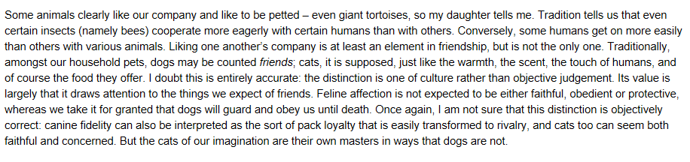
Read the short extract from Stephan Clark article “I know him by voice: Can animals be our friends?” and do the following tasks below!

feline: katzenartig, obedient: gehorsam

- Get together in groups of four
- You should discuss in your groups:
  - Can animals and humans be friends? Why/Why not? What does the article say about this issue?
  - Are there any animals you think that cannot be friends with people?
  - Cats or dogs? Which animals are more likely to be friends with human beings and why?
- Look at the picture and discuss it in your groups: Is this situation always possible? Why? Why not? How can a situation like this occur?
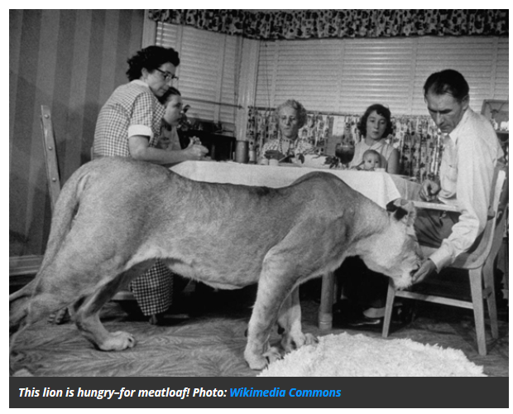

Clark, Stephan: I know him by voice: Can animals be our friends? 2008 Online im Internet: URL:https://philosophynow.org/issues/67/I_knew_him_by_his_voice_Can_Animals_Be_Our_Friends
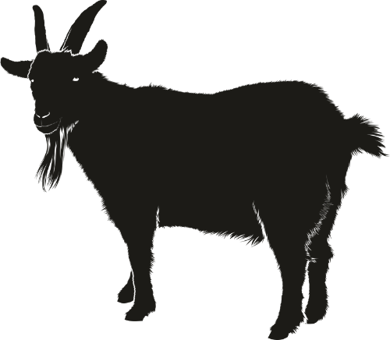
5.) Now, start reading the text!
!!!BUT!!!...
While you are reading…….
Take down notes concerning the feelings and thoughts of the animal and the human in this story (e.g. the animal’s feelings towards the human and vice versa..etc.) Also add the situations in which those feelings come up!
______________________________________________________________________________________________________________________________________________________________________________________________________________________________________________________________________________________________________________________________________________________________________________________________________________________________________________________________________________________________________________________________________________________________________________________________________________________________________________________________________________________________________________________________________________________________________________
6.) Get together in your groups of four again and do the following tasks:
- Compare your notes and agree on four situations in which you think the human – animal bond is reflected the most and why! (Each one of you should come up with a situation!)

- Now, get together with another group and compare your outcomes. Again, agree on four situations!

- Present your four situations to the other group and explain why you chose them. Agree on one or two situations and present it to your teacher. Also explain why you chose them!
7.) Imagine the story would have ended differently…
There had not been great joy in the family and the father was furious with Aaron because he came home with the goat. The father tells Aaron to bring the goat to the butcher without any protest (ohne Widerrede)! For fear the father could do it by himself, Aaron and Zlateh ran away the next day.
Imagine you are Aaron and want to explain to your father that you became really attached to the goat and that you do not want to take it away because it is your friend now. Write a letter to your father telling him all about human-animal friendships and why you resist taking Zlateh to the butchers. You should write at least 200 words!

_________________________________________________________________________________________________________________________________________________________________________________________________________________________________________________________________________________________________________________________________________________________________________________________________________________________________________________________________________________________________________________________________________________________________________________________________________________________________________________________________________________________________________________________________________________________________________________________________________________________________________________________________________________________________________________________________________________________________________________________________________________________________________________________________________________________________________________________________________________________________________________________________________________________________________________________________________________________________________________________________________________________________________________________________________________________________________________________________________________
8.) Homework
Watch the video “Friendship: Do animals have friends, too?” (The link can be found on moodle) and write a short summary (min. 60 words) about what the speaker says about why only few animals make friends and how they do it. Explain further why human beings usually have more friends (also mentioned in the video).

