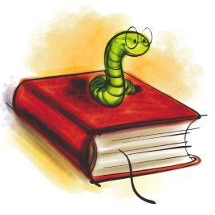
Book sharing

Prepare the following things for the book you have read:
5 nouns (things, objects…) | Choose 5 things that play an important role in your book and write them on the cards provided. (Example: broom, hour glass, magic potion, train, … for a Harry Potter book)
Big trouble | Choose a passage in your book where one of the main characters is in trouble, has a problem or is very sad. Practice reading this passage so you can later read it out to your group.
Happy moments | Choose a passage in your book where one of the main characters is happy. Practice reading the passage.
Important adjectives | Find three adjectives in your book that are somehow important for the story. Choose new and interesting adjectives – not words we all know. Copy the adjective on a card and write the sentence you found in the book on the BACK of the card.

Group Phase
Get together with the students who have the same adjective mood card as you.
Guess what… | Show your noun cards and adjective cards to your friends and have them guess what the book might be about.  Ask lots of questions about your friends’ books and try to find out as much as possible about the main characters, their problems, their wishes and hopes.  Do not give away the endings and solutions of your book.
Big trouble and  Happy moments | Read the passages that you have chosen to your friends and explain why your characters feel so happy or so sad.
Important adjectives | Put all the adjective cards on the desk (only show the adjectives, not the sentences)  Copy all the adjectives on the back of this sheet and guess what the words might mean. Discuss your ideas in the group.  Then turn over the cards and look at the sentences. How can these sentences help you guess the correct meaning of the adjectives?  Now ask the students who have written the cards to explain the meaning of the word and record it in the table.
Homework | Copy the new adjectives and sentences on vocab cards and add a second sentence where you use the new adjective in a TRUE sentence.

This is what your vocab cards should look like:
Use ONE card for ONE vocab item.
Word: | Dreadful
Sentence from the book: | Their dreadful voices sounded like dentists’ drills all grinding away together.
My true sentence: | My neighbor Gerti has a dreadful, whiny voice.
On the back write a translation of the main parts of the sentences. Example:
Ihre schrecklichen Stimmen klangen wie Zahnarzt Bohrer…
Gerti hat eine schreckliche, weinerliche Stimme.
Adjective | Sentence from the book:
1
2
3
4
5
6
7
8
9
10
11
12

