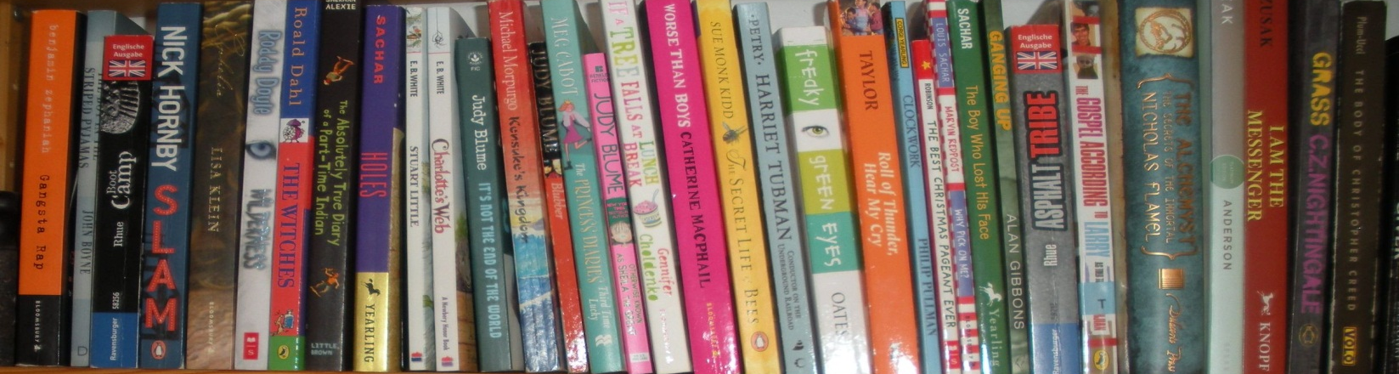
Bring your book
your reading diary
and a pen

Extensive Reading : Read and enjoy

- Find a book that interests you and find at least one partner who is going to read the same book. Choose relatively easy, high-interest books rather than hard-core literature to get started.
- If you do not like a book you do not have to finish it but you will find another book.
- During SSR time (Sustained Silent Reading) in class read quietly.
- Find additional reading time (at home, on the bus/tram. in school when waiting for elective classes…) Read as much as you can. Use even small time pockets (10 to 15 min are better than nothing).
- Set yourself a goal: How much will you read today/ this week/ this month? Start with a small step.
- Mark interesting/ memorable/ strange passages and quotes with sticky labels (or in pencil if you own the book). You will later read them out to your group-mates and discuss them in class.
- Write 2-3 short “free-writing” reflections about your book. Do not spend more than 10 minutes on these reflections. Write down whatever comes to your mind – you need not plan a coherent text. Use some of the following sentence starters to get going:
  - I wonder why…
  - I wonder if…
  - I have noticed that…
  - I think
  - The book/scene… reminds me of…
  - I like…// I do not like…
  - If I were…
  - If I could…
  - I do not understand …

In class:
- You will get regular in-class reading time.
- You will get regular class-time to discuss your reading in your reading group and with your teacher or co-teacher.
- In your reading-group time share interesting passages that you have marked or labelled.
- Ask any questions that have come up during reading.
- Go online to find answers to your questions or do some background research if relevant.
- Sometimes you will be given little tasks. Do them efficiently and collect all your work in your RD.
