Life Stories
Use the “life-line” below and mark three to five important moments in your main character’s life. Then add appropriate emoticons from the back of this sheet to show your character’s feelings at these moments.
Be prepared to talk about the following aspects:
- describe the situation and the circumstances
- describe the character’s feelings at this moment
- briefly explain what has lead up to this moment (without giving away too much about the story)
Work in groups of 4 and share your characters’ experiences.
Switch groups and share more experiences. Then choose a book that you would like to read next.



Image sources: https://www.angio.org/wp-content/themes/twentytwelve/images/lifeline.png

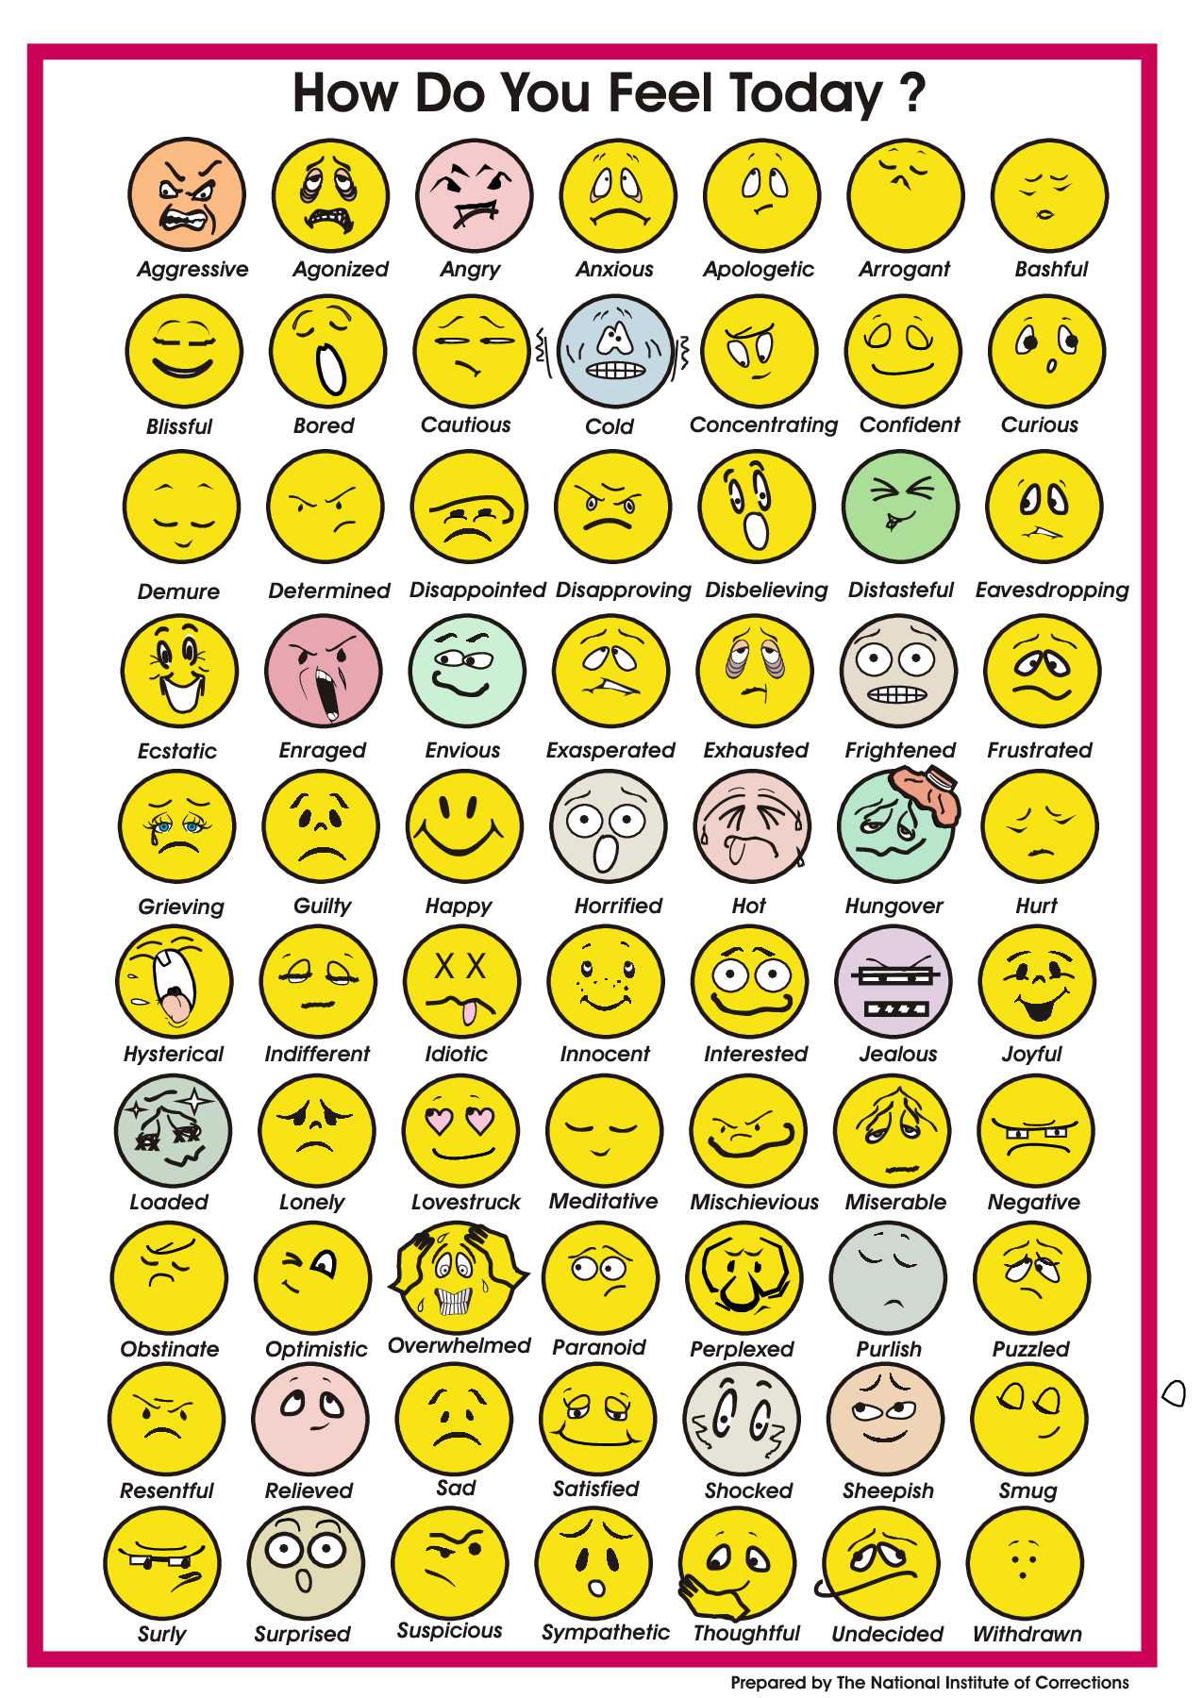
Help: Purlish (Verb) 1. To be sullen, or unhappy. 2. To have a mood or attitude influenced by a different, often unnconnected event. "He was purlish as he had not been picked for the team".
https://lilpickmeupdotcom.files.wordpress.com/2014/04/2579453.png

