Mindsets (Michelle Gilluly’s task for book projects)

You have 5 minutes to discuss the main perspective of your main character in the book. Can you identify and describe his/her attitude? What does he/she think?
___________________________________________________________________________________________________
___________________________________________________________________________________________________

Statements
Within your group, organize these slips of paper into logical groups. You can build as many ‘logical groups’ as you want. Be able to explain why you organized the papers the way you did. Are there examples of these statements in your book?
a) | He has natural talent.
b) | I wasn’t born with that ability.
c) | If I keep working at it, I will be able to accomplish my dreams.
d) | I just need to try a little harder.
e) | If I keep practicing, I will keep getting better.
f) | I will never be able to accomplish this task.

Mindset
Fixed mindset refers to the belief that you were born with a certain (fixed) amount of talent, which you cannot change or adjust, despite hard work or effort. It is the knowledge you have in your brain, which you need not study/learn; it is the way you are.
Growth mindset refers to the belief that through hard work, you can increase your potential and your abilities. You believe that you can grow your talent/knowledge/ability if you practice.

- Which of the above quotes talk about fixed and which talk about growth mindset? _______________________________________________________________________________________________

- Do you say such things as well? In what situations? _________________________________________________________________________________________________

- Within your group, find two more examples of each mindset.
a) Fixed:
b) Growth:
Fixed Mindset vs. Growth Mindset
Through more than three decades of systematic research, [Carol Dweck] has been figuring out answers to why some people achieve their potential while equally talented others don’t—why some become Muhammad Ali and others Mike Tyson. The key, she found, isn’t ability; it’s whether you look at ability as something inherent that needs to be demonstrated or as something that can be developed.
Fixed Mindset
Let’s have a look, starting with the Fixed Mindset side:
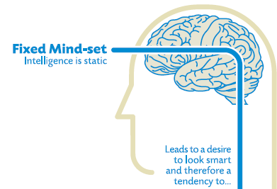
People who hold these beliefs think that “they are the way they are”, but that doesn’t mean that they have less of a desire for a positive self-image than anyone else. So of course they want to perform well and look smart. But to achieve these goals…

By definition, a challenge is hard and success is not assured, so rather than risk failing and negatively impacting their self-image, they will often avoid challenges and stick to what they know they can do well.

Same with obstacles. The difference here, as I see it, is that challenges are things that you can decide to do while obstacles are external forces that get in your way.
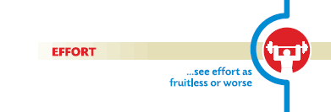
What’s the point of working hard and making efforts if afterwards you are still on square one? If your worldview tells you that effort is an unpleasant thing that doesn’t really pay dividends, then the smart thing to do is to avoid it as much as possible.

Useful negative feedback is ignored in the best of cases, and taken as an insult the rest of the time. The Fixed Mindset logically leads you to believe that any criticism of your capabilities is criticism of you. This usually discourages the people around and after a while they stop giving any negative feedback, further isolating the person from external influences that could generate some change.

The success of others is seen as a benchmark against which the person looks bad. Usually when others succeed, people with a Fixed Mindset will try to convince themselves and the people around them that the success was due to either luck (after all, almost everything is due to luck in the Fixed Mindset world) or objectionable actions. In some cases, they will even try to tarnish the success of others by bringing up things that are completely unrelated (“Yes, but did you know about his…”).

As a result, they don’t reach their full potential and their beliefs feed on themselves: They don’t change or improve much with time, if at all, and so to them this confirms that “they are as they are”.

Growth Mindset
Let’s now look at the Growth Mindset:
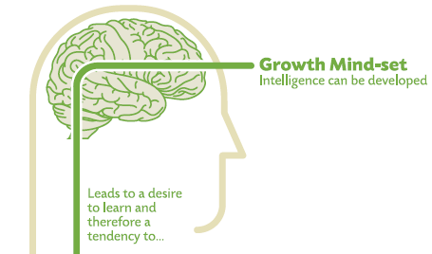
People who hold the Growth Mindset believe that intelligence can be developed, that the brain is like a muscle that can be trained. This leads to the desire to improve.

And how do you improve? First, you embrace challenges, because you know that you’ll come out stronger on the other side.

Similarly, obstacles – external setbacks – do not discourage you. Your self-image is not tied to your success and how you will look to others; failure is an opportunity to learn, and so whatever happens you win.

Effort is seen not as something useless to be avoided but as necessary to grow and master useful skills.

Criticism and negative feedback are sources of information. That doesn’t mean that all criticism is worth integrating or that nothing is never taken personally, but at least the Growth Mindset individual knows that he or she can change and improve, so the negative feedback is not perceived as being directly about them as a person, but rather about their current abilities.
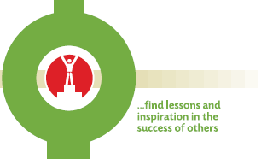
The success of others is seen as a source of inspiration and information. To Growth Mindset individuals, success is not seen as a zero-sum game.

And so, Growth Mindset individuals will improve and this will create a positive feedback loops that encourages them to keep learning and improving.

Online 26.05.2014:
[http://michaelgr.com/2007/04/15/fixed-mindset-vs-growth-mindset-which-one-are-you/]

What about your own mindset?
- Think about your own mindset, what do you think? E.g. “I think, that if I work hard I can learn any language I want. But I don’t think, that I will ever be a good volleyball player or artist. However, if I practice enough I will get better.”
- In what situations do you have a fixed or growth mindset?

Importance of mindset
Focus on why a certain mindset is important:
- Why do you think mindset is important? How does this play a role? Why? Talk to your partner about it.
- Do you think people can do/achieve anything they want to? Why / why not?

Mindset in your diaries
Now think about your book. What mindset did the main character have in general? In which situations did he/she show a certain mindset?

Read the following paragraphs from the book from YOUR reading project and match them to either a growth or fixed mindset.
Anne Frank

Diary of a Wimpy Kid

The Absolutely True Diary of a Part-time Indian






Big Mouth & Ugly Girl





    - What is happening in the three excerpts taken from your book?

    - According to the mindset worksheet, why are the characters exhibiting a growth/fixed mindset?

    - How would you interact with this person about his/her mindset?
Homework
Pick one of the three situations/excerpts. Now, write a letter to the character mentioned in the text, about the situation.
What would you say to this character to help him/her get through the situation? How could you help him/her to get a new view on the situation? What would you say to the main character?
- Brainstorm ideas with your reading group. (See “Collect Ideas”)
- Write a letter of advice/encouragement/empathy to the character (on your own paper).

Start writing the letter now and finish it as homework. Write at least one page.

Collect ideas:
Choose one character to encourage/advise in some way:
      - To keep working hard
      - To study more
      - To hold on to a friendship
      - …
______________________________________________________________________________________________________________
_____________________________________________________________________________________________________
_____________________________________________________________________________________________________
_____________________________________________________________________________________________________
_____________________________________________________________________________________________________
_____________________________________________________________________________________________________
_____________________________________________________________________________________________________
________________________________________________________________________________________________

