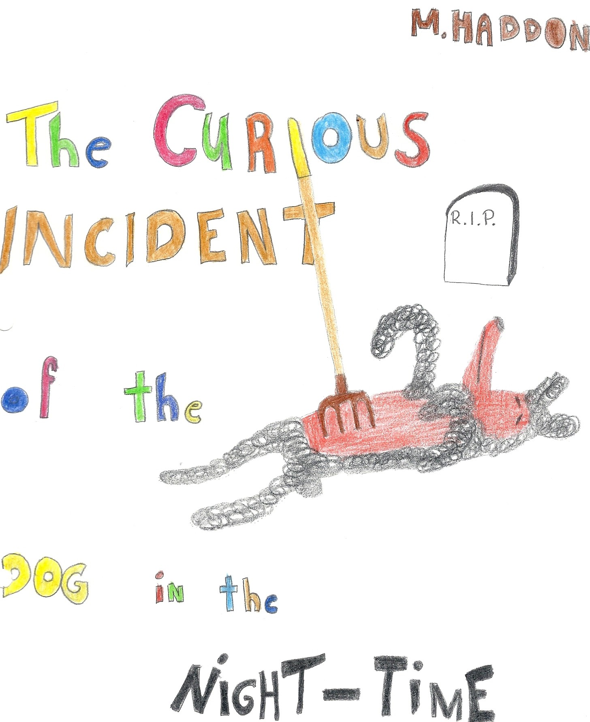
,

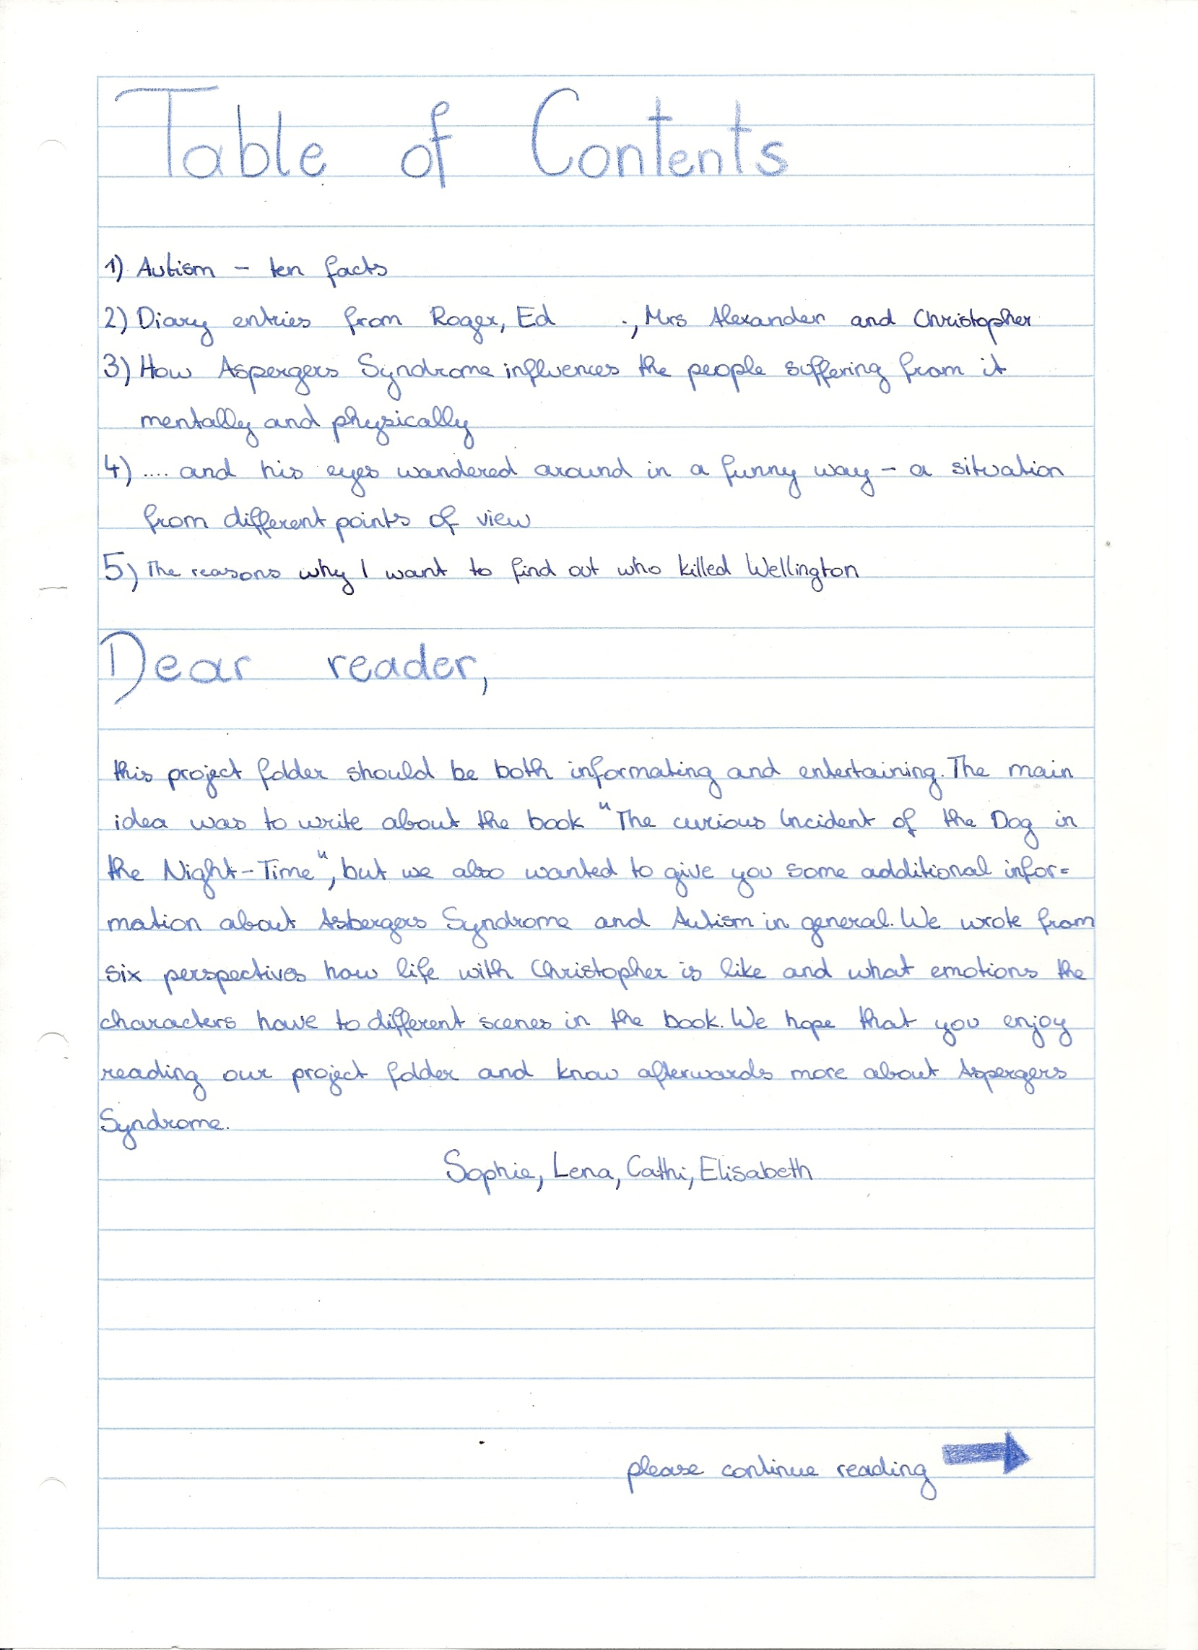

10 facts about autism

- Approximately 1 out of 250 children can develop autism or a simpler form of it.

- It is very hard for the autists to communicate, because they can’t express their feelings in words without special help. People really have to talk slowly and say clearly what they want, otherwise those kids will not do what they are asked to do.

- When kids have autism there is one thing they hardly understand: The sense of the world.
They just can’t think of this feeling to life, and what else there is.

- When something changes in their environment they freak out and can’t concentrate.
Everything has to stay the same so they have everything under control and know where everything is.

- They don’t like being touched. For them it feels like the hand is move into their body. This feeling of border is missing. One half of their brain isn’t working so well, and this is the one that is responsible for the feelings

- You are autistic if your brain can’t develop different nerves or neurons in your head.

- There is no cure for autism but doctors and special teachers can help those kids to communicate and talk about their feelings and not be scared of other people.

- Kids with harmless autism can live on their own but the others will always need some kind of help in everyday situations

- Those kids have problems linking words to different feelings or meanings, so they often don’t understand people when they say: I’m sad, or I’m happy. That’s very hard to cure!

- Often the first ones who recognize strange things are the parents. Then they want to help their kid but when they touch it, the kid just screams.

Dear Diary,
I’m sitting here under arrest in prison. Why? This is a long story:
It was seven minutes after midnight and I was lying in my bed with my five and a half pets (because I tore off the head of one) and watching the rain dropping on my window. Then I heard a door bumping, a scream and a loud bark of the neighbour’s dog. Then, nothing.
On the next day I woke up early in the morning. My Father was already at work and I went to my window to count cars, whether it is a good or a black day. I counted 4 yellow cars so it was a Black day. So I went outside in the garden and saw the wellington, the neighbour’s dog. Its eyes were closed. The dog was dead. Why I knew? In Wellington’s breast stuck a garden fork. I went to him and took out the fork. His blood was all over the grass, so I took him and held him in my arms. Suddenly Mrs. Shears, our neighbour, came out of her house and started to scream, ”What have you done to my dog, you stupid bastard! You can’t just kill a living thing! What has come on to your mind uhh?” I didn’t understand what she was talking about so I just watched her and said nothing. She yelled at me and called the police. I didn’t want to move. After a while the police arrived. He asked me: ” Have you seen anything strange in the last few days?” This was like in my favourite books: The murder mystery novels! So I negated: “No” “Have you killed the dog?” No” “But it looks like it, ‘cause not every person is sitting in the garden of the neighbour with a dead dog in his hands.” “But it is not my fault, I really haven’t kill the dog!” “Please come to the police station with me” he grabbed my arm and dragged me off. I screamed because it hurt so badly so I just hit the police man. He turned around and looked at me. “Are you crazy or what! What is wrong with you?” I curled up on the ground and started to grumble. That made me feel comfortable and safe. The officer touched me again and I yelled at him so he let me go. After a while we stood opposite each other and he said ,”Are you ill or what? You have to go to the police station with me, come on!”
So now I am here. I hear my Father screaming to let him see me but the officers want to talk to him first. After 12: 32 Father came in and we went home together in total silence.
Christopher

Dear diary,
Judy and I had a quarrel in a coffee shop after I blamed her of being egoistic and not bringing a second coffee along for me. It was such a bagatelle that I can’t even imagine why we were fighting about it, however, in that moment, we meant it seriously. I was into arguing so much that I didn’t even notice Christopher standing in front of our new flat. It was as if two worlds would crash into each other, the first one was my old home with my old wife and Christopher, Ed and Judy being nothing but my neighbours. But that was over, Ed and Judy where divorced and Christopher and Ed still lived in the same old street in Swindon. All I needed now was a bit of distance, a fresh start and no thoughts about old decisions. There was Christopher. The boy with Asperger’s Syndrome, the boy I never found a way to talk to each other properly, the boy who went to a special school and met psychologists. The one not wanting to be touched and the one that could tell the exact temperature of any date in the last few months. That was creepy and I couldn’t find a way to communicate with him without feeling watched. For Judy that was easy, she seemed to be so happy about Christopher being here that she hadn’t got the slightest problem with his disability. It was all so natural for her, she didn’t have to think what was best and worst to say, everything seemed to be so normal. “Christopher, Christopher!” she spread her hand out in a van and touched the one of her son. “Where’s Ed?” That might have been the worst thing to say in that moment, but it was the first to come into my mind. Judy punished me with a look in my direction. “In Swindon, I think”, Christopher replied. It turned out that the boy came here all by himself. I was very worried. It wasn’t that I didn’t try to get to know him better; I was just so unsure how to deal with him. What should I do now? Would Christopher stay and live with Judy and me forever? While I’m writing here he’s in the bathroom taking a good long warm bath. What then? I need to talk to Judy right away.
Roger

Dear Diary!
My Ex-wife, this stubborn person, had an affair with our neighbour when we were still married. We got divorced and she went to London with Mr. Shears. He was her affair. I hated him. He was so mean, this old nasty man.
But now it is o.k. for me. I don’t need my Ex-wife. I have Christopher and we are happy. But Christopher’s mom, my Ex-wife, writes him letters. That’s alright for me but I told him that she had had an accident and had died in hospital because of a heart attack. I always took his letters from his mom and gave them into a shirt box in my cupboard. I wanted to tell him this when he would be old enough. I wanted to explain to him that his mother went away with Mr. Shears and that she was alive and that I had lied at him, because I wanted to protect him, because I love him. But then he had an idea. The dog from our neighbour Mr. Shears was killed and Christopher wanted to find the murderer this is why he played detective. I said no and forbade it. He agreed on that and started to write this little book. When I once came home from work I found it lying on the kitchen table. I got really angry and shouted at him. But he has asperger syndrome and so he couldn’t show feelings but I knew he was mad at me. I was so sorry for that. Afterwards I went to my room and put the little book into the shirt box with all the letters addressed to him. I thought he wouldn’t find it there. But once when I came home I found Christopher sitting on his bed and reading all the letters from his mother. I was so angry that he was in my room and that he had searched for the booklet but on the other hand I felt guilty because I had lied at him for many months. Actually I had lied at him for many years.
I am so sorry for that. I really didn’t want to lie but... I just wanted to protect him. I don’t want him to think that he is the reason why we got divorced.
I told him this several times but he doesn’t listen to me. I can really understand him but... I only did it because I love him! Can’t he understand that?
What should I do now? Please help me.
Yours
Ed

Oh, that poor, poor Boy...
I just had a little chat with Christopher, that boy, who once came to my house while I was doing garden work. Back then he asked me about Wellington, the murdered dog of Mrs. Shears. (‘Till he came to me I haven’t even noticed, that there was a murder that happened in our neighborhood.) He talked to me, and I think that he has some kind of disability, because he didn’t want to chat with me, and he also said that he is not allowed to talk about this topic. In his behavior I could see that he was not an average 15-year old boy, so I was being very careful with him.
Today I met Christopher while I was on a little walk with Ivor (my dog).
To be specific... I met him at the shop at the end of our road, because I needed a pint of milk and some cakes, because I have guests coming on Saturday, and I don’t want them to starve at my house. I don’t remember the whole conversation, but we were talking about Mr. Shears and Christopher’s mother and about their relationship. Before that he didn’t know about any of this, and I just wanted to be true and nice to him, and now I think I have made him very upset and sad. I really didn’t mean to make him feel that way, and I should have been more careful about the things I was saying. The thing is that he was telling me that his father had forbidden him to talk about Mr. Shears, because he is an evil man. At that time Christopher hadn’t got a clue what his father meant with this expression, so I told him that his mum had an affair with Mr. Shears, while she was still married to Christopher’s father. Christopher actually just asked me who Mr. Shears was, and about his relationship to his wife, Mrs. Shears (who is of course not Mrs. Shears anymore, but I have forgotten her new name) and towards her dog Wellington (because it was killed shortly before).
Oh, I’m so sorry for him and his mum and dad.
I wish I would have been more careful, so he wouldn’t have these stupid feelings.

How Asperger Syndrome Influences the People Suffering from it mentally and physically

People who have Asperger syndrome are handicapped in certain ways, and may therefore not be able to live on their own. Sometimes they can, but sometimes they can’t, depending on how much they are affected by the disease. It is possible, but it is really hard for them. Everyday everything has to be the same. So for example if a person suffering from Asperger syndrome takes the bus at 8 am, this has to stay the same for their whole life. But if the bus does not come, the person gets nervous and for him/ her everything would break into pieces. So he/ she couldn’t deal with this situation.
But they have also physically problems. For example they can’t touch anybody, because for a person with Asperger syndrome it feels like the other person gets into your body and this is really uncomfortable. You better don’t touch a person with Asperger syndrome because he/ she can become very angry and can get out of control.
Children who have Asperger syndrome have to go to a special school with teachers who can deal with students that have it. All teachers have to study and make a test, before they are allowed to work in that special school. The students are really intelligent but they can’t join a class with students in a school like ours. Children with this disease are much happier if they can work individually. But the children are very unhappy if they are treated like babies because of their disease. They are normal children and adults like we are and they want to be treated like this.

…and his eyes wandered around in a funny way
When grandpa and I came around the corner with the shops that have the brightest commercials in the whole street, there was a boy walking towards us. He might have been fifteen or sixteen; he was tall and dressed like a normal teenager. Jeans, a T-shirt with a brand, some leather sneakers. But still, something in his appearance was weird; he was totally different from the other guys I knew at his age, friends of my brother or the boyfriend of my older sister. It wasn’t just him, all the others that passed by were whispering and making comments, or glanced at him. It was definitely his face that was unusual and his eyes wandered around in a funny way. He looked lost. So I simply asked:” Oh, hi, what are you looking for?” His eyes met mine; he stared at me, surprised and long, as if I was something to study, as if he could read my mind. I felt uncomfortable, however, he started smiling. Not a big grin, but a try. “I need to find the train station.” Okay, that was easy, “then take the next road on the left and follow it until you see the flash light, from there you already see the signs.” “Does the sign look like two horizontal parallel lines and two half circles, fitted in an estimated angle of 50° towards them and two lines, the one normal to the tow first, the second one parallel to them, forming the first part of a train? Is the sign always about 25 cm² big and in a perfect square shape?” Did he try to make fun of me? “Yeah...”, I said rather stiffly. He didn’t seem to want a good laugh, just some information. I only got half of the stuff he talked about, I would describe the sign as rather small and with a train on it, but it seemed to make sense to him.

Marion, my granddaughter, and I walked around the corner “Main Road”-“Rail Street”, when suddenly the atmosphere changed. People were giggling and whispering, and a teenage boy was coming towards us, from the first moment on I knew that he was an autist. I’ve read a lot in the news and in the library about autism, but I haven’t met a person with autism. However, I had no clue how to deal with him and it made me sweaty. Can autists live as independent as other people at the same age, shouldn’t there be an adult around that cared for him? “Oh, hi, what are you looking for?” I froze. Marion’s voice was so friendly and open as the one of an eleven year old can be. She didn’t know a thing about autism and yet she managed to talk to the lonely boy without any problems. Could he even talk the way we are used to? “ I need to find the train station” No! Don’t tell him, he shouldn’t go by train on his own. But Marion and the boy were talking in a quite normal way, and then the boy smiled and continued walking. Okay, I had to try to be fair, maybe I was underestimating him.


Last Thursday, about seven minutes after midnight I found Wellington, Mrs. Shears’ dog, lying on the lawn. His eyes were closed. He looked like he was running. Like dogs “run” when they are asleep and think they are chasing cats or cars in a dream. But he was not chasing cats or cars. And he was not asleep. The dog was dead. Wellington had a garden fork sticking out of its body. I decided that he had probably been killed by the fork because I could not see any other injuries. And I think that nobody would stick a garden fork into a dead dog’s body after it had died for another reason, like a car accident or an illness. But I could not be sure about that. Wellington’s fur was still warm as I touched it.
Wellington was a poodle. But he was none of the small poodles you see on TV, but a big poodle with curly black fur and a very pale yellow skin underneath it, like the color of a chicken’s skin. Wellington belonged to a woman called Mrs. Shears who is a very good friend of us. Mrs. Shears lives in the neighborhood. To be exact: She lived opposite to us. That’s why I found her dog so quickly, because he was lying in her garden. I like dogs. You always know how they feel, and what they are up to. Dogs cannot lie. They always tell the truth and that’s also a reason why I like them. Wellington was always a good friend with me. Like Mrs. Shears is for father and me. I also want to find out who killed Wellington, because Siobhan said that I should write a book about that. I liked Wellington very much and the only person who could have killed him is probably a person who did not like him. It could also have been a person who wanted to harm Mrs. Shears. I want to do a lot of research about Wellington’s death and then write it into my book so others can read it one day. I also want to remind them what a good dog Wellington was.

