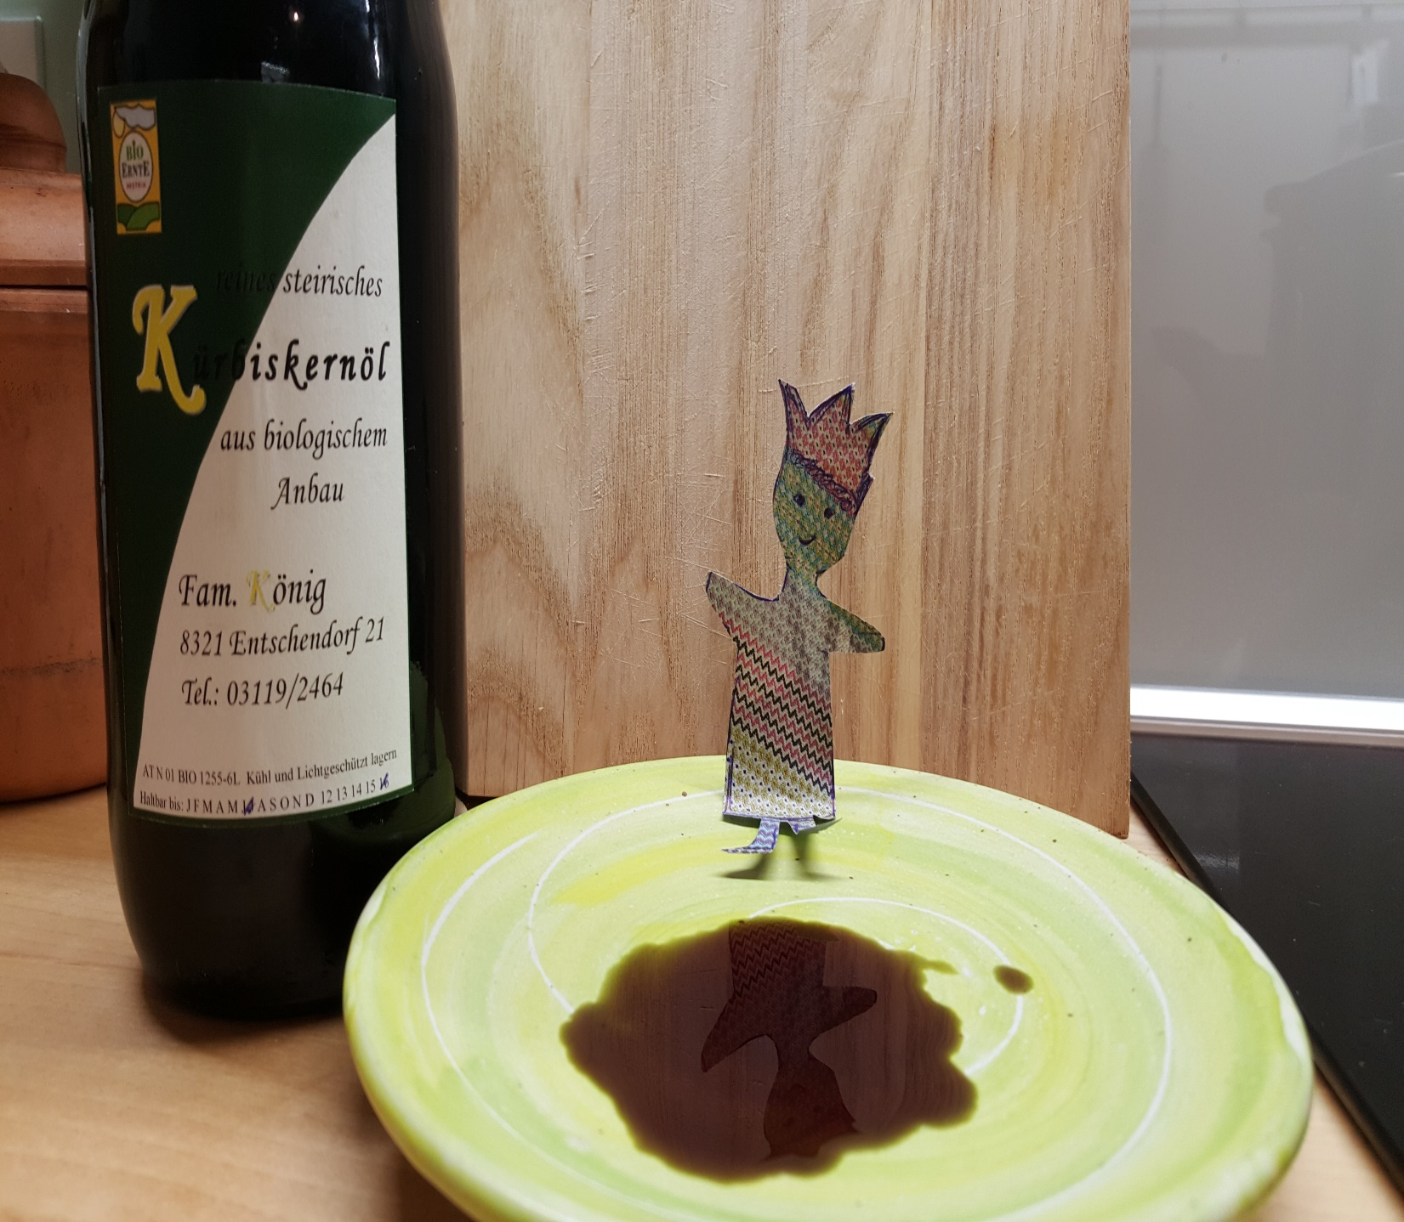
Eric’s Transcultural Experiences
A reading-writing project to prepare you for your exchange trip
Elisabeth Pölzleitner, Jennifer Schumm |  | GIBS and Uni-Graz


  - A reading-writing project to prepare and accompany your foreign exchange trip

Eric’s Transcultural Experiences
Read the story of the foreign exchange student Eric, then discuss the following questions in class:
- At the beginning of the story the narrator says:
“Secretly I had been looking forward to having a foreign visitor – I had so many things to show him. For once I could be a local expert, a fountain of interesting facts and opinions. Fortunately, Eric was very curious and always had plenty of questions.”

However, they weren’t the kind of questions I had been expecting.

What kind of questions would you have expected from Eric?

Eric’s Questions
What kinds of questions do you think Eric actually asked? Look at the pictures taken from the story and speculate what kind of questions Eric might have asked. Write them down on this page. Then discuss possible answers with your partner.
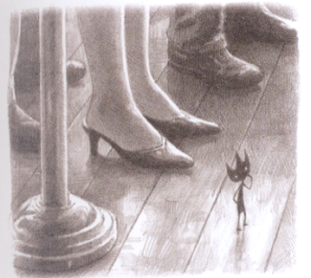
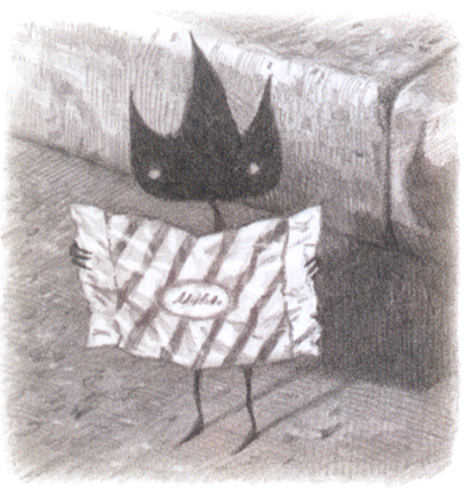
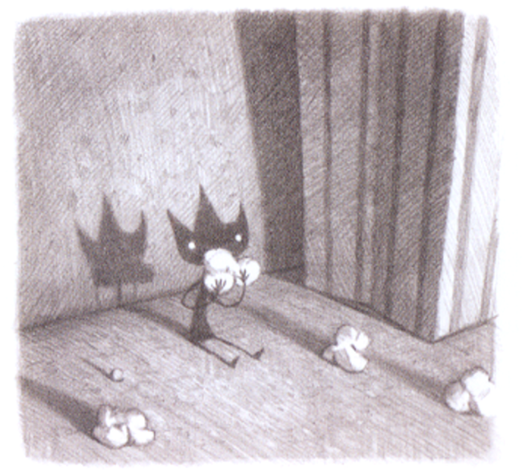

Questions about culture
Eric’s questions are unexpected; they cannot be answered by a guidebook for tourists. His questions refer to “deep culture”, while the typical tourist questions would refer to “surface culture”. Have a look at the cultural iceberg to understand these two concepts better.
The Cultural Iceberg

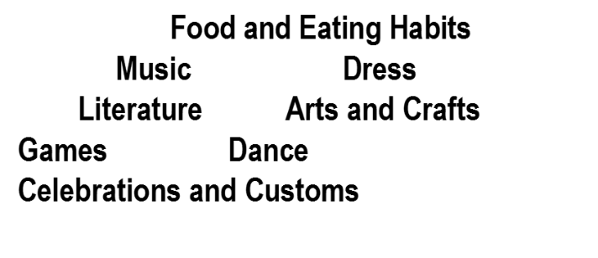

http://www.clipartpanda.com/clipart_images/iceberg-18785260-jpg-18775600

Deep Culture
Surface Culture
role of group and individual
competition or cooperation
gender roles
definition of obscenity
core values

manners and etiquette punctuality and time concept of beauty religious belief
facial expression and eye contact tone of voice
body language and touching cleanliness
showing emotions nature of friendships
attitudes towards elders and children

The cultural iceberg of Austria
manners and etiquette punctuality and time concept of beauty religious belief
facial expression and eye contact tone of voice
body language and touching cleanliness
showing emotions nature of friendships
attitudes towards elders and children

Deep Culture
role of group and individual
competition or cooperation
gender roles
definition of obscenity
core values

What interesting facts and opinions would you want to share with Eric? What questions might Eric ask?
Draw a cultural iceberg of Austria and fill it with keywords of things and ideas that make up Austrian culture. What would you put in surface culture? deep culture?


The cultural iceberg of France/Spain
Now do the same for the country you are going to travel to. Draw your iceberg before your trip and fill in all the things you already know or expect to find. Add, change and correct your ideas after your trip. What would you put in surface culture? deep culture?

Universal, Cultural, Personal
The family explains Eric’s behavior by saying that ‘It must be a cultural thing’.
Culture is only one dimension of human behavior. It is therefore important to see it in relation to the other two dimensions: universal and personal. The three can be seen as follows:
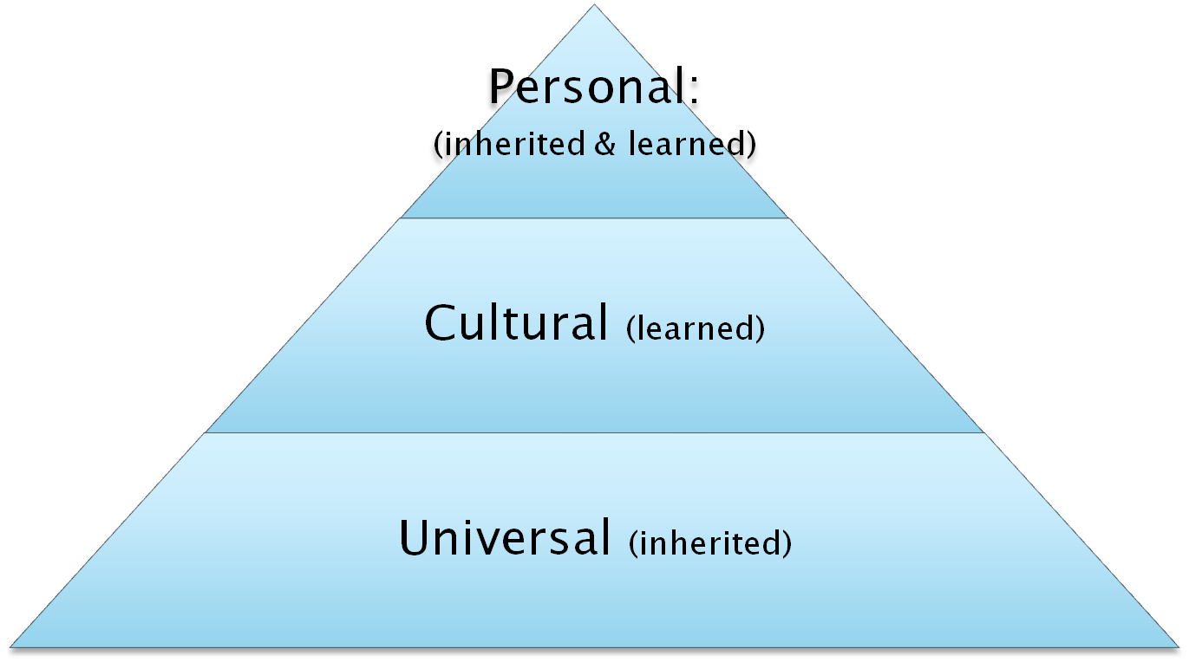
- universal refers to ways in which all people in all groups are the same (e.g., everyone eats, needs friends)
- cultural refers to what a particular group of people have in common with each other and how they are different from every other group (e.g., if people eat with knife/fork, how people make friends)
- personal describes the ways in which each one of us is different from everyone else, including those in our group (e.g., if we decide to only eat with a fork, who we decide to be friends with)

Two things to remember when interacting cross-culturally:
1. Because of universal behavior, not everything about people in a new culture is going to be different; some of what you already know about human behavior is going to apply.
2. Because of personal behavior, not everything you learn about a given culture is going to apply in equal measure, or at all, to every individual in that culture.

- Look at the pictures in Eric and consider his behavior. Do you think everything he does is cultural? Can you find examples of behavior that can be seen as universal? personal? Would you put some of the things he does in two categories? Write your ideas below:
Universal behavior:
Cultural behavior:
Personal behavior:

TIP: When you are abroad, you might want to consider these dimensions.

Saying ‘thank you’.
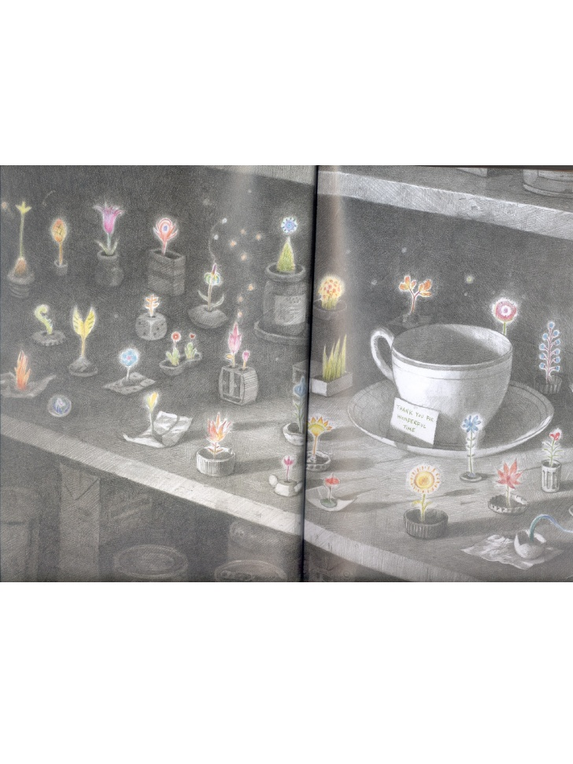
After Eric leaves, the family isn’t really sure whether he enjoyed his stay or not. However, when they open the cupboard where he had slept and studied, they got their answer.
How did Eric say ‘thank you’ to his host family?

Why do you think this page is in color and not black and white?

How do people show their gratitude (Dankbarkeit) in Austria? your culture?

How do people say ‘thank you’ in France/Spain?

How do people show their gratitude in France/ Spain? If you aren’t sure, try looking on line
at: http://www.kwintessential.co.uk/resources/country-profiles.html

Write a THANK YOU CARD for a host family in France/Spain.


Thank your potential host family for your wonderful stay. Include details of what you liked a lot and what you are grateful for. Write your card in English and in French/Spanish. Ask your French/Spanish teacher for any words that you need in order to express your ideas.




Tip: Buy a postcard of Graz and take it along to France/Spain. On the last day of your stay in your host family write them a nice Thank You card, referring to all the little things that you liked in their home. Hide the card in the refrigerator or another place where they will find it after you have left.

Eric in Austria
  - Now it’s your turn to write your own Eric story
Imagine this: After leaving the narrator’s family Eric came to Austria and stayed with you in Graz. Work with a partner and create your own story in the vein of Shaun Tan’s Eric. Decide what you want to show Eric and what he will notice about your life in Austria. Remember: Eric is more interested in the small things of deep culture than in tourist sights and surface culture events.

Step 1: Create your own Eric
Use FIMO to make a little figure, small enough to fit into any bag or cut out the shape of Eric from a soft-drink aluminum can. Take good care of your Eric – you will need him here in Austria and on your class-trip abroad.

Step 2: Planning your story

2.1. Collecting ideas: How others see us…
In order to get good ideas and understand what kinds of things seem interesting and odd to foreigners, interview some new students or foreign exchange students at our school. Ask what they find most interesting, strange or extraordinary about living in Austria. What (big or small) differences have they noticed?
Take notes so you can use this information for your story.

2.2 Slipping into Eric’s mind
Before you start writing, reread the original Eric story. This will help you to slip into Eric’s mind and stay in the same style and vein. The only thing that has changed since the original story is the fact that you and Eric know each other better now. This will help you to describe Eric’s feelings and reactions to new things and ideas in more detail than in the original story. Watch Eric closely as he explores our culture. What puzzles him? What fascinates him? What scares him? What questions does he ask you and how can you answer them?

Step 3: Take pictures of Eric and the little things that he might be interested in.
If you would like to create vintage-style pictures for your story use the program http://apps.pixlr.com/o-matic/ This is an online program – you do not need to download it or register on the website. It is very easy to use and will turn your snapshots into creative, vintage-style pictures. You can choose different styles, overlays and frames.
Tip: your book will look better if you use the same features for each of the pictures.

Step 4: Write your story.
Tip: Describe a few interesting scenes and events in detail. Create an atmosphere. Remember to use the past simple for events and the past progressive to describe the circumstances and the background in detail. Show Eric’s reactions and thoughts and try to answer some of Eric’s questions.

Step 5: Revise and polish
Get feedback from your peers and revise your story carefully. Add your pictures and polish the layout of your book. Upload your finished file to Moodle so your classmates will be able to read it.

Eric in France/ Spain
During your trip abroad collect little details, differences and interesting things that you notice. What are the things that Eric would notice? Take pictures of Eric in different places and situations and use them for the second chapter of your book.
Examples of pictures that I recently took in New York. Unfortunately Eric was not with me.

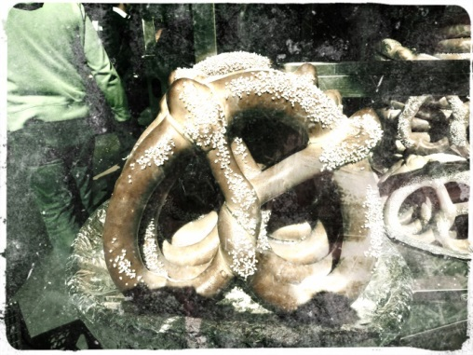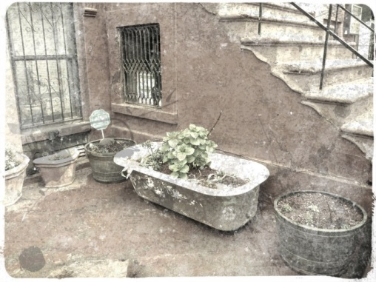

Follow the steps of “Eric in Austria” and create two more stories full of interesting details about your trip abroad that Eric has noticed and “normal tourists” might have missed. Write one of these chapters in English, the other one in French or Spanish. Use your Eric to ask all your secret questions and describe all the little things that you noticed or wondered about during your stay abroad.

- Collect all your ideas and look through all your pictures.
- Decide which parts you want to use for your English chapter and which parts you can easily express in your second foreign language.
- Choose a fitting format: Your “story” might also be written in form of a letter or a diary entry or any mix of these.
- Write your texts and layout them nicely using your pictures.
- Revise your stories carefully after getting feedback from your peers and teacher.

Brainstorming for Eric in France/Spain

English part

French/Spanish part

Publishing your stories

We are going to publish our stories as flipbooks online. All you have to do is:
- Save your polished stories in one pdf file. Use a nice, fairly large font – just like a real picture book.
- Upload your pdf file to Moodle.
- Upload your pdf to https://fliphtml5.com/ and share the link to your awesome flipbook with the class.

Shaun Tan. (2009). Tales From Outer Suburbia. New York: Scholastic BK Services, American edition. pp 8ff
If you prefer you can also write a girl version of the story and call your character Erica.

