The Refugee Experience
  - A reading project to help us understand refugees a bit better




Pictures:
Haeferl: https://roamingryan.files.wordpress.com/2015/09/2013-02-16_-_wien_-_demo_gleiche_rechte_fc3bcr_alle_refugee-solidaritc3a4tsdemo_-_refugees_are_human_beings.jpg
http://www.strathink.net/wp-content/uploads/2015/04/refugees.jpg

The Setting: Maps

Where does your story take place?
Find a map that covers your character’s path and glue it on this page. Mark your character’s path on the map and note interesting events that happened there.

The Conflict
Find some background information about the political and social conflicts in your character’s country of origin.
Choose important and relevant information. Collect your findings on this page and be prepared to share them with the class. Start your search at the Simple English Wikipedia at: https://simple.wikipedia.org/wiki/Main_Page


Getting Help

Background Info
The truth about asylum: Read facts and figures about refugees and asylum seekers. You will find lots of useful information at http://www.refugeecouncil.org.uk/. Collect the main facts on this page and be prepared to share it with the class.

To Leave or not the leave… that is the question
Leaving one’s home is not an easy decision. Before leaving people will think of all the pros and cons this decision entails. Fill in and complete the following mind map for your character (or the person who made the decision on your character’s behalf).
I don’t want to leave because….   |   I should leave because…  Add more thought bubbles yourself….


Email or letter

Your character has finally arrived in a safe place and is planning to seek asylum. In order to prepare for this process your character is going to contact the Children’s Panel Advice Service run by the Refugee Council.
To familiarize yourself with what the Refugee Council does in order to aid children seeking asylum please visit the following webpage.
http://www.refugeecouncil.org.uk/what_we_do/childrens_services/the_childrens_panel_-_advice_service

Write your character’s letter or email to the Children’s Panel Advice Service. In the letter
- explain your present situation,
- your background and the circumstances in your home country
- ask for advice and support in order to be granted asylum
Proofread your letter carefully – you want to show your best in order to convince the officials to help you win your case.


Diary
Imagine that the main character of your story has come to our town and is going to attend our school.
Write your character’s diary after the first day of school. Describe the main events of the day and focus on your character’s personal experiences and feelings in this new environment. How was he/she welcomed? What was new/ strange/ odd/ different? What made him/her feel good/bad?
Tip: To make your diary sound really plausible use specific places, names and events known to us all.
E.g.: …. I was introduced to my new English teacher. Her name is too long and weird to remember, I’ll just call her Mrs. Poe.

Diary continued…

Life can be like an emotional roller coaster…
1Franklin Heujnen on Flickr.com ,30. 09.2015 


Expressive Reading

Find some of the happiest and the saddest moments in your character’s story. Mark them in your book with post its and practice reading them out fluently including verbal and non-verbal expressions. Make sure you convey your character’s feelings in each of the reading passages.
Try these tricks to convey different feelings and meanings:
Speed: go slow or speed up to increase tension
Emphasize important words: use your voice to emphasize important ideas. Try raising the volume of your voice, changing tone and (again) speed.
Dialog: When reading passages that contain dialog use different voices for the characters. Choose a fitting voice for each character and a fairly neutral voice for the narrator.
Facial expression and gestures: Use your facial expressions and gestures consciously to emphasize your message. How would an actor read or speak this text?

 Find a quiet place and play with these tricks to see what works best for your passages.

 Then meet in your group and take turns reading out your passages. Discuss your character’s feelings in these passages.

Good guys and bad guys

In the course of the novel your main character meets good and bad people. Some people were friendly and helpful while others were aggressive, brutal and mean.
Give examples of good and bad people your character has met and design a mind map or a sociogram of these characters. Find passages in the book where each of these characters are described. In addition to their names collect specific details of their behavior and adjectives that describe them.

What if you could turn back time…

In the course of the novel your main character had to make many important decisions that have strongly influenced his/her life.
- List at least five important decisions that your character made.
- What dangers were involved in each of these? What might have happened to him/her if things had gone differently??
- What were the alternatives? What could he/she have done instead?
- What would YOU have done in his/her place?
Tip: In order to practice the use of the right tenses here always write full sentences as shown in the following example:

Decision: After being deported by the police in Iran Enaiatollah decided to cross the mountains into Turkey.
Dangers: He might have frozen to death or he might have died of exhaustion while crossing the mountains into Turkey.
Alternatives: He could have stayed in Iran, hoping the police would not find him again.
My choice: I would have tried to cross the mountains as well but I would have collected more information about the dangers of the crossing in order to be well prepared. I would have bought better shoes and warm clothes at least.

1
2
3
4
5

Vocabulary improvement

Step 1: Collect 5 useful expressions from your reading and design a vocab card for each of them. Do this on your own – you will LATER share your words with your reading group partners.
For each expression design a vocab card similar to the entries in our Language Reference Book. Find 2-3 example sentences. Use Merriam Webster’s Learner Dictionary online. http://www.learnersdictionary.com/
Example:

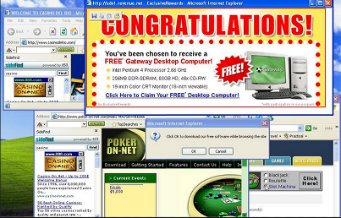
Nuisance
The pop-up ads in my browser are a real nuisance.
Tom made a real nuisance of himself, so the teacher sent him out.
Sorry to be a nuisance, but I forgot my password for Moodle.

Step 2: Get together in your reading group. Share your cards and explain the meaning and usage of each expression to one another. Then play the game Voctivity using these cards. Find the boards, counters and dice on your teacher’s desk.
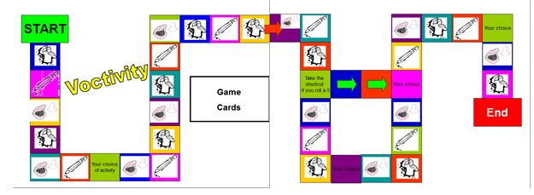

Step 3: After the game transfer all the new expressions and examples into your Language Reference Book /Vocab book. You can do this by copying each other’s cards and gluing them in.

My useful expressions

