
Understanding what it means to be a refugee

Activity 1: Reasons for moving
In pairs write down as many reasons as you can for why people move from their homes.

Activity 2: Now sort those reasons into two different categories:

Reasons people move voluntarily


Reasons people move against their will.

Activity 3: Define the following terms:
- Migrant

- Refugee

- Asylum seeker

- Internally displaced person


Activity 4: Facts and Figures
Go to the UN Refugee Agency website (http://www.unhcr.org.uk/about-us/key-facts-and-figures.html) to find out about the number of refugees across the world and the countries where refugees come from and escape to. Write down some of your findings below.

Activity 5: Watch and listen to refugee stories
Go to http://www.planet-schule.de/wissenspool/seeking-refuge/inhalt/sendungen/seeking-refuge.html# and watch and listen to the story of either Ali, Hamid, Juliane, Rachel, and Navid. Take notes on:
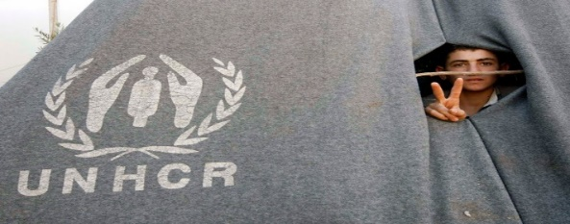
- Where they are from
- Hardships they have faced
- Fears and difficulties in their new countries
- Positive influences on their lives
Take notes on your own paper. Then transfer your information into the diagram below. What do they have in common?

What do they all have in common?

Activity 6: Describing pictures

Describe the following pictures in as much detail as possible.
- What do you see?
- What are the people doing?
- What do you think about the picture?
The following phrases will help you:

In this picture you can see..
The focal point of the photograph is…
In the foreground/ background you can see…
In the top-left /bottom-right (hand corner) there is/ there are…
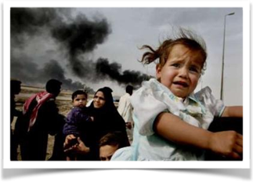
The people in the picture are…
It seems as if…
The woman might want to…
It makes me think of…

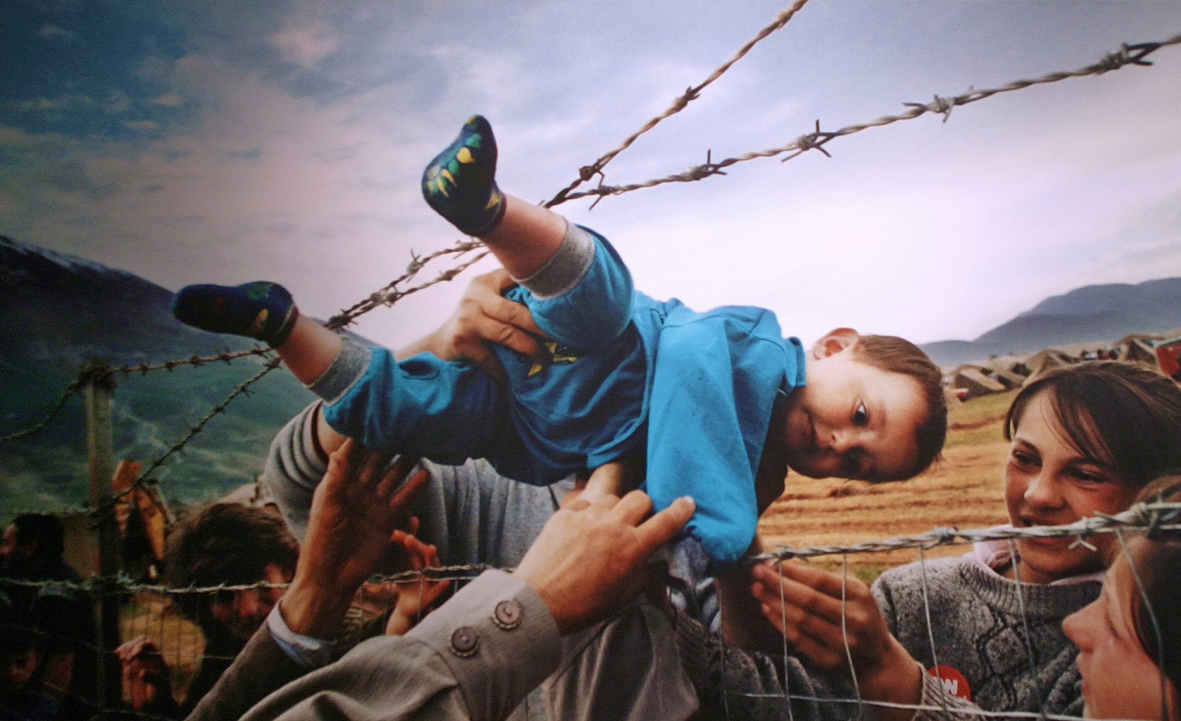


Homework:
Find a recent picture of refugees in a newspaper or online and glue it on an A4 sheet.
On a second A4 sheet describe your picture in detail. Type your text (14pt or 16 pt).
In class we will put up all the pictures and descriptions and try to mach them
Do NOT put your name on the sheets.

