The Refugee Experience Book Choosing
Finding out about the books: Open each of the books on Amazon and read the first few pages.
Title and Author | Setting: Where and when | Main character and his/her problem | Dangers and obstacles | Interest factor  
Refugee Boy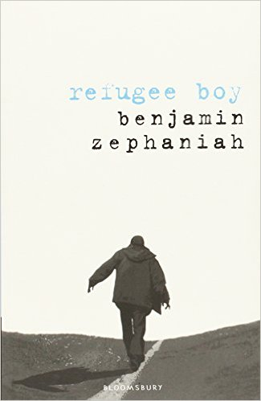
The Breadwinner
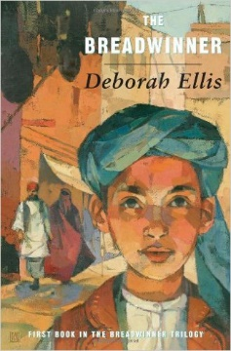
I am Malala

Little Bee
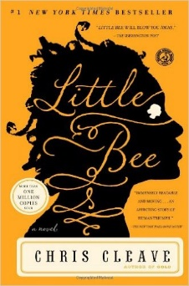
In the Sea there are Crocodiles
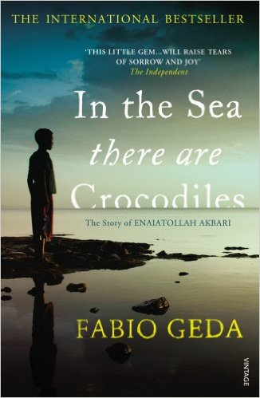
A Long Walk To Water
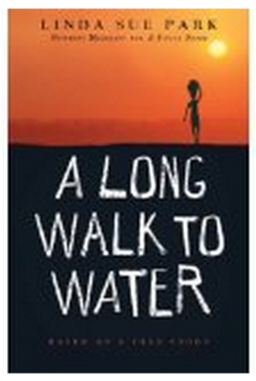

I would like to read the book …………………………………………….. because…

