The Refugee Experience
  - A reading project to help us understand refugees a bit better
All materials downloadable from epep.at
http://epep.at/?page_id=3576



Pictures:
Haeferl: https://roamingryan.files.wordpress.com/2015/09/2013-02-16_-_wien_-_demo_gleiche_rechte_fc3bcr_alle_refugee-solidaritc3a4tsdemo_-_refugees_are_human_beings.jpg
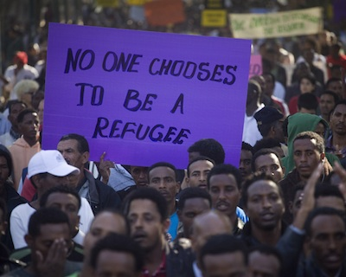
http://www.strathink.net/wp-content/uploads/2015/04/refugees.jpg

