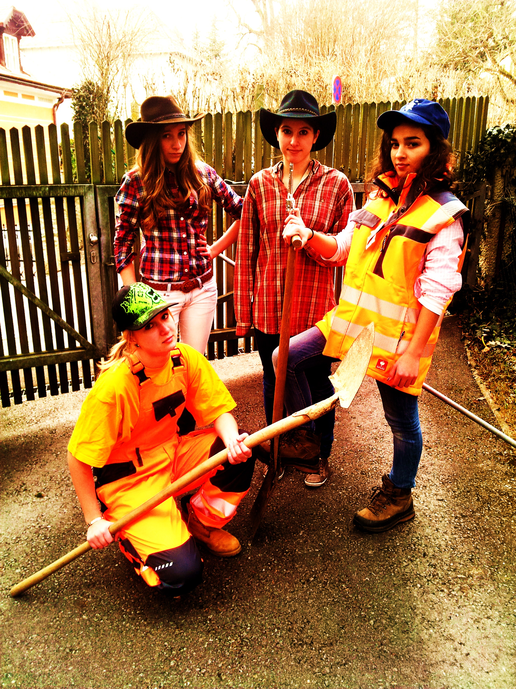

Holes Magazine

TABLE OF CONTENTS


1: Dear Reader
2-3: Interview with Stanley Yelnats

4-5: Camp Greenlake – Guided Tour
6: Surviving Rules


7-8: Character Quiz
9-10: The story of Kissing Kate Barlow

11: Sploosh Recipe
12. Letter toi Stanley’s Mum
13. Plan of Camp Green Lake
14. Stanley’s thoughts while driving to Camp Green Lake


Dear Reader,
So, this is our magazine. It is about the book ‘HOLES’ and we tried to make it very interesting. In the magazine you can read many texts about the book for example diary entries, Newspaper articles and quizzes. I think we did a good job and we hope that you, readers like it and enjoy reading our texts.
Greetings, Laura, Cati Sophie and Hanna ♥♥♥
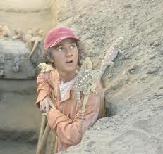
Interview

Reporter: Hello and good morning Mr. Yelnats it’s great to meet you here. How do you feel after this eventful adventure? I mean isn’t it great that everybody knows you now??
Stanley: Yes it’s really a great feeling if everybody knows you and on the streets everybody is showing with their finger on me and whispering to their neighbors: “Oh my god, he’s the one who found the treasure and belongs now to the richest men of the world.” Sometimes some people are also jealous. When My family and I were poor we never thought that we would get rich. But wonder does happen!
Reporter: Do you want to do anything special with the money? For example spend it or build a new house…
Stanley: Oh yes I want to spend some money to camps like Camp Green Lake was. Because I think that the kids there haven’t got enough money to buy better things, like better food. That was the most thing I hated in the camp. The food was really horrible after I lived so long at home and ate the things that my mother cooked. And I will save some money for the helpless people if there is again a natural damage.
Reporter: That are great things. And you can be sure the people will be happy about the money and the help! But you could also get more money if you would tell us your secret why you and Mr. Zeroni had survived about one week in the desert without water? Everybody would like to know that.
Stanley: Well it has to do something with my family history but Mr. Zeroni and I don’t want to tell the secret because if we would tell it to you, probably lots of people would build houses there and the nature is to beautiful to be destroyed!
Reporter: Reasonable reason. And I also heard some rumors that you and Mr. Zeroni were occupied of yellow sprinkled lizards. Is that true because I’ve also heard that if you see one of these creatures you will die?!?
Stanley: Yes it’s not just a rumor it’s the truth! That has also to do something with the water! Mabey we will later sell some of these things that the lizards haven’t bitten us!
Reporter: You will make a lot of money with that! I’ve also heard that you were innocent so you were really free of charge in the camp but I think you won’t regret that you were in the camp?
Stanley: Well it’s great to have much money but I could also live without because I have a very nice great family! But my grand-father always says that there was a curse over my family and that I’ve dissolved it while I was in the camp. It could be true that there was a curse because after I found the treasure my father founded the anti-stinking foot spray also called “sploosh”
Reporter: Probably I don’t believe at curses. But your story does sound very believable. I just will say thank you to you that you’ve taken you time and met us here!

Welcome to Camp Green Lake. Today I will show you the camp of green lake. In this camp boys who have done something bad, have to dig holes to form a good character.
As you can see, the camp has no fences or big walls around it. Do you know why? It is because the place is surrounded by desert. Nobody has ever ran away from Camp Green Lake, they all know the next town is far away and you can´t survive more than two weeks in the desert without water.
100 years ago the desert was a big lake, but it dried out. Now these 10squarekilometers are desert. But let´s start the tour.
- Here you can see the office of Mr. Sir. He is not the boss but the delegate. Mr Sir is a very demanding man and often grumpy.

- This is the dining room. The boys get one warm meal per day, and a packed lunch. The food that the children get is very old and not good at all.

- These are the 6 cottages, where the boys can sleep. There are six cottages, for each group one. The boys sleep in dirty old beds next to each other.
Let´s go on…

- Here you can the shower. This cottage has got no roof (as you can see). There is only cold water and you have only a limited time to shower.

- This is the house of Ms. Warden. She is the boss of the camp. Everybody is scared of her! She can decide who gets punished or not.

- The last cottage is he last we see. This is the last cottage you will see today. It is the so called rack-room. It is a room the boys can relax a bit. As you can see the furniture and the things are very old or broken. But they like it here, because they can play table tennis or watch TV.

Now please go into the bus again. I want you two show you the thumb of god.

- The thumb of god is a mountain, and it is like a little oasis. On this mountain plants grow, and you can find water, fruits and lots of onions there. The mountain is called the thumb of god, because it looks like a big thumbed up.


That was our tour. I hope you liked it, and now you know a little bit more about camp green lake.
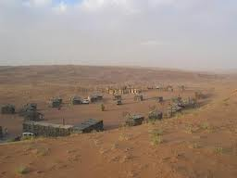

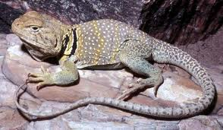
Surviving rules for Camp Green Lake.
- Be careful of yellow spotted lizards and rattlesnakes. If you don’t scare them, they won’t revenge it.

- Don’t disappoint the Warden. She’s the boss. You have to do what she says.

- Save your water. You need it for the whole day.

- Don’t get on Mr. Sir’s nerves. He is responsible for your food and if you make him angry, he won’t give you your cantine.

- Call Mr. Sir Mr. Sir. He wants it this way and I’d better not risk making him angry.

- You have to eat every food you can get. Even though it might taste disgusting, your body needs it for strength and power.

- If you are new in this Camp, you should make sure that you don’t get in trouble with the other boys. Be careful about X-ray. He has his own crew where he’s the boss.

- Each day you have to dig a whole. It must be five feet deep and wide. Measure it with your shovel.

- When you find something, the Warden likes, you get a day off. So, don’t keep anything.

Don’t even think about to run away. You will starve. There’s absolutely no way to survive because the Camp is the only place, which owns water.
Which Holes-Character are YOU ?

Do you often feel
Misunderstood?

Yes Never
Sometimes

If one of your friends turns away from your group and
gets more and more into
another group, are you trying to get him/she back?

Do you care about how people look?

Do you like to play the boss?

No No! Yes
Yes Sometimes
Do you immediately feel bad and apalogize when you notice that you´ve done something wrong?
Yes
Do you like to help and teach people, if they have problems?
Have you a lot of self-confidence?
No

No A little bit Yes
Sometimes Yes Yes No

Do you often fall in love with the guys/girls that your friends don´t like?

Do you always try to look on the bright side of things?

Are you curious and always want to learn new things?

Yes Often Sometimes Always No Never
Yes

Stanley Zero Kate Barlow X-Ray

Stanley Yelnats
You are like the main character of Holes, Stanley Yelnats. You always try to see the bright sides of the way things are and that is a really great attitude. You are always there for your friends and although you don´t have so much self-confidence, you stand up for your and your friends´ rights. You don´t like to get in trouble, so you admit that you´ve done something, even if you´re innocent. Don´t be so shy! You can prove your innocence!

Zero (Hector Zeroni)
You are like Zero. You are smart and you are always open for new things. You are really curious and want to know everything. But you are very spontaneous and you don´t think ahead. At the beginning you are very shy and introverted, but when you get to know someone better, you get open and lovely.

Kissin´ Kate Barlow

You are like Kissin´ Kate Barlow. You are always friendly and happy. Everyone likes you, because of your nice and lovely character. You love to teach other people, and actually you are a very quiet person. But when one of you friends is called names or not accepted from other people, you get really angry and dangerous.

X-Ray
You are like X-Ray. You love to be the boss and control everyone. You try to get many friends, so you will never be alone. But if one of your friends turns away from you, you don´t really care, because you have so many other friends. But be careful, because if you keep this attitude, you will soon lose all your friends!

The story of Kissin’ Kate Barlow


Kate Barlow was also known as “Kissin’ Kate Barlow”. She lived in a village near the green lake where she was a popular teacher. She taught the children and the men in a beautiful little house. But this house was already very old and friable so she asked the charming onion seller if he could fix the holes in the roof. If he repaired the roof he must get the well tasting peaches form Mrs.Barlow. After he finished his work Kate realized that the windows weren’t thick. So he also did that. While he was working he felt in love with her. One afternoon he kissed her and another man who also loved Kate saw them. The problem was: that the onion-seller was black and she white! It was forbidden to love a black guy! The man who saw them was very jealous so he burned Kate’s school down and killed her black-man. While that happened Kate ran to the sheriff to ask him for help. But he was drunk, and he wanted a kiss from Kate before he would help her. She was shocked and ran away.
A few years later, Kate went to the sheriff again and asked him if he want another kiss from her. Before he could said anything she shot him and kissed him, so there was print of her lips because of her lipstick. Then she became a robber. Robbed every bank in Texas. After she killed a person she kissed him to show the people that she was there. She also robbed Stanley’s great-great grand-father Stanley Yelnats the first. Nobody knew where she hid the treasure.
She committed suicide with a yellow-sprinkled lizard.

Kissin´ Kate Barlow´s

Sploosh


Ingredients:


- 29 ounces (ca. 850 g) peach halves, drained

- The syrup of the peach halves
- 2⁄3 cup apple cider vinegar
- 1 cup light brown sugar
- 1⁄4 teaspoon salt
- 8 whole cloves
- 1 cinnamon stick

- 1⁄4 teaspoon ground nutmeg
- Secret Ingredient... 2 onions!!!

Directions:
In a saucepan, combine 2⁄3 cup of the peach syrup with all the
other ingredients except the peaches. Don’t forget the secret ingredient! Simmer uncovered for

10 minutes.
Pour over peaches. Cool, then cover and chill for at least 24
hours.
Bring to room temperature and eat. Any leftover peaches will
keep in the refrigerator for a week.

Dear Mum, 
I have to tell you something. All the things that I wrote in my letters, about swimming and climbing, are not true. I am so sorry that I lied to you, but I had to. The warden (the boss of the camp) checked our letters if we are writing something bad about the camp. But now I want to tell you the truth.
Camp green lake is not a summer camp at all! We have to dig holes to build good character again. It is stupid. The wholes have to be exactly 7meters deep and 7 meters wide. We have to dig one hole per day. We are working in the dessert and it´s extremely hot, because there are no trees to give shade. We have to get up at 5 in the morning, and then we get a breakfast, including an old toast and orange juice. No warm lunch, just a packed lunch and sometimes a disgusting tasting hotpot for dinner. The first week was terrible for me. I was not used to the high temperatures. My hands were bleeding, because the handle of my shovel was so rough, that I always ripped them open. By the time I got used to those bad conditions.
Here in the camp are more than 50 boys, who have committed a petty crime. I am in group with ten other boys. They are not my best friends, but really okay. I don´t like X-ray, he is the leader of our gang and thinks he is the best. I like Zero. He is an orphan and the youngest of our group. The boy can´t read and write, because of that everybody makes fun of him. I have compassion with zero, now I try to teach him. We also have an adult who is responsible for our group, his name is Mr. Pendesky. He is quite nice, but I hate Mr. Sir. He thinks he is the boss, but he is just the deputy. Mr. Sir always shouts at us. Warden, she is the boss of camp green lake. Everybody knows her and is scared of her, because she can decide who gets punished, and who not.
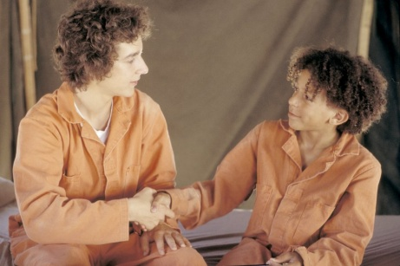
I hope you get the letter! And don`t be concerned about me. I will survive her, and soon I will be home again. I love you. Stanley
Me and my friend Zero
Me and my group


So…… I’m sitting here in the bus, driving to Camp Green Lake. Oh Gosh, I don’t know what to expect. Everything began a few weeks ago. I was just walking home from school when suddenly; a pair of shoes fell onto my head. You have to know that my father is trying to invent a way to recycle sneakers and when those old dusty ones fell onto me, I thought that he could maybe use them for trying out things and so I took them with me. What I don’t know until now is, why I ran away with them. After a few minutes, I heard a voice shouting: “The shoes, the shoes! The boy has them!” I wondered and suddenly, I felt pain. What to do? Tell them, they fell onto my head? Tell them, that I ran away with them even though they just fell on my head?! Although I tried to explain the truth, nobody believed me. That was again typical because of my no-good-dirty-rotten-pig-stealing-great-great-grandfather. Yeah, it sounds funny but he had been cursed years ago and now all of my family is suffering to this curse. Well, the story I told you hasn’t finished yet. So, I and my family went to the judge to decide my charge and it came out that I’d either go to jail or to ‘Camp Green Lake’. So, fortunately, I decided to go to the Camp to ‘build character’ as the judge said. Well, I haven’t been to a Camp before, so as I said, I don’t know, what to expect. Hopefully, it won’t be too silly. But I, Stanley Yelnats go through this now.

