Crossing Borders: Reading Project

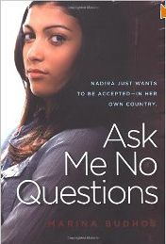 | Somebody:  Wants:  Something:  But:
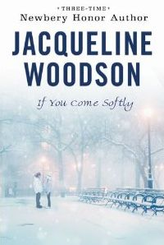 | Somebody:  Wants:  Something:  But:
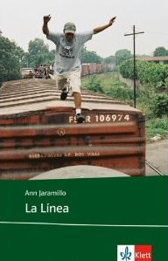 | Somebody:  Wants:  Something:  But:
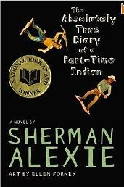 | Somebody:  Wants:  Something:  But:

Who am I?

My cultural autobiography
How would you define yourself? Think about things that are especially important to you in how you think about yourself and how you like others to see you. Think of your family background, your country, community, language(s), groups you belong to, activities that are important to you. Start by putting a few keywords in the box below:

Then write about yourself.

My Language-Self -- My Cultural-Self
The languages that you speak are an important part of you and your cultural identity. What languages do you speak? How well and how often do you speak them? In what circumstances and situations do you speak them? Choose a color for each of your languages and decide where in your body they are located. Add more colors and symbols for other aspects of your cultural-self. Do you feel like a “SteirerIn”? A GIBS student? A Boy/Girl Scout?... Where in your body do you want to put these symbols and colors? Label your drawing and be prepared to discuss it in class.
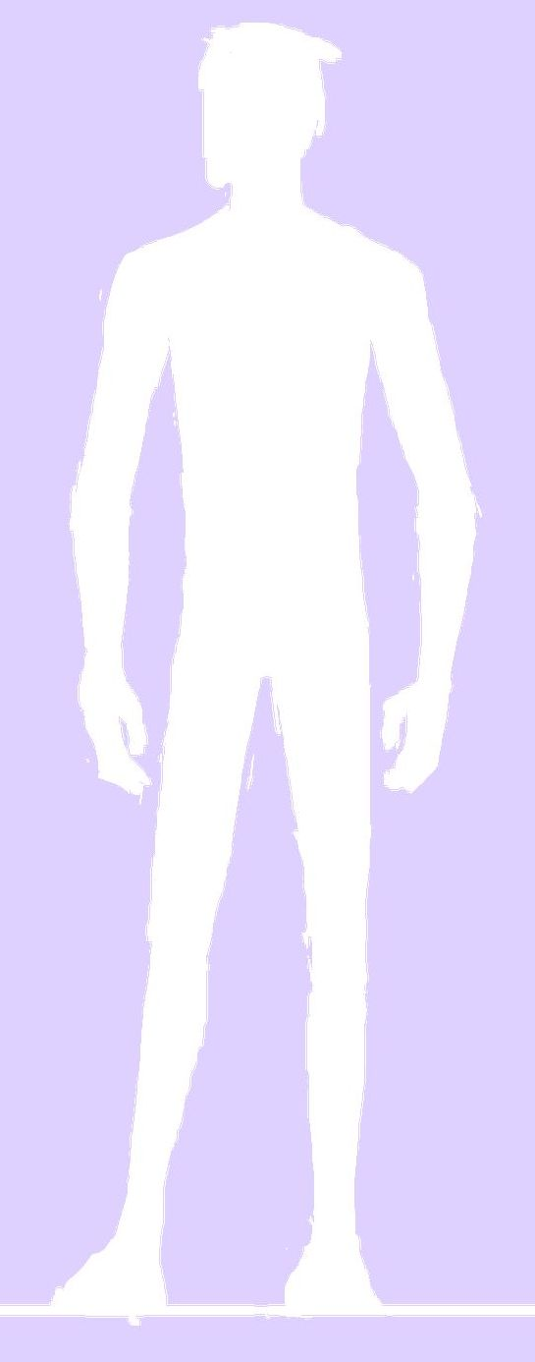

An Intercultural Encounter
You have certainly met people from very different cultures and backgrounds. Think of a specific incident where you had such an intercultural encounter and describe it briefly. Tell us who/where/when… you met the person(s). What was your first impression? How did you feel about it? What did you find out later?

What I know, think and have heard about…
People from Bangladesh

People from Mexico

Native Americans

Americans

Canadians

Turkish people

Start reading your book…
The topic of our reading project is CROSSING BORDERS. In each of the books you will find characters who are crossing borders. Some of them have moved into a new country or culture, others have moved to a new school or neighborhood and find themselves in a different ethnic, social or religious group. We will explore how the characters deal with these difficult situations. Mark all the instances where the main character in your book crosses any “borders”. Use the table below to record your findings.
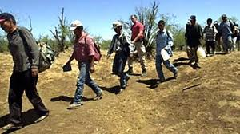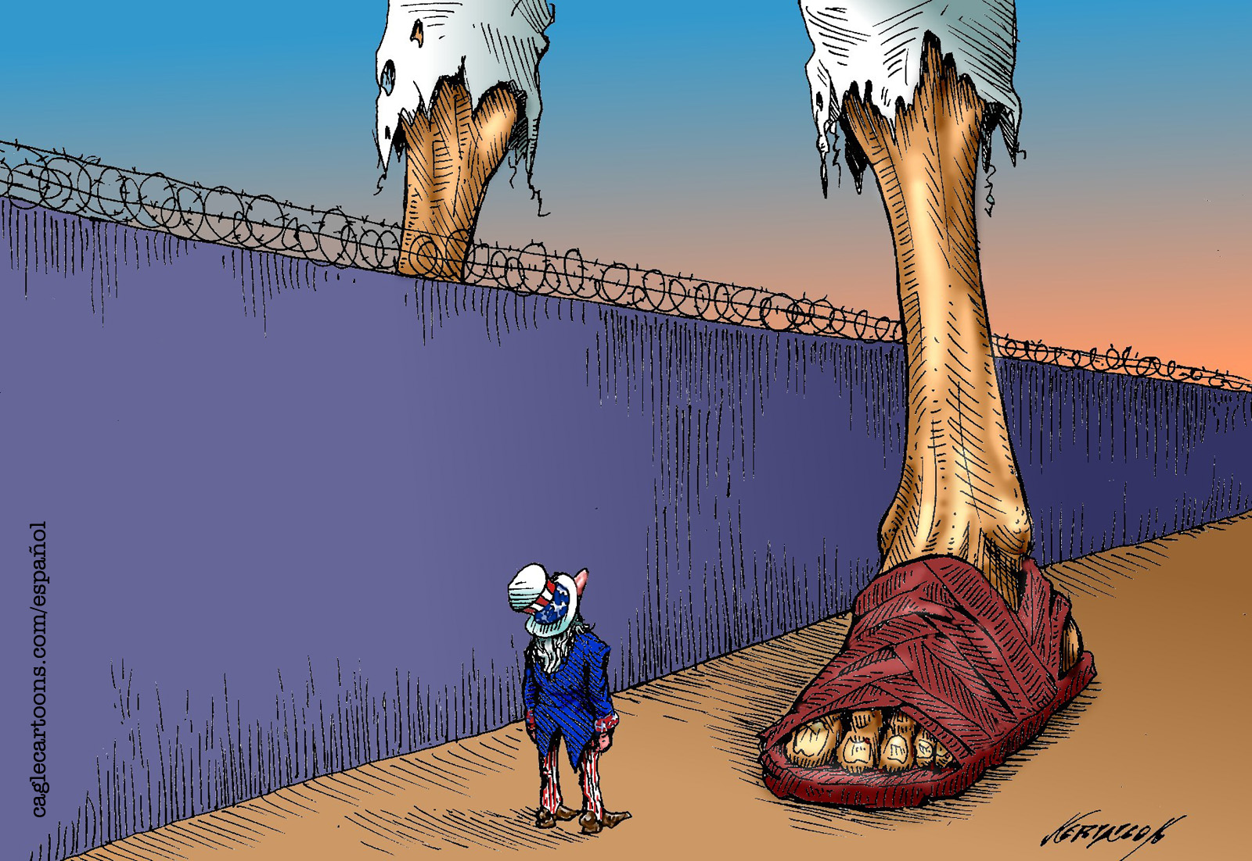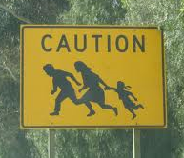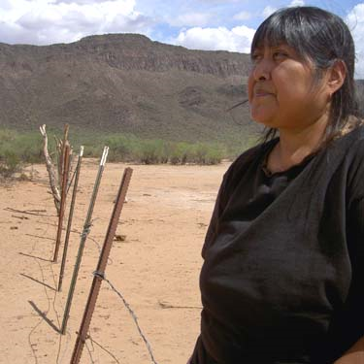
Type of border: (country, reservation, new school, new culture, race, ethnic group,…) | How is the character welcomed in the new environment?  Does he feel accepted/like an outsider/scared/curious/… | Evidence in your book/  Page number

The future belongs to those who believe in the beauty of their dreams
THE STUFF THAT DREAMS ARE MADE OF…….
Step 1: My views…
Each of the following key words appears in your book. Before you start reading, jot down what they mean to you, give an example from your life or say how they make you feel.

HOPE
DREAM
STRANGER
BEAUTY
TO BE IGNORED
SECRET
TRUTH

LONELY/ LONLINESS

Step 2: My character’s views…
Reality is wrong. Dreams are for real.
Tupac Shakur
Then collect your character’s views on these topics. Make a note of when the words come up in your book—again looking for examples and how the characters felt. Use key words and write down the page number where you found them.
HOPE
DREAM
STRANGER
BEAUTY
TO BE IGNORED
SECRET
TRUTH

LONELY/ LONLINESS


Stereotype Detectives
Every culture creates stereotypes about other cultures. The books you have read contain many examples of both positive and negative stereotypes. Chart the stereotypes that you find throughout the book. Try to find both positive and negative ones for each topic. Don’t forget to write down where you found the examples.
TOPIC | Chapter or page | Negative Stereotype | Positive Stereotype
dwelling
(where and how they live)

language
(how do they communicate with others-both in their group and outside)
physical appearance (generic look, clothes, exaggerated features, how they move, sit, stand…)
compared to other Americans, minority members in your book are... (smarter, more athletic, lazy,etc.)

My culture – their culture
In your book you see some characters living in a very different culture or place. What have you learned about their culture and how does it compare to your own life? Fill in the following Venn-diagram. In one circle you write important things about your own life, in the other circle you write important things about your character’s life. Use the overlapping parts for the things you have in common.
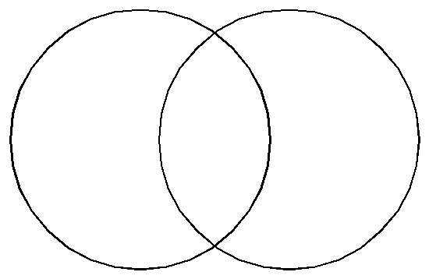

Story Pie
On an extra sheet make a list of 8 important events in your story. Then put them in the correct order and write them into the 8 pieces of the pie. Write the title of the story in the middle.

Start here…

Constellations
First make a list of all the characters that you can remember in your book.

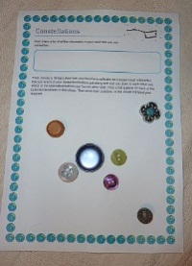
Then choose a fitting button from your teacher’s collection to represent each character. Discuss which of your characters/buttons get along well and are close to each other, and which of the characters/buttons are “on the other side”. Find a fitting place for each of the buttons/characters on this sheet. Then draw their positions on the sheet and label your diagram.

Group Discussions
Find the youngest member in your group. He/she will be the LANGUAGE POLICE for this activity. Make sure you use ENGLISH ONLY in your discussions.
Work with the little discussion cards provided by your teacher. Discuss each topic in detail. After each activity write a few sentences about your results on this page.

Presentations

Novel Museums
For the Novel Museum imagine that the characters in your book were REAL people. Our town wants to make their stories public and has, therefore, dedicated a whole room in the museum to these people and their stories. There they show real artefacts from your characters’ lives. These objects are presented nicely in showcases and on tables around the room. Each of the objects has a label explaining the importance of the item, where it is from and what role it played.
In your museum display you might show some of the following things:
Maps, short newspaper articles about what happened to your characters, diary pages, letters, objects they used during their adventures, photos, clothes they were wearing, favorite items of your characters….. or any other things that play an important role.

Our presentations will take place on December 16th in periods 2 to 5.
You will be presenting your books in front of your class and a group of students from Graz University. These students will also give presentations on the same books. We will then have open discussions and get to know one another better.
For your presentations plan several interesting and creative activities.
Each group should have the following parts:
- Who is who? (posters, acting out, character bags…)
- What’s the story? (plot on the line, plot mountain, storyboard, story pie…)
- Where does it play? (map, background information…)
- Novel Museum: see instructions on the right.
- Any other ideas are highly welcome.

My Culture – Your Culture
On our presentation day we will also share different cultural experiences and customs with our guests. Work with a partner and decide on one typical thing you would like to present about your own culture.
Ideas box:
- How you celebrate Christmas in your family
- How you celebrate birthdays in your family
- How you celebrate another big holiday in your family
- Traditional clothes you wear at special occasions
- Traditional foods you prepare for special occasions
- Traditional decorations you make for special occasions or holidays
- Objects and symbols that are important in your culture
- Any other ideas…

My Language-Self – My Cultural-Self

The languages that you speak are an important part of you and your cultural identity. What languages do you speak? How well and how often do you speak them? In what circumstances and situations do you speak them? Choose a color for each of your languages and decide where in your body they are located. Add more colors and symbols for other aspects of your cultural-self. Do you feel like a “SteirerIn”? A GIBS student? A Boy/Girl Scout?... Where in your body do you want to put these symbols and colors? Label your drawing and be prepared to discuss it in class.

