Crossing Borders
  - Crossing Borders: Using Young Adult Literature to promote intercultural competence in Task-based Learning
‘Don’t judge a man until you have walked two moons in his moccasins.’
(From Walk Two Moons by Sharon Creech)
Speaking a foreign language can obviously open doors and allow us to see the world through different eyes. After a strong wave of communicative language teaching that mainly focused on speech act and discourse competence, educators around the world are becoming increasingly aware of the fact that being a competent non-native speaker of a foreign language involves more than knowing all of the grammar rules, possessing a wide vocabulary of the respective foreign language and having native to near native fluency (Lázár & al, 2007, p. 5). In line with recommendations of the Common European Framework of Reference for Languages (Council of Europe, 2001), they see the ever increasing need for developing their language learners’ intercultural competence in today’s globalized world. In doing so, language learners are not only equipped with the necessary linguistic tools but are also able ‘to promote mutual understanding and tolerance, respect for identities and cultural diversity through more effective international communication’ (Council of Europe, 2001, p. 3). Literature has long been seen as a rich medium to impart knowledge about cultural issues in the language classroom. The aim of this paper is to show how taking a task-based approach to literature, more specifically young adult literature (YAL), can be used to enhance language learners’ (aged 13 -16) intercultural competence. This paper is divided into two parts. The first part provides a brief theoretical framework while the second part presents tasks which can be used together with YAL to develop teenage learners’ intercultural competence.

Defining Culture
Traditionally the teaching of culture in most school curricula has been associated with literature, arts, music, geography, history and institutions. This understanding of culture is often described as ‘big C’ culture and has played a prominent role in the language classroom due in part to a ‘clearly identified curriculum of topics to be covered, and textbooks which deal with them (Tomalin & Stempelski, 1993, p. 7). However, as Seelye (1993, p. 16) observes, ‘[t]his narrow definition of culture, unfortunately, does not fully prepare a student to understand the wide range of behavior exhibited by other species’. Therefore the teaching of culture must be understood in a broader sense, which in the literature is often referred to as ‘little c culture’. This conception of culture ‘includes elements that are perhaps less visible and less tangible and have no traditional subjects assigned to them in schools’ (Lázár & al, 2007, p. 7). It ‘is often described as subjective culture, as people’s everyday thinking and behavior, or as the common traditions, practices, and customs of people’ (Wintergerst & McVeigh, 2011, p. 8). In this paper, the term culture will be used primarily to mean culturally-induced behaviors, customs and values. The authors have found that a task-based approach to YAL allows them to combine culture and language in the foreign language classroom and thus contribute to developing their language learners’ intercultural competence.

Intercultural Competence in Language Teaching
Michael Byram’s approach to intercultural competence, which is a component of his comprehensive intercultural communicative competence model, has strongly influenced the teaching of culture in the language classroom. It was particularly designed for the purpose of language teaching where ‘both culture-general and culture-specific dimensions, are equally important” (Risager, 2009, p. 27). The model also lends itself nicely as a set of teaching objectives which can be drawn on in the development of tasks for reading and responding to YAL. Byram’s five dimensions of intercultural competence are,
- “Attitudes: curiosity and openness, readiness to suspend disbelief about other cultures and belief about one’s own.
- Knowledge: of social groups and their products and practices in one’s own and in one’s interlocutor’s country, and of the general processes of societal and individual interaction.
- Skills of interpreting and relating: ability to interpret a document or event from another culture, to explain it and relate it to documents from one’s own.
- Skills of discovery and interaction: ability to acquire new knowledge of a culture and cultural practices and the ability to operate knowledge, attitudes and skills under the constraints of real-time communication and interaction.
- Critical cultural awareness/political education: an ability to evaluate critically and on the basis of explicit criteria perspectives, practices and products in one’s own and other cultures and countries.” (Byram, 2000)
These elements of intercultural competence will be referred to again later in this paper when we present various tasks which can be done with YAL to raise teenage learners’ intercultural competence.

Selecting Literature
Deciding on literature appropriate for enhancing intercultural competence in the language classroom for 13-16 year olds can be quite difficult as language teachers often find themselves being forced to compromise either on the language or content level. Abridged or simplified texts are often recommended. However, Rönnqvist and Sell (1994, p. 126) have found through their English program with Swedish-speaking Finnish children that many abridgments or simplifications lack in providing subtle cultural nuances and are often criticized by teenage learners due to the simple language used. Their experience has shown that YAL, which can be defined as novels written specifically for a young adult audience, finds resonance with teenage language learners. Our own experience with Austrian high-school students strongly corroborates these findings. Teenage learners identify strongly with the protagonists of YAL stories and want to use the same authentic language as these characters.
Since the aim of this paper is to present a task-based approach to using YAL for enhancing young adult language learners’ intercultural competence, we will only briefly cite the reasons why this type of literature has been selected. Firstly, teenage novels written in a foreign language present life in unfamiliar environments as experienced by characters that are the same age as the teenage language learners. This experience is often heightened by the fact that most YAL is written from the first person perspective (Wu, 2008). By looking at a world different to their own through the eyes of a young person, teenage language learners are invited to reflect on their own world/culture, which is vital in developing their intercultural competence (Rönnqvist & Sell, 1994, p. 129). Secondly, teenage language learners can acquire first hand cultural insights into the cultures of other teenagers that they might otherwise never have the chance to encounter. In this way, YAL can provide them with valuable cultural knowledge and thus expand their understanding of the world. Finally, Rönnqvist and Sell have found that young adults enjoy the ‘up-to-date’ language used in YAL (ibid: 127). Thus teenage readers are also introduced to the contemporary language used by the target culture which provides them with a language ‘as genuine and undistorted as can be managed in the classroom context’ (Collie & Slater, 2000, p. 3). Since language, culture and thought are closely intertwined, according to Kramsch (1998, p. 3), we can say that the language used in YAL ‘expresses, embodies and symbolizes cultural reality’ of the target culture.
Based on our experience with using YAL to enhance young adult learners’ intercultural competence, we have found that certain criteria should be considered when selecting it. Bredella (Bredella, 2000, p. 378) recommends using ‘post-colonial and minority texts because these often dramatize intercultural conflicts and reveal causes for misunderstanding and misrecognition of others’. Reading novels with characters from various cultural backgrounds is a helpful way for teenage language learners to notice more easily differences but also similarities. Ghosn (2002, p. 177) adds that the characters should be presented ‘in contexts that accurately reflect the culture of the English-speaking world today’ and that the stories ‘mirror the prevailing cultural values and traditions of a people, and avoid stories that portray outdated customs and beliefs’. In other words, the literature should be representative of the given contemporary society portrayed so as to provide young adults with ‘a feel for the codes and preoccupations that structure a real society’ (Collie & Slater, 2000, p. 4).

A sample YAL project: Crossing Borders
The following section describes a sample YAL project carried out with a class of 13 to 14 year old EFL students in Austria in which a selection of tasks where used in conjunction with YAL to promote intercultural competence. The project was entitled “Crossing Borders” in order to highlight the various borders the young protagonists in the novels must cross on their journey to discovering their cultural identity. These borders can be understood literally, like neighborhood, country or state borders but can also be interpreted figuratively like linguistic, racial, religious, gender, social, ethnic and educational borders.

The main teaching objectives of this project were:
- to acquire knowledge of the lifestyles, problems and practices of the social groups represented in this project;
- to challenge the learners’ attitudes including their preconceived notions and stereotypes;
- to develop learners’ curiosity about new cultures and experiences as well as about their own;
- to promote learners’ empathy towards others
- to interpret the various ‘borders’ the characters cross on their way to discovering their cultural identity;
- to critically evaluate immigration laws in the US as well as in their home country.
The following 5 young adult novels were used in the project and will be referred to in the various tasks presented below. The students were only required to read one of the books for the project, which they chose based on personal preference. They read their novels prior to completing the tasks.
- Sherman Alexie, The Absolutely True Diary of a Part-Time Indian
- Marina Budhos, Ask Me No Questions
- Ann Jaramillo, La Linea
- Melissa Schorr, Goy Crazy
- Jacqueline Woodson, If You Come Softly
Further suggestions of books can be found in the appendix.
Getting Started
On the first day of the project, the students were given a copied project-booklet including all 13 tasks which they would be required to do both individually and in small groups. The tasks are presented below. For each given task student instructions are provided, followed by teachers’ observations and reflections on teaching goals around the field of intercultural competence. Tasks 1-3, 5 and 7 in the project focus on the learners’ personal cultural experiences and identity while tasks 4, 6 and 8-13 deal with questions about the book-characters’ experiences. By comparing these two perspectives, it was hoped that the language learners would gain a better understanding of the personal and cultural ‘borders’ the protagonists had to overcome in an age-appropriate way.
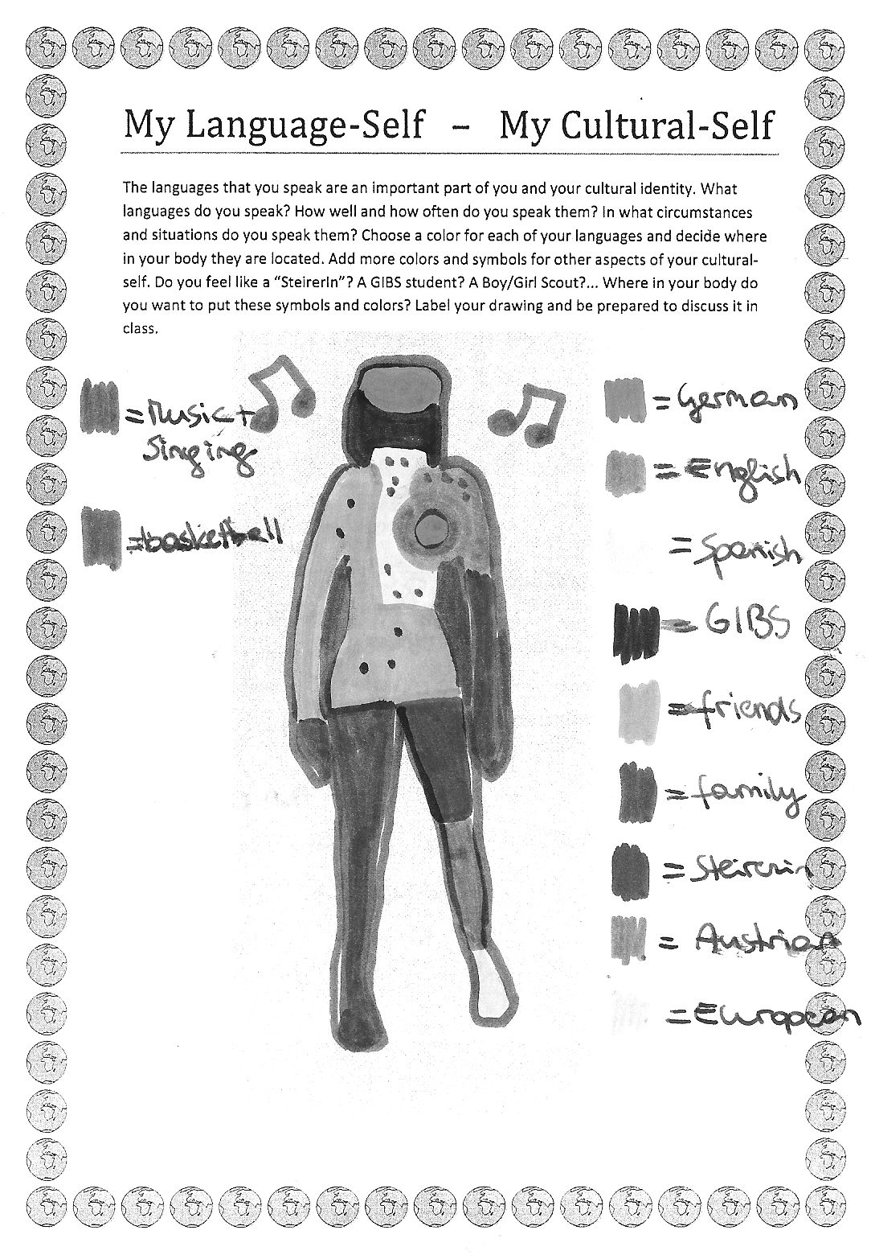
Task 1: Who am I? My cultural autobiography
How would you define yourself? Think about things that are especially important to you in how you think about yourself and how you like others to see you. Think of your family background, your country, community, language(s), groups you belong to, activities that are important to you. Write about one page.
Task 2: My Language-Self – My Cultural-Self
The languages that you speak are an important part of you and your cultural identity. What languages do you speak? How well and how often do you speak them? In what circumstances and situations do you speak them? Choose a color for each of your languages and decide where in your body they are located. Add more colors and symbols for other aspects of your cultural-self. Do you feel like a typical Austrian? A Boy/Girl Scout?... Where in your body do you want to put these symbols and colors? Label your drawing and be prepared to discuss it in class.
Figure 1: My Language-Self
Teachers’ Observations: Tasks 1 and 2 were challenging for the students because for most of them, their social and cultural environments had never been presented in such an explicit way. By making these environments visible and sharing them in the class, many teenage learners noted that their self-concepts were quite different even among the majority who had a local, Austrian background. An interesting observation is that those students who were foreign born or had multi-cultural backgrounds had fewer difficulties with these tasks. This could be due to the fact that many of them had already had experiences that had made them more strongly aware of their cultural identity. Task 2, especially, seemed to develop the learners’ curiosity about their cultural self. Many commented that being different and finding more than one “color” in themselves made them feel special and proud rather than embarrassed about their differences.
Task 3: Intercultural Encounter:
You have certainly met people from very different cultures and backgrounds. Think of a specific incident where you had such an intercultural encounter and describe it briefly. Tell us who/where/when… you met the person(s). What was your first impression? How did you feel about it? What did you find out later?
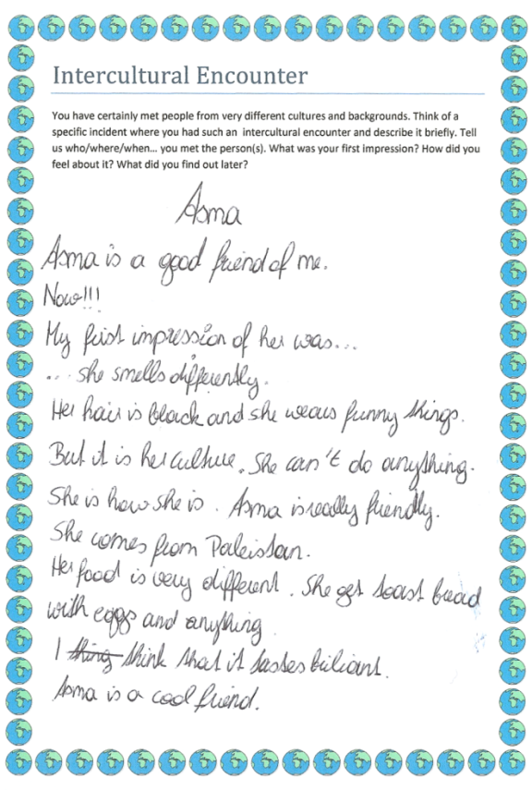
Teachers’ Observations: While tasks 1 and 2 focused on defining the learners’ cultural identities, task 3 required them to leave their familiar environments and describe an intercultural encounter. The learners expressed a wide range of emotions from surprise or fear in the face of strangers to sadness about feeling like outsiders themselves in their texts. Due to the nature of the task, many students focused on the differences and the unexpected things that they had experienced. For example, they described situations where they had met people that acted in uncommon ways or where they felt like outsiders themselves.
The texts were also discussed in class which provided the students with a forum to voice their fears and preconceived opinions about strangers as well as misunderstandings and misconceptions about different cultures. By addressing these issues in the classroom setting, it could be observed that many students began to question the various conclusions that had been drawn about other cultures and display an openness about those different to themselves.
Figure 2: Intercultural Encounter
Task 4 Start reading your book:
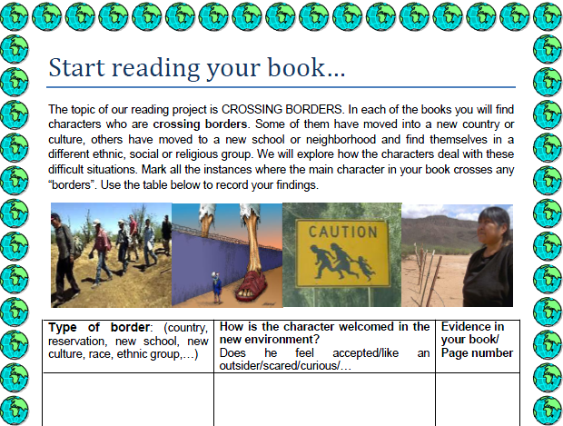
The topic of our reading project is CROSSING BORDERS. In each of the books you will find characters who are crossing borders. Some of them have moved into a new country or culture, others have moved to a new school or neighborhood and find themselves in a different ethnic, social or religious group. We will explore how the characters deal with these difficult situations. Mark all the instances where the main character in your book crosses any “borders”. Use the table below to record your findings.
Figure 3: Start reading
Teachers’ Observations: In this task the learners had to identify the various borders that the characters in their books crossed and evaluate how those characters felt every time they found themselves in a new place. Many students noted that the characters felt unwanted and like outsiders; many suffered from some kind of discrimination. For example, the young Native American protagonist in ‘The Absolutely True Diary of a Part-time Indian’ decides to cross the border of his reservation in order to attend a predominantly white high school in a nearby town. Students noted how he felt when he arrived at his new school and how he was also greeted when he arrived back on the reservation. This task helped students to identify the various borders which the characters had to cross on their way to seeking their cultural identity. This task also helped to enhance students’ understanding of the concept of immigration and the effects of immigration laws as the main characters in the novels ‘Ask Me No Questions’ and ‘La Linea’ both have difficulties with crossing borders to the United States.
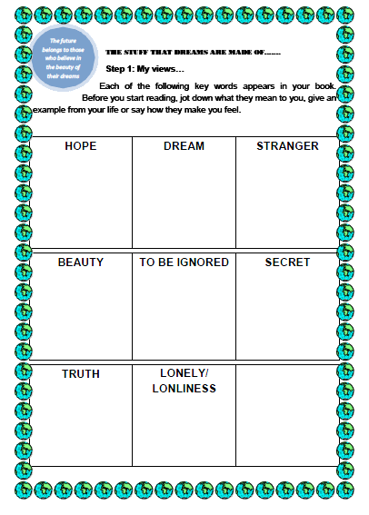
Tasks 5 and 6: Hopes and Dreams
Each of the following key words appears in your book. Before you start reading, jot down what they mean to you, give an example from your life or say how they make you feel. Write down as many ideas and keywords as possible.
Hope / Dreams/ Stranger/ Beauty/ To be ignored/ Secret/ Truth/ Loneliness
Then collect your character’s views on these topics. Make a note of when the words come up in your book—again looking for examples and how the characters felt. Use key words and write down the page number where you found them.
Teachers’ Observations: In tasks 5 and 6 the learners compared several key concepts in the novels with their own personal views and experiences. The students first looked at their own associations with each key-word and then analyzed the same concepts from a specific character’s point of view. It was observed that the students often noticed a big difference between their own rather ‘comfortable’ lives where dreams can come true and hopes can be fulfilled and the difficult lives of the book characters, who struggle with feelings of loneliness and unfulfilled dreams. When discussing the task in class, the teenagers often expressed feelings of empathy with the protagonists and wondered why they had to struggle so hard to be integrated into their given environments/societies. Some students also remarked that the teenage characters in their novels are very strong characters who find creative ways out of their crises. The students seemed to like the fact that even in adverse situations, the characters did not surrender.
Figure 4: Hopes and Dreams
Tasks 7 and 8: Stereotype Detectives
What I know, think and have heard about…
Quickly write down your first thoughts about Americans, Canadians, Native Americans, Mexicans and people from Bangladesh.
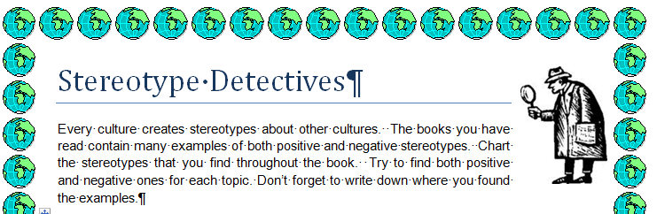
Stereotype Detectives: Every culture creates stereotypes about other cultures. The books you have read contain many examples of both positive and negative stereotypes. Chart the stereotypes that you find throughout the book. Try to find both positive and negative ones for each topic. Don’t forget to write down where you found the examples.
Figure 5: Stereotype Detectives
Teachers’ Observations: Tasks 7 and 8 dealt with the topic of stereotypes which the students were already familiar with; however, some were surprised by the outcome of the tasks. Task 7 required the learners to consider their personal associations with the cultural groups in the novels while task 8 asked the students to take a step back and evaluate stereotypes in the books they read. As teachers, we observed that the first task was quite revealing for the students because it was often hard for them to explain why they held these stereotypes. When comparing the stereotypes found in the novels with the learners’ personal lists, many students found it comforting that they found similarities. Both tasks seemed to make the students start to question stereotypes and it was often commented on how easily people in general are influenced by them.
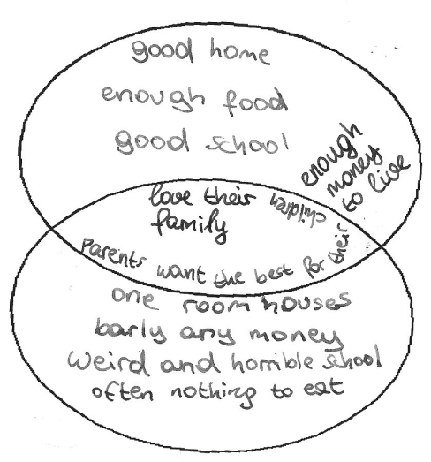
Task 9: My culture – their culture
In your book you see some characters living in a very different culture or place. What have you learned about their culture and how does it compare to your own life? Fill in a Venn-diagram. In one circle write important things about your own life, in the other circle write important things about your character’s life. Use the overlapping parts for the things you have in common.
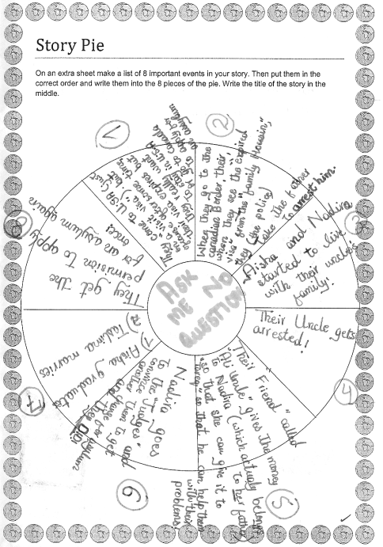
Teachers’ Observations: This task required the students to look for relevant similarities and differences between themselves and the characters in the books. The most interesting outcome of this activity was that almost all of the students found that irrespective of their differences, they all shared the same hopes and dreams with their protagonists. For example, they want to be safe, have a family as well as good friends whom they can trust. This task seemed to challenge the students’ attitudes as well as raise their curiosity about other cultures.
Figure 6: My culture - their culture
Task 10: Story Pie
On an extra sheet make a list of 8 important events in your story. Then put them in the correct order and write them into the 8 pieces of the pie. Write the title of the story in the middle.
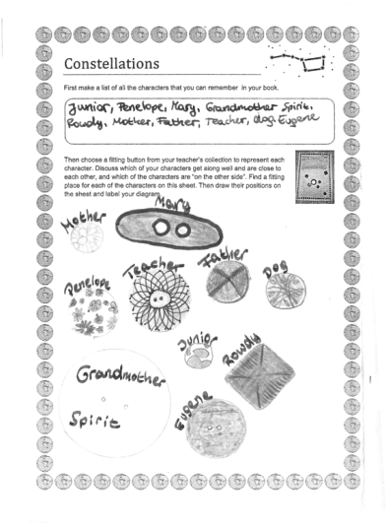
Teachers’ Observations: The “story pie” was used as a scaffold for summarizing the plots of the novels. This structure helped the learners to pick out the main events in the novels whereby making transparent the most important borders which the characters had to cross. Besides being a very useful tool to highlight the most important events in the novels, it also gave students the opportunity to reflect once again on the various experiences the characters had on their way toward understanding their cultural identity.
Figure 7: Story Pie

Task 11: Constellations
First make a list of all the characters that you can remember in your book. Then choose a fitting button from your teacher’s collection to represent each character. Discuss which of your characters get along well and are close to each other, and which of the characters are “on the other side”. Find a fitting place for each of the characters on this sheet. Then draw their positions on the sheet and label your diagram.
Figure 8: Constellations
Teachers’ Observations: In this activity the learners designed socio-grams showing the relationships among the characters of their novel. They chose a fitting button from the teacher’s collection to represent each of the main characters and positioned these buttons on their worksheets according to the closeness or distance of their relationships. After completing this activity, many learners commented on their constellations. An interesting comment which was made concerned the concept of friendship. A few students noted that friendships and strong relationships developed irrespective of the characters’ cultural backgrounds. In fact, some of the closest friends in the novels were from different ethnic groups and had to overcome their prejudices. This task seemed to challenge the learners’ concept of friendship in their respective cultures and how they are developed. On a more personal level, it also required them to reflect on who they choose to be their friends and why.
Task 12: Group Discussions
Find the youngest member in your group. He/she will be the LANGUAGE POLICE for this activity. Make sure you use ENGLISH ONLY in your discussions.
Work with the discussion cards provided by your teacher. Discuss each topic in detail. After each activity write a few sentences about your discussion into your project booklet.
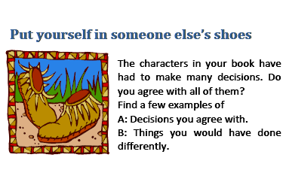
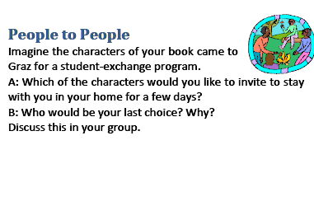
Figure 9: examples of discussion cards

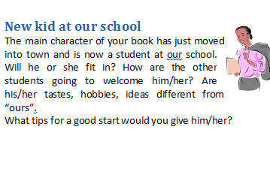

Teachers’ Observations: In this task, the learners were given eight discussion prompt cards which required the students to consider how they would interact with the characters in their novels and how they felt about various events/decisions that occurred. As in the previous task, this task required the students to consider their own cultural standpoints and compare them with the main characters in their books. This often meant that they also had to explain why they would react in a certain way which was quite challenging because their value systems and attitudes were called into question. The discussion prompts have been adapted from Laura Robb’s Fabulous Discussion Prompt Cards (Robb, 2001). Figure 9Figure 9 shows three of the cards we used.

Task 13: Novel Museums
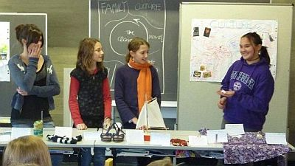Figure 10
For the Novel Museum (Filkins & Szabos, 1984) imagine that the characters in your book were REAL people. Our town wants to make their stories public and has, therefore, dedicated a whole room in the museum to these people and their stories. There they show real artifacts from your characters’ lives. These objects are presented nicely in showcases and on tables around the room. Each of the objects has a label explaining the importance of the item, where it is from and what role it played. In your museum display you might show some of the following things:
Maps, short newspaper articles about what happened to your characters, diary pages, letters, objects they used during their adventures, photos, clothes they were wearing, favorite items of your characters….. or any other things that play an important role.
Teachers’ Observations: This was the final task of the ‘Crossing Borders’ project. Novel museums required the students to present items that had been important in the characters’ lives and explain these items to the class like in a museum exhibit. These items represented the protagonists’ lifestyles, their cultural practices and attitudes as well as the borders they had to cross. By picking relevant items and explaining their importance for the characters, the students showed that they had not only gained knowledge about the respective cultures in their novels but also understanding for why the characters acted in certain ways based on cultural assumptions. This final task seemed to draw together all of the various cultural aspects which had been written about and discussed in the previous tasks.

Conclusion
Taking a task-based approach to YAL in order to enhance teenage learners’ intercultural competence proved to be an effective approach on many levels. Not only did the type of literature satisfy the language learners’ reading needs but due to the variety of tasks, they could consider (inter)cultural concepts on many different levels. In the tasks that required them to compare their personal situations and attitudes with those of the characters’, they had the opportunity to reflect on their personal assumptions and question the underlying values and beliefs. In the book-related tasks, the language learners had to come to terms with cultures and experiences which were often new for them and show their understanding of them. As the tasks could be done individually as well as in small groups, students could work at their own pace and thus spend more time on those they found particularly challenging, interesting, informative etc. Classroom discussions and the final presentation also provided students with a forum to express their thoughts about intercultural issues and discover how others view these aspects. Finally, the flexibility of this approach meant that the tasks did not have to be done in a prescribed order and could be completed both as homework as well as class work. This aspect added to the enjoyment of the project since there was no pressure to finish the tasks due to any constraints. In conclusion, the ‘Crossing Borders’ project provided the teenage learners with many opportunities to discover, learn about and discuss intercultural issues. We hope that by sharing this project, we have provided some useful approaches to developing this essential competence.

Appendix

Other books that would be suitable for this project are:

- Randa Abdel-Fattah, Ten Things I Hate About Me
- Sandra Cisneros, The House on Mango Street
- Sharon Creech, Walk Two Moons
- Linda Crew, Children of the River
- Donald R. Gallo (ed.), First Crossing. Stories about Teen Immigrants
- Francisco Jiménez, The Circuit
- An Na, A Step from Heaven

Works Cited
CEFR: Common European Framework of Reference for Languages: Learning, teaching, assessment. (2001). Cambridge: Cambridge University Press.
Bredella, L. (2000). Literary texts. In M. Byram, Routledge Encyclopedia of Language Teaching and Learning (pp. 375 - 381). London: Routledge.
Budhos, M. (2006). Ask Me No Questions. New York: Athenum Books for Young Readers.
Byram, M. (2000). Sprogforum NO.18: Assessing Intercultural Competence in Language Teaching. Retrieved 04 13, 2011, from Sprogforum: http://inet.dpb.dpu.dk/infodok/sprogforum/Espr_nr18.html
Collie, J., & Slater, S. (2000). Literature in the Language Classroom: A Resource Book of Ideas and Activities. Cambridge: Cambridge University Press.
Filkins, J., & Szabos, V. (1984). Reading: A Novel Approach. Good Apple Inc.
Ghosn, I. (2002). Four Good Reasons to use Literature in Primary School ELT. ELT Journal 56/2, 56/2, pp. 172-179.
Jaramillo, A. (2008). La Linea. Stuttgart: Klett.
Kramsch, C. (1998). Language and Culture. Oxford: Oxford University Press.
Lázár, I., & al. (2007). Developing and assessing intercultural competence. A guide for language teachers and teacher educators. Graz: ECML.
Risager, K. (2009). Intercultural Competence in the Cultural Flow. In H. A., & B. M., Interkulturelle Kompetenz und fremdsprachliches Lernen: Modelle, Empirie, Evaluation/ Intercultural competence and foreign language learning: Models, empiricism, assessment. Tübingen: Narr.
Robb, L. (2001). 52 Fabulous Discussion-Prompt Cards. Scholastic Teaching Resources.
Rönnqvist, L., & Sell, R. (1994). Teenage Books for Teenagers: Reflections on Literature in Language Education. ELT Journal, 48/2, pp. 125-132.
Schorr, M. (2006). Goy Crazy. New York: Hyperion Teens.
Seelye, H. (1993). Teaching Culture, Strategies for Intercultural Communication. Lincolnwood, Illinois: NTC.
Sherman, A. (2007). The Absolutely True Diary of a Part-Time Indian. New York, Boston: Little Brown.
Tomalin, B., & Stempelski, S. (1993). Cultural Awareness. Oxford: Oxford University Press.
Wintergerst, A., & McVeigh, J. (2011). Tips for Teaching Culture. Practical Approaches to Intercultural Communication. White Planes, New York: Pearson Longman.
Woodson, J. (1998). If You Come Softly. New York : Puffin.
Wu, Y. (2008, May). The Internet TESL Journal . Retrieved 08 20, 2011, from itesl.org: http://iteslj.org/Articles/Wu-YoungAdultLiterature.html

The booklet can be downloaded from Elisabeth Polzleitner’s English Pool at :http://epep.at (search for: cultural values in the search box)

