  - Young Adult Literature: helping teenage language learners cross cultural borders while raising their intercultural competence
Speaking foreign languages allows us to communicate with people from different linguistic and cultural backgrounds. Although effective communication involves more than linguistic proficiency, this aspect of language learning has been mainly given precedent in the language classroom. Strongly influenced by the communicative approach to language teaching, many foreign language teachers still seem to place more emphasis on developing their learners’ linguistic competence than on the cultural dimension of their language learning. However, more recently many foreign language teachers have become increasingly aware of the fact that being a competent non-native speaker of a foreign language involves more than knowing all of the grammar rules, possessing a wide vocabulary of the respective foreign language and having native to near native fluency (Lázár et al 2007: 5). In line with recommendations of the Common European Framework of Reference for languages (CEFR), they see the ever increasing need for developing their language learners’ intercultural competence in today’s multicultural world. In doing so, language learners are not only equipped with the necessary linguistic tools but are also able ‘to promote mutual understanding and tolerance, respect for identities and cultural diversity through more effective international communication’ ( CEFR, 2001: 3).
Literature has long been seen as a rich medium to impart knowledge about cultural issues in the language classroom. The aim of this paper is to show how literature, more specifically, young adult literature (YAL) can be used to enhance language learners’ (aged 13 -16) intercultural competence by taking a task-based approach or learner-centered approach??. It is suggested that YAL is particularly suitable for this purpose. Although it may present a world that is in many ways different to theirs, young adult often gain quick access due in part to the teenage point of view and the language used. In the final part of this paper, practical suggestions for how to use YAL in the language classroom will be provided.

Defining Culture
Traditionally the teaching of culture in most school curricula has been associated with literature, arts, music, geography, history and institutions. This understanding of culture is often described as ‘big C’ and has played a prominent role in the language classroom due in part to a ‘clearly identified curriculum of topics to be covered, and textbooks which deal with them (Tomalin and Stempleski, 1993, 7). However, as Seelye (1997) observes, ‘[t]his narrow definition of culture, unfortunately, does not fully prepare a student to understand the wide range of behavior exhibited by other species’ (16). Therefore the teaching of culture must be understood in a broader sense which in the literature is often referred to as ‘little c’. This conception of culture ‘includes elements that are perhaps less visible and less tangible and have no traditional subjects assigned to them in schools’ (Lázár et al 2007: 7). It ‘is often described as subjective culture, as people’s everyday thinking and behavior, or as the common traditions, practices, and customs of people’ (Wintergerst 2011, 8). In this paper, the term culture will be used primarily to mean culturally-induced behaviors, customs and values. The authors have found that a task-based approach to YAL allows them to combine culture and language in the foreign language classroom and thus contribute to developing their language learners’ intercultural competence.
Intercultural Competence in Language Teaching
Michael Byram’s approach to intercultural competence, which is a component of his comprehensive intercultural communicative competence model, has strongly influenced the teaching of culture in the language classroom. It was particularly designed for the purpose of language teaching where ‘both culture-general and culture-specific dimensions, are equally important” (Risager 2009: 27). The model also lends itself nicely as a set of teaching objectives which were draw on in the development of the tasks for reading and responding to YAL. Byram’s 5 dimensions of intercultural competence are,
- “Attitudes: curiosity and openness, readiness to suspend disbelief about other cultures and belief about one’s own.
- Knowledge: of social groups and their products and practices in one’s own and in one’s interlocutor’s country, and of the general processes of societal and individual interaction.
- Skills of interpreting and relating: ability to interpret a document or event from another culture, to explain it and relate it to documents from one’s own.
- Skills of discovery and interaction: ability to acquire new knowledge of a culture and cultural practices and the ability to operate knowledge, attitudes and skills under the constraints of real-time communication and interaction.
- Critical cultural awareness/political education: an ability to evaluate critically and on the basis of explicit criteria perspectives, practices and products in one’s own and other cultures and countries.” (Byram 2000: 9)
These elements of intercultural competence will be referred to again later in this paper when we present various tasks which can be done with YAL to raise teenage learners’ intercultural competence.

Selecting Literature
Deciding on literature appropriate for enhancing intercultural competence in the language classroom for 13-16 year olds can be quite difficult as language teachers often find themselves being forced to compromise either on the language or content level. Abridged or simplified texts are often recommended. However, Rönnqvist and Sell have found through their English program with Swedish-speaking Finnish children that many abridgments or simplifications lack in providing subtle cultural nuances and are often criticized by teenage learners due to the simple language used (1994: 126). Their experience has shown that YAL, which can be defined as novels written specifically for a young adult audience, finds resonance with teenage language learners.
Since the purpose of this paper is to address the usefulness of YAL for enhancing young adult language learners’ intercultural competence, we will only cite the reasons they present for using YAL for this purpose. Firstly, teenage novels in the foreign language present life in unfamiliar environments as experienced by characters that are the same age as the teenage language learners. This experience is often heightened by the fact that most YAL is written from the first person perspective (Wu 2008). By looking at a world different to their own through the eyes of a young person, teenage language learners are invited to reflect on their own world/culture, which is vital in developing their intercultural competence (ibid: 129). Secondly, teenage language learners can acquire first hand cultural insights into the cultures of other teenagers that they might otherwise never have the chance to encounter when reading YAL. In this way, YAL can provide them with valuable cultural knowledge and thus expand their understanding of the world. Finally, Rönnqvist and Sell have found that young adults enjoy the ‘up-to-date’ language used in YAL (ibid: 127). Thus teenage readers are also introduced to the contemporary language used by the target culture which provides them with a language ‘as genuine and undistorted as can be managed in the classroom context’ (Collie and Slater 2000, 3). Since language, culture and thought are closely intertwined, according to Kramsch (1998, 3), we can say that the language used in YAL ‘expresses, embodies and symbolizes cultural reality’ of the target culture.
Based on our experience with using YAL to enhance young adult learners’ intercultural competence, we have found that it must fulfill certain criteria. Bredella (2000: 378) recommends using ‘post-colonial and minority texts because these often dramatise intercultural conflicts and reveal causes for misunderstanding and misrecognition of others’. Reading novels with characters from various cultural backgrounds helps teenage language learners more easily notice differences but also similarities. Ghosn (2002: 177) adds that the characters should be presented ‘in contexts that accurately reflect the culture of the English-speaking world today’ and that the stories ‘mirror the prevailing cultural values and traditions of a people, and avoid stories that portray outdated customs and beliefs’. In other words, the literature should be representative of the given contemporary society portrayed so as to provide young adults with ‘a feel for the codes and preoccupations that structure a real society (Collie and Slater 2000, 4). For a recommended reading list of YAL that fulfill these criteria, please see the appendix.

Task-based approach or learner-centered approach ???
The following tasks can be used on their own or in combination to raise teenagers’ intercultural competence while reading YAL. The tasks can, therefore, be adapted to fulfill the teaching outcome. For each given task a short explanation is provided as well as teacher observations as to what intercultural competence is being practiced? as well as what we have experienced ourselves when doing these tasks. About half of these tasks focused on the learners’ personal cultural experiences and identity, the other half dealt with questions about the book-characters’ experiences. By comparing these two perspectives we hoped to create a better understanding of the protagonists’ problems.
Task 1: Who am I? My cultural autobiography
How would you define yourself? Think about things that are especially important to you in how you think about yourself and how you like others to see you. Think of your family background, your country, community, language(s), groups you belong to, activities that are important to you.

Task 2: My Language-Self – My Cultural-Self
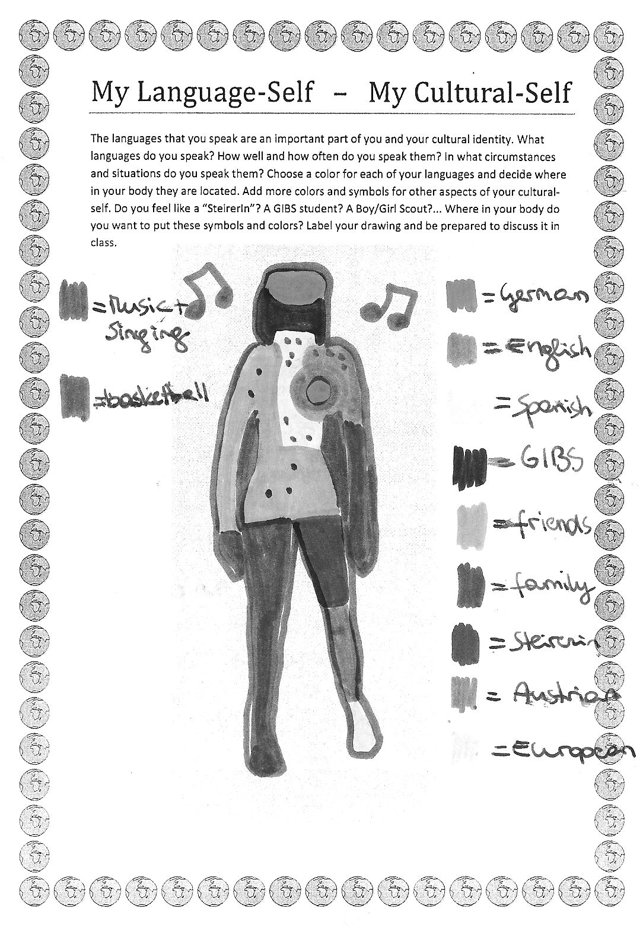
The languages that you speak are an important part of you and your cultural identity. What languages do you speak? How well and how often do you speak them? In what circumstances and situations do you speak them? Choose a color for each of your languages and decide where in your body they are located. Add more colors and symbols for other aspects of your cultural-self. Do you feel like a “SteirerIn”? A GIBS student? A Boy/Girl Scout?... Where in your body do you want to put these symbols and colors? Label your drawing and be prepared to discuss it inclass.

Teachers’ Observations: For the young adult learners these tasks were quite challenging because most of them had never thought about themselves in this way before. Their social and cultural environment seemed to be “normal” and the only obvious possibility. By making these environments visible and sharing them in the class, the children realized that their self-concepts were quite different even among the majority who had a local, Austrian background. Those children in the class who were foreign born or had multi-cultural backgrounds found this activity easier, because they were more strongly aware of their differences. The activity showed the children that their self-concepts were “colored” by their cultural backgrounds and environments and that each of them was different. Being different and finding more than one “color” in themselves made them special and proud rather than embarrassed about their differences.

Task 3: Intercultural Encounter:
You have certainly met people from very different cultures and backgrounds. Think of a specific incident where you had such an intercultural encounter and describe it briefly. Tell us who/where/when… you met the person(s). What was your first impression? How did you feel about it? What did you find out later?
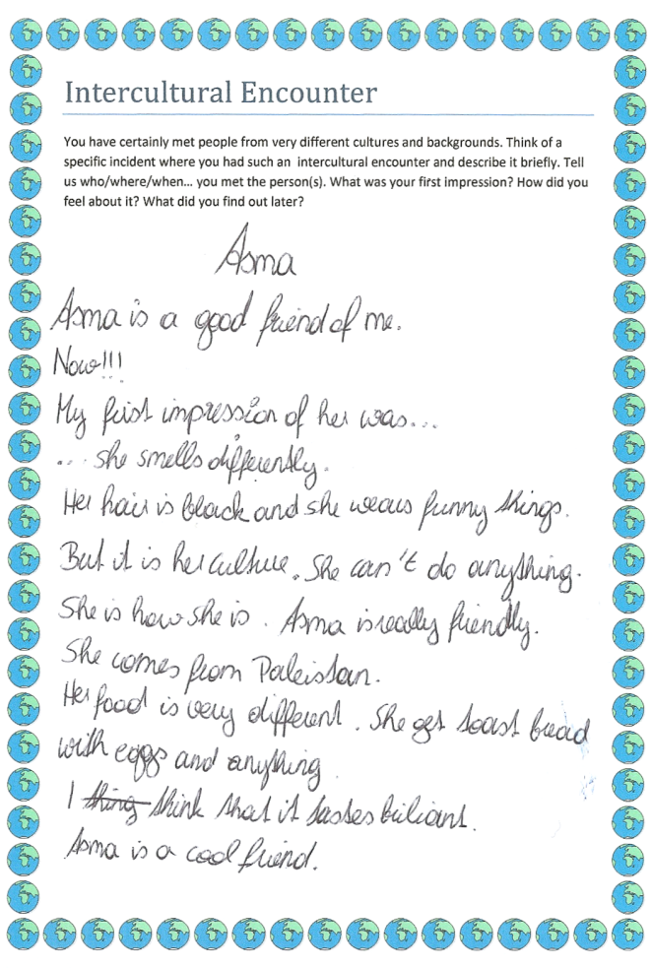
While tasks 1 and 2 focused on defining the learners’ personal, social and cultural identities, task 3 led them out of their home-environment and into a new and different world. By describing an intercultural encounter the children focused more on the differences and the unexpected things that they had experienced. The children described situations where they had met “strange” people that acted in uncommon ways or where they felt like outsiders themselves. This task gave them the chance to voice their fears and preconceived opinions about strangers.
In these texts the children expressed all kinds of feelings ranging from surprise or fear in the face of strangers to sadness about being an outsider themselves. Discussing the texts in class gave us the chance to clear up some misunderstandings and misconceptions about different cultures. The children could see that many of the encounters their classmates had shared, dealt with misunderstandings that had finally been cleared up. It also showed them both perspectives: that of the stranger and that of the majority, and helped them to step in and out of these consciously.
Task 4 then lead into the novels: Start reading your book:
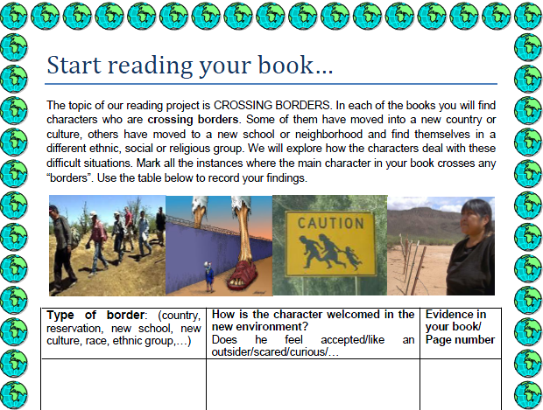
In this task the learners found that many of the characters felt unwanted and like outsiders, had to hide or suffered all kinds of discrimination. .The protagonist of Ask Me No Questions is an illegal alien from Bangladesh who has outstayed her tourist visa and now faces all kinds of troubles in the United States. The character of La Linea is trying to cross the border between Mexico and the US with a coyote in order to join his parents. The main character in The Absolutely True Diary of a Part-time Indian has left the reservation in order to attend a white high-school. The protagonists of If You Come Softly are crossing racial borders: the Jewish girl is dating an African American boy in New York City.
Last but not least, Rachel in Goy Crazy struggles with her Jewish heritage and navigates between the values of her traditional upbringing and the expectations of her WASP school-mates.
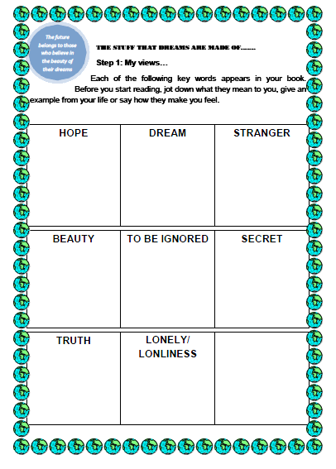
Tasks 5 and 6:
In tasks 5 and 6 the learners compared several key concepts in the novels with their own views and experiences. Again the children first looked at their own views and associations on each key-word, and then saw the same concepts from the protagonist’s point of view. They all noticed a big difference between their own comfortable lives where dreams come true and hopes can be fulfilled and the difficult lives of the book characters, who struggle with loneliness and unfulfilled dreams. All the children felt empathy with these protagonists and wondered why they couldn’t be integrated more easily. Fortunately all the characters in these novels are very strong characters who find creative ways out of their crises. The books do not put all the blame on mainstream society but offer a good balance of criticism and creative solutions and thus empower the young readers.
Tasks 7 and 8 :
Stereotype Detectives: What I know, think and have heard about…
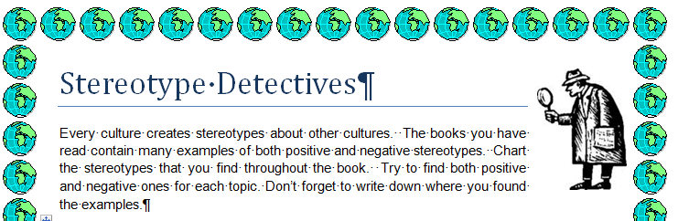
The next two tasks dealt with detecting stereotypes. Again this was done on two levels. First the learners collected their ideas and associations with the different social groups from the novels. We added the group of Turkish people, because they constitute the biggest group of immigrants in our area and are often faced with discrimination and aggression. Although our students attend an international school and generally come from very liberal and open-minded families, many of them wrote down things like: “Turks are often brutal and dirty”, “Americans are fat”, “Canadians are friendly”. After collecting their personal views they looked at the stereotypes in the novels and collected examples of positive as well as negative stereotypes under the following headings: dwelling / language / physical appearance/ compared to other Americans minority members in your book are …
When comparing the stereotypes in the novels with their personal lists, the learners soon noticed the many similarities. They realized how unfounded and unjust most of these stereotypes were and how easily we all seem to be influenced by them.
Task 9: My culture – their culture
In this activity the students completed a Venn diagram comparing their own culture with that of their novel. The children found many relevant similarities and differences on a variety of levels: The most interesting outcome of this activity was that almost all the children found that irrespective of all the differences, they all shared the same hopes and dreams with their protagonists. They want to be safe, have a family and good friends whom they can trust.
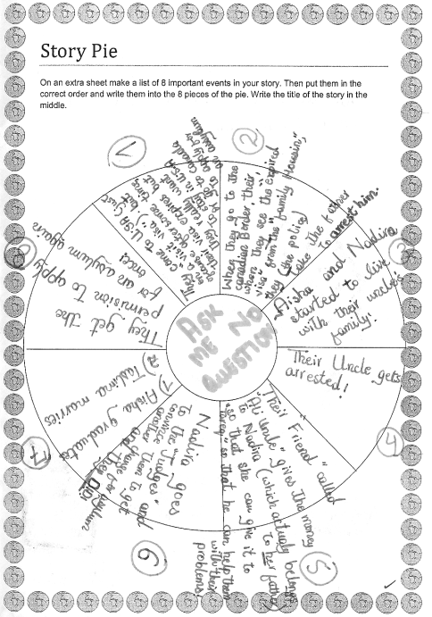
Task 10: Story Pie
We used the classic “story pie” as a scaffold for summarizing the plots of the novels. This structure helped the learners to pick out the main events in their books rather than getting lost in minor details. These story pies were useful resources later in the project, when we cross-grouped the learners and asked them to share their stories with students who had read a different book.
Task 11: Constellations
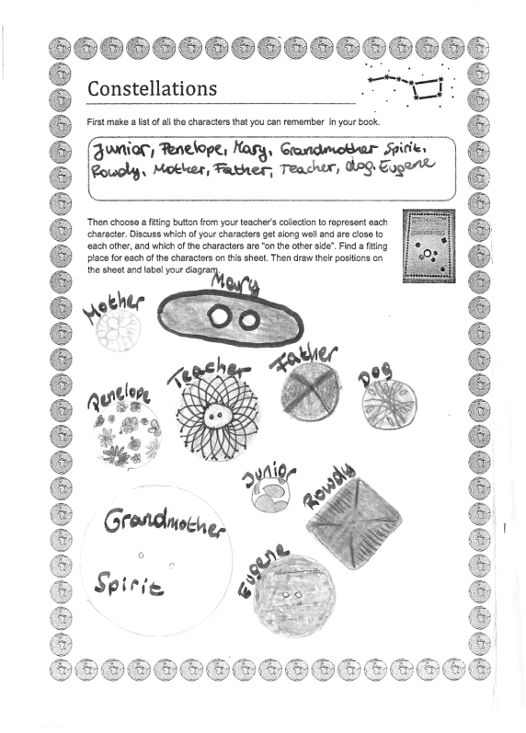
In this activity the learners designed socio-grams showing the relationships among the characters of their novel. They chose a fitting button from the teacher’s collection to represent each of the main characters and positioned these buttons on their worksheets according to the closeness or distance of their relationships. In this activity the learners saw that friendship and strong relationships can develop irrespective of the characters’ cultural backgrounds. Some of the closest friends in the stories were from different ethnic groups and had overcome their prejudices.
Task 12: Group Discussions
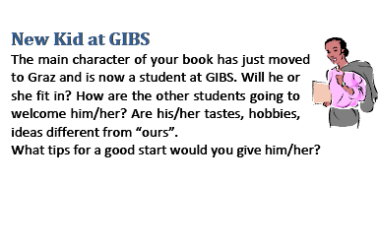
In the group discussions the learners were given eight discussion prompt cards to trigger interesting discussions about the novels and their characters. These discussion prompts have been adapted from Laura Robb’s Fabulous Discussion Prompt Cards (Robb, 2001). Apart from standard questions about great expressions, places, cliff-hangers, highs & lows and advice to a friend, we asked the following three questions:

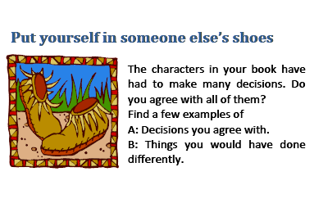
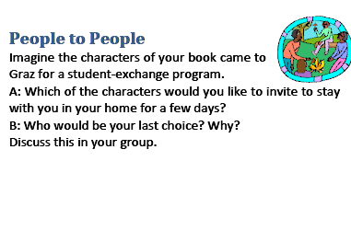

Works Cited
Bredella, L. 2000. ‘Literary texts’ in M. Byram. Routledge Encyclopedia of Language Teaching and Learning. London: Routledge, 375-381.
Byram, M. (2000). ‘Sprogforum NO.18: Assessing Intercultural Competence in Language Teaching’ in http://inet.dpb.dpu.dk/infodok/sprogforum/Espr_nr18.html [04 13, 2011].

Collie, J. and Slater, S (2000). Literature in the Language Classroom. A Resource Book of
Ideas and Activities. Cambridge: Cambridge University Press.
Common European Framework of Reference for Languages: Learning, teaching, assessment. (2001). Cambridge: Cambridge University Press.
Filkins, J. S. (1984). Reading: A Novel Approach. Good Apple Inc.
Ghosn, I. (2002). “Four Good Reasons to use Literature in Primary School ELT,” ELT Journal 56/2, 172-179
Lázár, Ildikó, et al. (2007). Developing and assessing intercultural competence. A guide for language teachers and teacher educators. Graz: ECML.
Risager K. (2009). ‘Intercultural Competence in the Cultural Flow’ in A. Hu and M. Byram. Interkulturelle Kompetenz und fremdsprachliches Lernen Modelle, Empirie, Evaluation/ Intercultural competence and foreign language learning Models, empiricism, assessment. Tübingen: Narr, 15-31.
Robb, L. (2001). 52 Fabulous Discussion-Prompt Cards. Scholastic Teaching Resources.
.
Rönnqvist, L. and Sell, R. (1994). “Teenage Books for Teenagers: Reflections on Literature in
Language Education,” ELT Journal 48/2, 125-132.

Seelye, H.N. (1993). Teaching Culture. Strategies for Intercultural Communication.
Lincolnwood, Illinois : NTC.

Tomalin B.and Stempleski, S. (1993). Cultural Awareness. Oxford : Oxford University Press.

Wintergerst, A. and McVeigh J. (2011). Tips for Teaching Culture. Practical Approaches to
Intercultural Communication. White Planes, New York : Pearson Longman.

Wu, Yongan (2008) ‘Teaching Young Adult Literature in Advanced ESL Classes’ in
http://iteslj.org/Articles/Wu-YoungAdultLiterature.html [20.8.2008].

Appendix

Alexie, Sherman The Absolutely True Diary of a Part-Time Indian
Budhos, Marina Ask Me No Questions
Crew, Linda Children of the River
Frank, E.R. Life is Funny
Jaramillo, Ann La Linea
Myers, Walter Dean Monster
Schorr, Melissa Goy Crazy
Woodson, Jacqueline If You Come Softly

