Crossing Borders
  - Using Young Adult Literature to Raise Intercultural Awareness
A different language is a different vision of life. ~Federico Fellini
Learn a new language and get a new soul. ~Czech Proverb

Speaking a foreign language can obviously open doors and allow us to see the world through different eyes. After a strong wave of communicative language teaching that mainly focused on speech act and discourse competence, educators around the world are becoming aware of another dimension of language teaching that is at least as important in the long run, and that has the potential to contribute to peace and harmony among citizens, both locally and internationally. We are talking about intercultural awareness and intercultural competence, which have been defined as one of the main aims of the Council of Europe language policy. They hope “to promote mutual understanding and tolerance, respect for identities and cultural diversity through more effective international communication.” (Common European Framework of Reference for Languages: Learning, teaching, assessment 2001, 3)
In this paper we will show how learners’ intercultural awareness can be raised through the use of Young Adult Literature (YAL). We will describe how reading and analyzing young adult novels can be used in a task based approach, in order to teach both sociocultural knowledge as well as intercultural awareness as defined by the CEFR (p. 102ff). We will show how young adult novels can be used effectively with very different age groups, from lower intermediate teens (ages 13-15) to university students studying ESL.

What is intercultural competence?
The CEFR defines several aspects of intercultural competence. Firstly, sociocultural knowledge (savoir) includes knowledge of the distinctive features of a society and culture of a given country or community. These may include living conditions, interpersonal relations, values and beliefs, social conventions, rituals and celebrations, etc. The second aspect, intercultural awareness, refers to knowledge and understanding of similarities and differences between the culture of origin and the culture of the target community. In addition to this objective knowledge the CEFR describes intercultural skills (savoir-faire) and existential competences (savoir-être) that will help the learners use their acquired knowledge effectively. (CEFR: p. 102-104). Byram (Byram 2000, 8-13) combines and simplifies these into five main aspects of intercultural competence:
- Attitudes: curiosity and openness towards other cultures and a willingness to relativize one’s own cultural viewpoint.
- Knowledge: of social groups, their products and practices and interaction
- Skills of interpreting and relating: ability to interpret a document or event from another culture, to explain it and relate it to one’s own culture.
- Skills of discovery and interaction: ability to acquire new knowledge of a culture and cultural practices.
- Critical cultural awareness/political education: an ability to evaluate critically and on the basis of explicit criteria perspectives, practices and products in one’s won and other cultures and countries.
This paper will show in what way Young Adult Literature projects can help build all of these skills and how both young learners as well as advanced ESL students at university level can profit from such projects.

Young Adult Literature Project: Crossing Borders

Goals:
In this project we have worked with two groups of students in Austria: Lis Poelzleitner’s class of 13 year old ESL students, and Jennifer Schumm’s “Socio-cultural Competence” class of ESL students at university. We wanted to use the young adult novels to build our students’ intercultural knowledge and awareness as well as improving their language skills. By reading novels from different cultural backgrounds the students should learn to “walk in someone else’s shoes” for a little while and see the world from a different perspective. This experience, together with the subsequent analysis of the novels, should make a difference on most of Byram’s aspects of intercultural competence. The students should
- acquire knowledge of the lifestyles, problems and practices of the social groups represented in this project
- change their attitudes and challenge their preconceived notions and stereotypes
- develop curiosity, discover and explore new cultures and experiences
- critically evaluate immigration laws in the US as well as in their home country

We decided to call our project “Crossing Borders” and to focus the learners’ attention on the different ways the young protagonists cross borders on their journey to discover their cultural identity.
Obviously, thirteen-year-old learners would go about this in very different ways from university students, whose language skills, cultural knowledge and experience, as well as abstract cognitive skills are much more advanced. In order to adapt the level and depth of analysis to these two age-groups we decided to set a different focus for each of the groups.
We designed the young learners’ project around the characters’ personal identity and experiences, focusing on the characters’ hopes and wishes and the obstacles that were in the way. The university students analyzed the same novels from a more adult perspective and focused mainly on the characters’ cultural identity. At the end of the project we planned a joint presentation day, where both groups would “cross borders” and present their results to each other.

The Books:
We chose five young adult novels in which the main characters are “crossing borders” of some sort. The borders can be understood literally, like neighborhood, country or state borders but can also be understood figuratively like linguistic, racial, religious, gender, social, ethnic and educational borders.
Ann Jaramillo, La Linea
Sherman Alexie, The Absolutely True Diary of a Part-Time Indian
Marina Budhos, Ask Me No Questions
Jacqueline Woodson, If You Come Softly
Melissa Schorr, Goy Crazy

In the following pages we will describe the project step by step as it was carried out by the two groups. Let us start with the young learners.

The Children’s Project:
Three weeks before the project actually started we briefly presented the main project idea of “crossing-borders” to the learners, who then chose one of the five books that interested them most. They were asked to read the books at home and enter a short reflection about the books into their reading diaries. The children are used to writing such reflections and usually express their likes and dislikes about certain characters and events in a book. While the children were reading the books at home we started to work on the project in school. The learners were given a copied booklet including all the tasks for this project. About half of these tasks focused on the learners’ personal cultural experiences and identity, the other half dealt with questions about the book-characters’ experiences. By comparing these two perspectives we hoped to create a better understanding of the protagonists’ problems. For the next two weeks the children worked individually and in small groups and completed the tasks in their booklets.
Task 1: Who am I? My cultural autobiography
How would you define yourself? Think about things that are especially important to you in how you think about yourself and how you like others to see you. Think of your family background, your country, community, language(s), groups you belong to, activities that are important to you.

Task 2: My Language-Self – My Cultural-Self
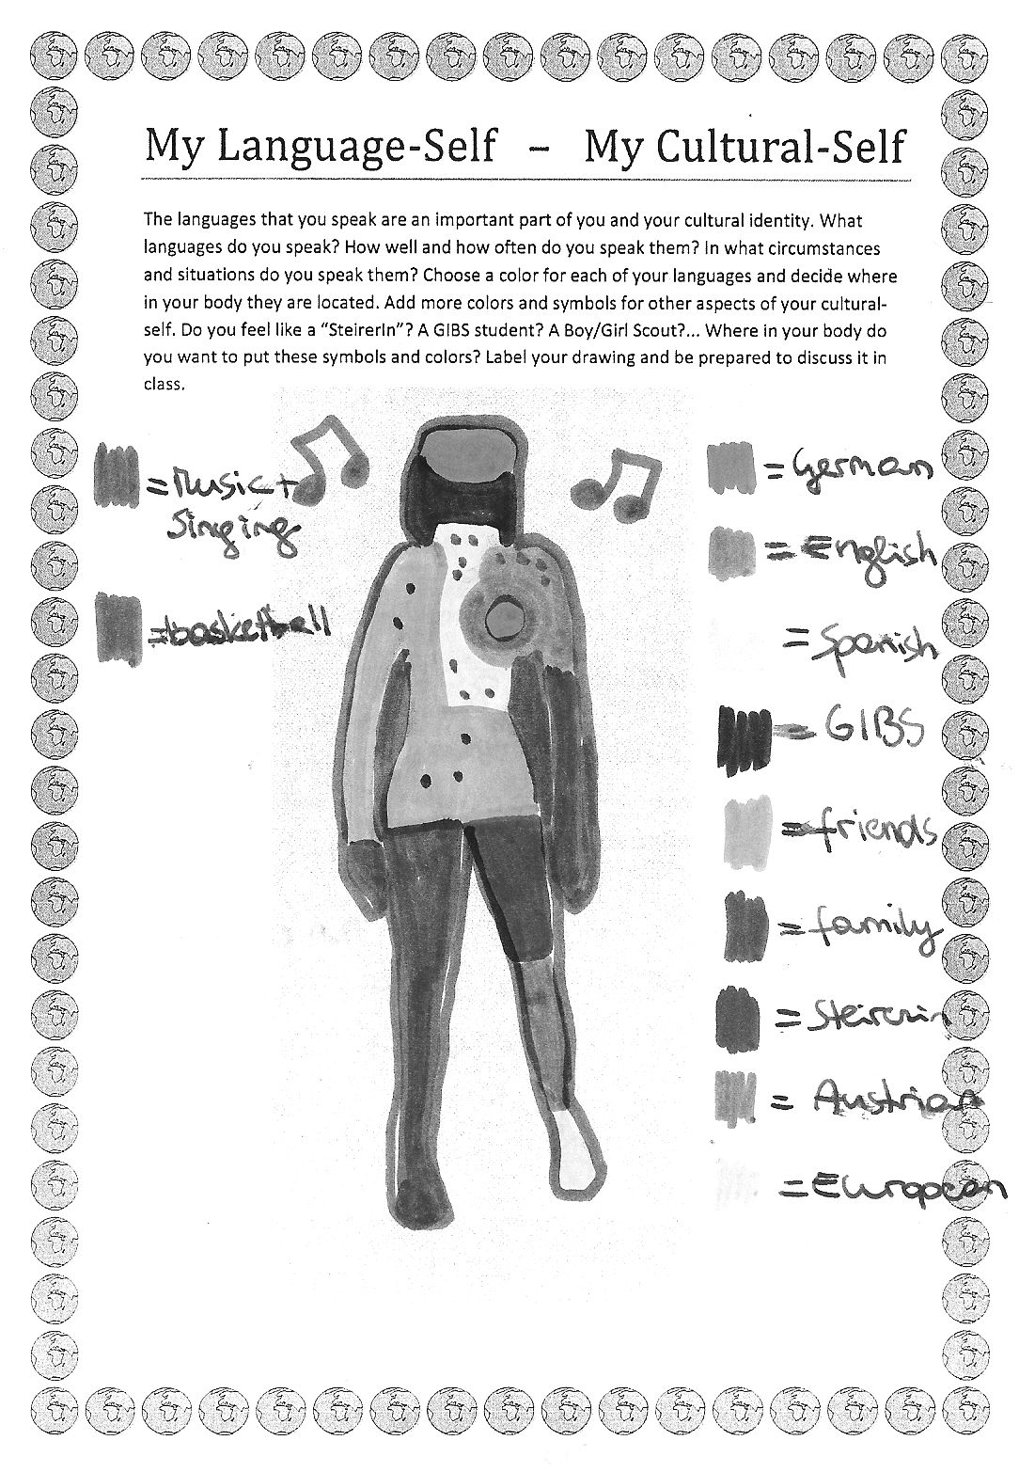
The languages that you speak are an important part of you and your cultural identity. What languages do you speak? How well and how often do you speak them? In what circumstances and situations do you speak them? Choose a color for each of your languages and decide where in your body they are located. Add more colors and symbols for other aspects of your cultural-self. Do you feel like a “SteirerIn”? A GIBS student? A Boy/Girl Scout?... Where in your body do you want to put these symbols and colors? Label your drawing and be prepared to discuss it inclass.
For the children these tasks were not easy because most of them had never thought about themselves in this way before. Their social and cultural environment seemed to be “normal” and the only obvious possibility. By making these environments visible and sharing them in the class, the children realized that their self-concepts were quite different even among the majority who had a local, Austrian background. Those children in the class who were foreign born or had multi-cultural backgrounds found this activity easier, because they were more strongly aware of their differences. The activity showed the children that their self-concepts were “colored” by their cultural backgrounds and environments and that each of them was different. Being different and finding more than one “color” in themselves made them special and proud rather than embarrassed about their differences.

Task 3: Intercultural Encounter:
You have certainly met people from very different cultures and backgrounds. Think of a specific incident where you had such an intercultural encounter and describe it briefly. Tell us who/where/when… you met the person(s). What was your first impression? How did you feel about it? What did you find out later?
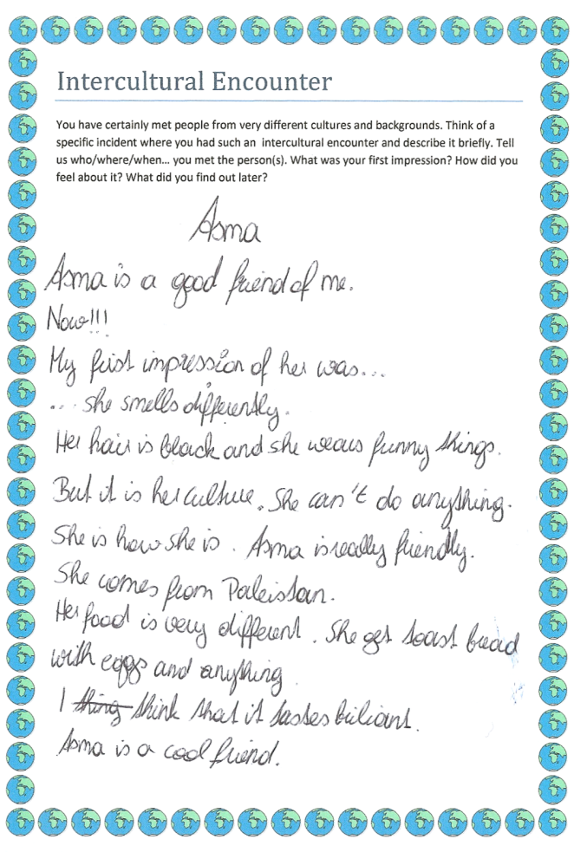
While tasks 1 and 2 focused on defining the learners’ personal, social and cultural identities, task 3 led them out of their home-environment and into a new and different world. By describing an intercultural encounter the children focused more on the differences and the unexpected things that they had experienced. The children described situations where they had met “strange” people that acted in uncommon ways or where they felt like outsiders themselves. This task gave them the chance to voice their fears and preconceived opinions about strangers.
In these texts the children expressed all kinds of feelings ranging from surprise or fear in the face of strangers to sadness about being an outsider themselves. Discussing the texts in class gave us the chance to clear up some misunderstandings and misconceptions about different cultures. The children could see that many of the encounters their classmates had shared, dealt with misunderstandings that had finally been cleared up. It also showed them both perspectives: that of the stranger and that of the majority, and helped them to step in and out of these consciously.
Task 4 then lead into the novels: Start reading your book:
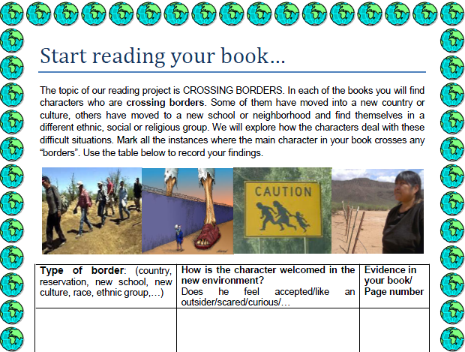
In this task the learners found that many of the characters felt unwanted and like outsiders, had to hide or suffered all kinds of discrimination. The protagonist of Ask Me No Questions is an illegal alien from Bangladesh who has outstayed her tourist visa and now faces all kinds of troubles in the United States. The character of La Linea is trying to cross the border between Mexico and the US with a coyote in order to join his parents. The main character in The Absolutely True Diary of a Part-time Indian has left the reservation in order to attend a white high-school. The protagonists of If You Come Softly are crossing racial borders: the Jewish girl is dating an African American boy in New York City.
Last but not least, Rachel in Goy Crazy struggles with her Jewish heritage and navigates between the values of her traditional upbringing and the expectations of her WASP school-mates.
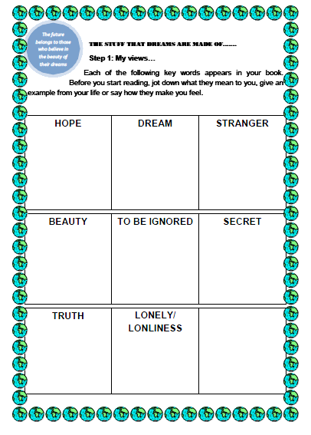
Tasks 5 and 6:
In tasks 5 and 6 the learners compared several key concepts in the novels with their own views and experiences. Again the children first looked at their own views and associations on each key-word, and then saw the same concepts from the protagonist’s point of view. They all noticed a big difference between their own comfortable lives where dreams come true and hopes can be fulfilled and the difficult lives of the book characters, who struggle with loneliness and unfulfilled dreams. All the children felt empathy with these protagonists and wondered why they couldn’t be integrated more easily. Fortunately all the characters in these novels are very strong characters who find creative ways out of their crises. The books do not put all the blame on mainstream society but offer a good balance of criticism and creative solutions and thus empower the young readers.
Tasks 7 and 8 :
Stereotype Detectives: What I know, think and have heard about…
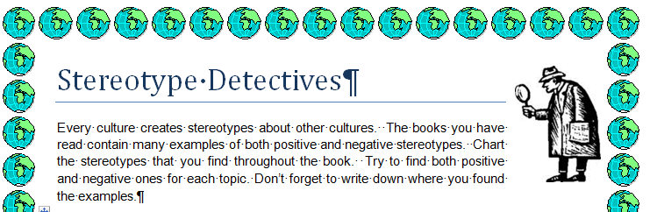
The next two tasks dealt with detecting stereotypes. Again this was done on two levels. First the learners collected their ideas and associations with the different social groups from the novels. We added the group of Turkish people, because they constitute the biggest group of immigrants in our area and are often faced with discrimination and aggression. Although our students attend an international school and generally come from very liberal and open-minded families, many of them wrote down things like: “Turks are often brutal and dirty”, “Americans are fat”, “Canadians are friendly”. After collecting their personal views they looked at the stereotypes in the novels and collected examples of positive as well as negative stereotypes under the following headings: dwelling / language / physical appearance/ compared to other Americans minority members in your book are …
When comparing the stereotypes in the novels with their personal lists, the learners soon noticed the many similarities. They realized how unfounded and unjust most of these stereotypes were and how easily we all seem to be influenced by them.
Task 9: My culture – their culture
In this activity the students completed a Venn diagram comparing their own culture with that of their novel. The children found many relevant similarities and differences on a variety of levels: The most interesting outcome of this activity was that almost all the children found that irrespective of all the differences, they all shared the same hopes and dreams with their protagonists. They want to be safe, have a family and good friends whom they can trust.
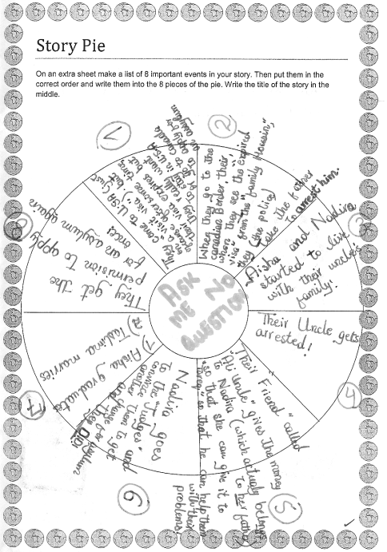
Task 10: Story Pie
We used the classic “story pie” as a scaffold for summarizing the plots of the novels. This structure helped the learners to pick out the main events in their books rather than getting lost in minor details. These story pies were useful resources later in the project, when we cross-grouped the learners and asked them to share their stories with students who had read a different book.
Task 11: Constellations
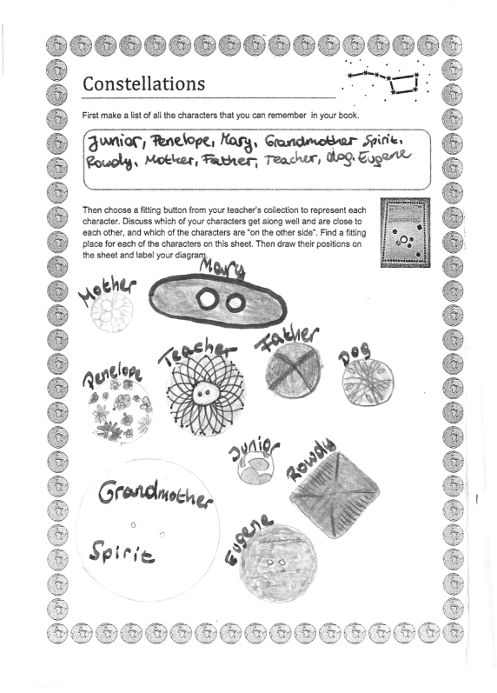
In this activity the learners designed socio-grams showing the relationships among the characters of their novel. They chose a fitting button from the teacher’s collection to represent each of the main characters and positioned these buttons on their worksheets according to the closeness or distance of their relationships. In this activity the learners saw that friendship and strong relationships can develop irrespective of the characters’ cultural backgrounds. Some of the closest friends in the stories were from different ethnic groups and had overcome their prejudices.
Task 12: Group Discussions
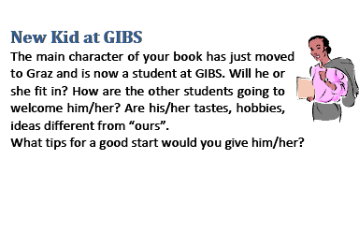
In the group discussions the learners were given eight discussion prompt cards to trigger interesting discussions about the novels and their characters. These discussion prompts have been adapted from Laura Robb’s Fabulous Discussion Prompt Cards (Robb 2001). Apart from standard questions about great expressions, places, cliff-hangers, highs & lows and advice to a friend, we asked the following three questions:

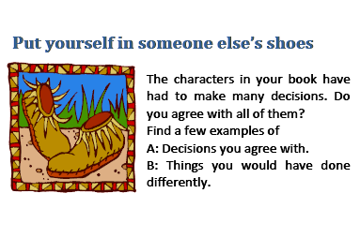
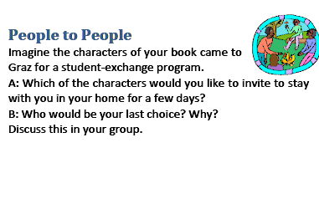

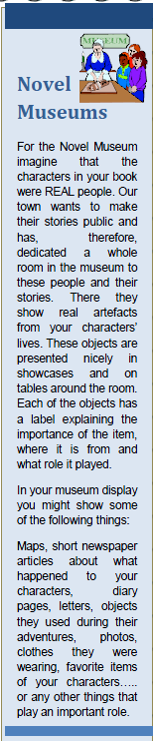
After all this work the students had a very good idea of the novels and the cultural background of the protagonists. They were now ready for the last, and most exciting step in this project: our joint presentation day with the university students.
For their presentations the learners prepared “Novel Museums”, based on an idea from Janice Szabos and Vanessa Filkins (Filkins 1984). Each group prepared a table of objects and artefacts that had played an important role in their novels and presented these as REAL and important evidence of the events in their books. Based on these objects they talked about the characters and their experiences in the novels.
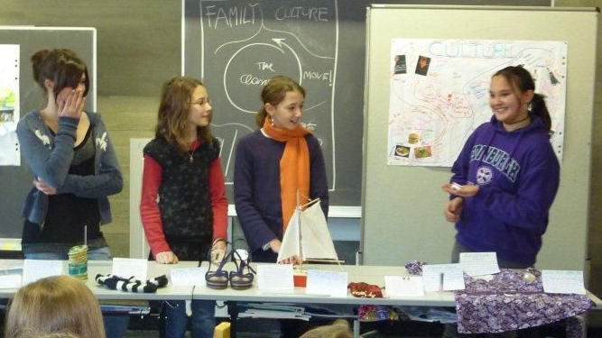

After each Museum presentation, the university students presented their more advanced views on the matter. Let us now look at the project from their point of view:

Thanks to the very creative and interactive presentations prepared by Ms. Schumm's group, 3b students were still active and wide awake after 5 hours!!! of hard work on this project.
Last but not least: My Culture – Your Culture
My Culture -- Your Culture:
In the last part of our project day we shared personal cultural experiences and habits.Many students presented typical holiday foods or traditional clothes or items from their cultural backgrounds. After five hours of hard work we all enjoyed the international food and ended the day with an informal chat, appreciating the colorful, multicultural atmosphere we had created.

Learning Outcomes and Conclusions
…sure learned a lot on all of Byram’s levels…
…feedback…
going to do it again…

Works Cited
Byram, Michael. "Sprogforum NO.18: Assessing Intercultural Competence in Language Teaching." Sprogforum. 2000. http://inet.dpb.dpu.dk/infodok/sprogforum/Espr_nr18.html (accessed 04 13, 2011).
Common European Framework of Reference for Languages: Learning, teaching, assessment. Cambridge: Cambridge University Press, 2001.
Filkins, Janice Szabos and Vanessa. Reading: A Novel Approach. Good Apple Inc, 1984.
Robb, Laura. 52 Fabulous Discussion-Prompt Cards. Scholastic Teaching Resources, 2001.

The booklet can be downloaded from Elisabeth Polzleitner’s English Pool at :http://epep.at (search for: cultural values)

