Book Circles

1. Telling Passages
Choose two passages from your novel that you find particularly interesting and telling.
What do these passages tell us about the character(s) and/or the conflict in this story?
Practice reading these two passages so you can later read them to your group-members clearly and distinctly.

Read the two passages to your group-members and explain why you chose them.

2. Points of View: What I would have done...
Think about one of the main characters in the novel you have just read. Think of their actions, decisions and opinions. Do you disagree with any of them? Fill in the following diagram and explain what you would have done differently and how this would have influenced the story.
My point of view:
What I would have done:

Character's name:
Actions/Decisions

If ................. had ..........................
How would this have influenced the story?

3. Compare the different novels you have read in your group and find the common core as well as the differences. Enter your findings into a Venn Diagram (Use a separate sheet to draw a full-page diagram)
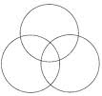
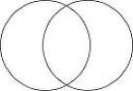
4. Good Expressions:
Find two good expressions that you would like to remember and fill in vocab-cards from them. Then share them with your group-mates and transfer all the new phrases of your group into your vocab-books.

Word: Picture/Color/Doodle

Sentence I found in my reading:

Second example sentence from ….........................................................................(dictionary):

Useful collocations:

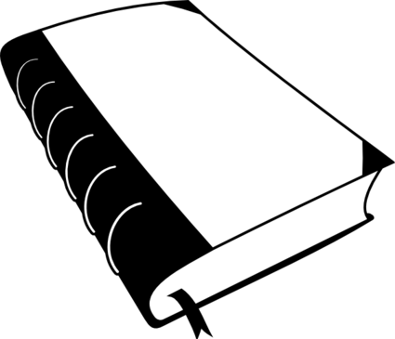
5. Alternative title and cover
Think of a new title for a new edition of your book and make a quick sketch of a fitting cover page.

