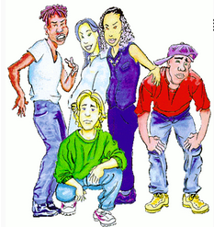
Teens in Trouble
  - Reading Circle Activities

- Plot Telegrams: Follow your teacher’s instructions

- Get together in your reading group and decide who is going to be the Language Police and Group Leader today? Remind your friends to use English only in their discussions and to stay on track ( = not digress from the topic). In case of disagreements make sure that your friends argue their point politely.

- Sharing Reading Diaries: Read each others' reading diaries and discuss your reactions to the story.

- Work with the small Discussion Prompt Cards. Sort the cards by color and put the piles face down on your desk. Take a card from the top of a pile and read it out to your classmates. If the card doesn't apply to your book at all, put it back and take a new one. Do the task carefully in your group. Write all your answers into your reading diary. When you have completed a task, take a new card from a different pile. Take turns reading out the tasks and leading the discussion. Do as many tasks as you can but do them carefully and thoroughly.

- Booklets: Discuss in your group how you could present the content, ideas and problems of your novel in a booklet. Be creative. Do not write summaries and character descriptions but find other ways of showing how you have understood the book.

- Vocabulary: Collect 20 new phrases that you would like to remember and copy them into your vocab-books, together with the German translation.
Do not write single words!!! Leave at least one line between each new phrase.

- Presentation: For the presentation prepare at least 2 of these things. Make sure every group-member is actively involved in the presentation.

  - Plot on the Line
  - Museum
  - Act out your favorite scene

Plan and prepare your presentation well and practice it in class. Make sure you present the book in an interesting way, so that your classmates want to read it as well. Decide whether you want to give away the ending or keep it a secret.
In your presentation you will not be allowed to read your text from a sheet of paper. Make sure you can speak independently and address the class.

